**Building Benchmark Assessments**

**CCSSM - F-BF .3– Building a quadratic function from *f(x) = x2*.**

<http://www.illustrativemathematics.org/illustrations/741> (use as the classroom assessment)

Benchmark Assessment

1. Match the function with the functions below:

Bold line is *f(x).*

1. Identify the function of the thin line from the list below.
2. Identify the function of the dashed line from the list below.
3. *g(x) = 2f(x)*
4. *h(x) = 2 + f(x)*
5. *k(x) = f(x - 1)*
6. *m(x) = f(x + 1)*

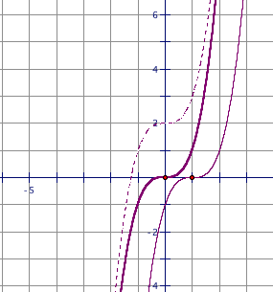

2. Suppose *f(x) = x2.* Write the equations for the following transformations for *f(x).*

1. *p(x)* is function *f(x)* translated to the right 2 and up 3 units.
2. *q(x)* is function *f(x)* flipped across the *x*-axis.

**System for identifying level of CCSS Math Achievement**

|  |  |  |  |  |
| --- | --- | --- | --- | --- |
| F-BF.3 | 1 | 2 | 3 | 4 |
| 1 | Not correct | Either 1(a) or 1(b) correct. | Both 1(a) or 1(b) correct. | Both 1(a) or 1(b) correct. |
| 2(a) | Not correct and not set up p(x) = function of f(x). | Not correct but set up p(x) = function of f(x). | Either 2(a) correct or 2(b) correct. | Both 2(a) correct and 2(b) correct. |
| 2(b) | Not correct and not set up q(x) = function of f(x). | Not correct but set up q(x) = function of f(x). | Either 2(a) correct or 2(b) correct. | Both 2(a) correct and 2(b) correct. |