Learning Progression – Building new functions from existing functions
This is learning progression for the Math 3 courses that uses Integrated Mathematics 3, Rubenstein, Craine, and Butts, published by McDougal Littell.

In unit two of the textbook the functions linear, absolute value, quadratic, polynomial, radical, composite, and rational functions are built ^{F-BF.1} and modeled ^{F-BF.2} which also aligns with (MP 4) modeling with math. Once students build functions and modeled situations to create functions they need to develop a notion for families of functions and translations of functions ^{F-BF.3}. For each type of function in the unit, the second day of the lesson will be spent interpreting the meaning of the transformation and practicing the equation and graphical procedures associated with performing these transformations. In each case an application bases will be described, a functions will be built, and viewed using a graphing calculator (MP 5). The teacher will use the calculator to represent a related function from the original: f(x) + c, cf(x), f(x-c), or f(cx) and ask the students the application situation meaning represent by the transformation. Also, the class will discuss the differences and similarities between the functions using equation, graphical, and tabular representations of the graphing calculator (MP 7). An example of this process is lesson 2-4 when students are using Galileo’s formula for falling objects: d(t) = – 16t².

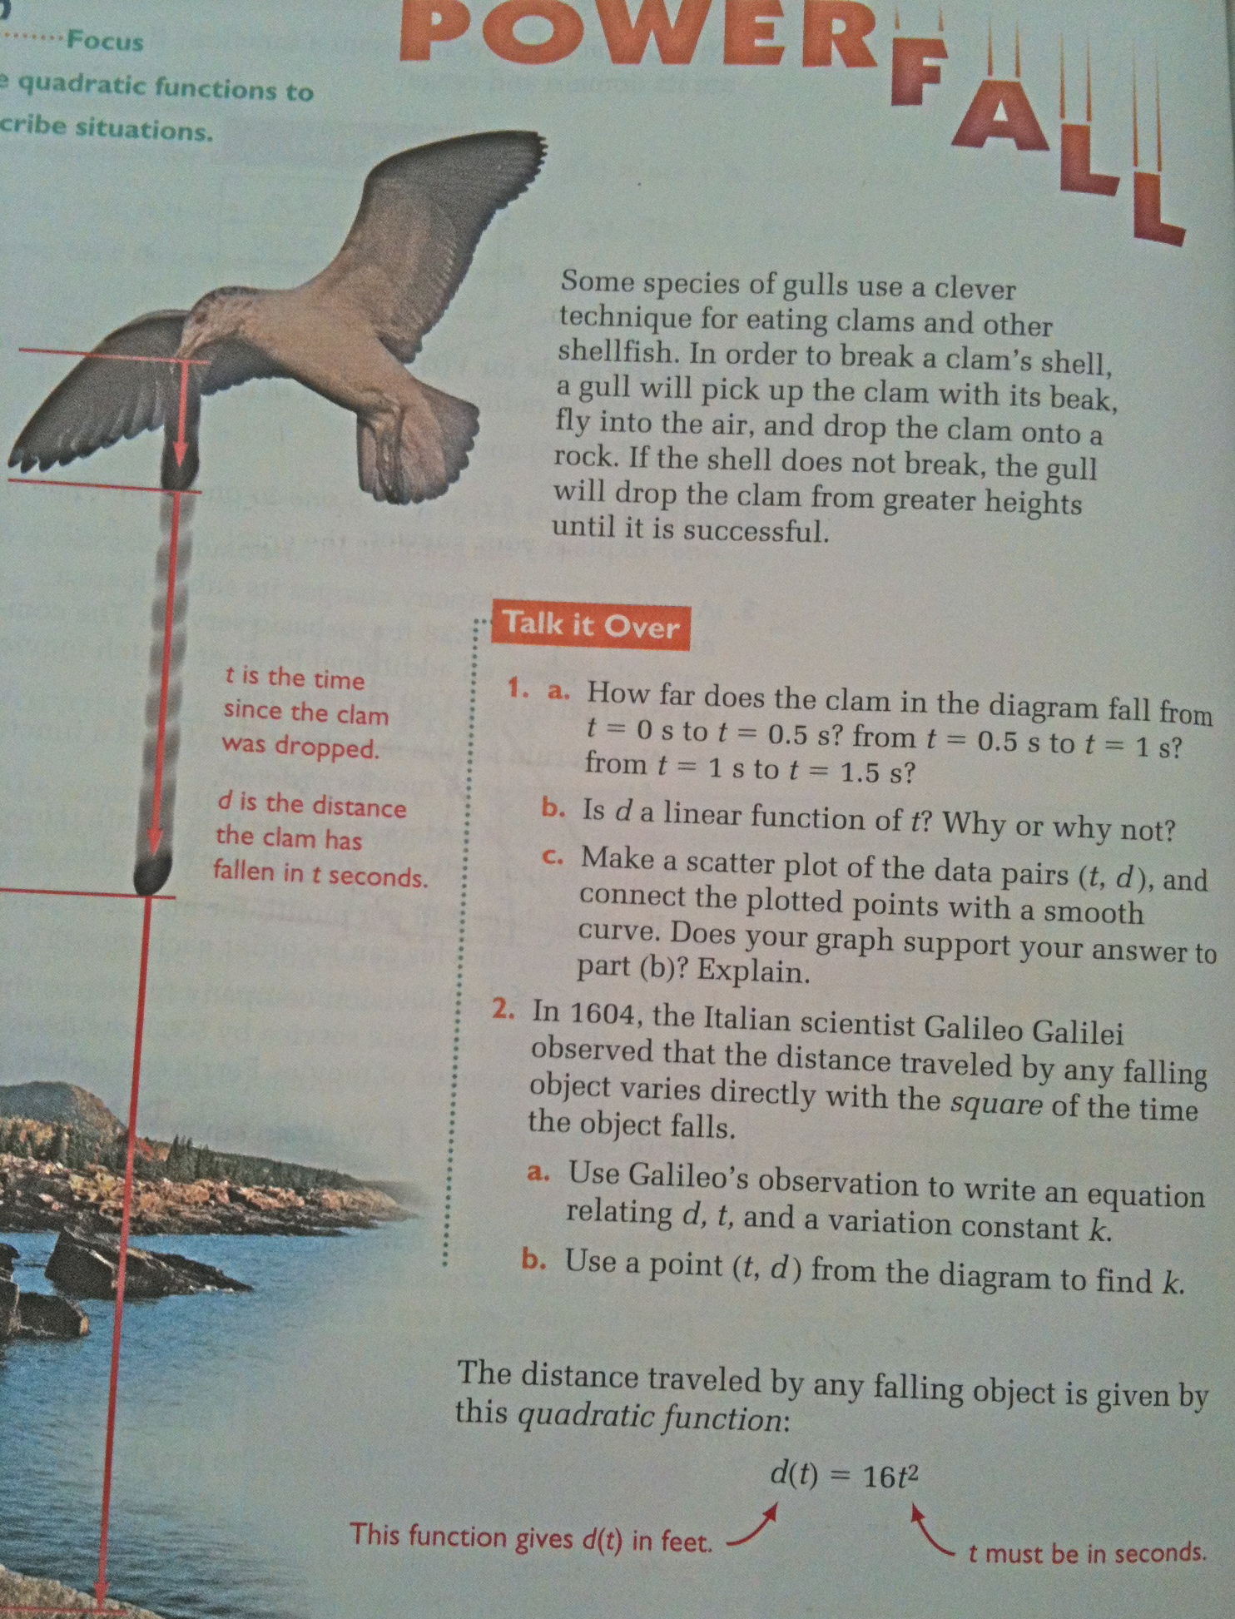
Questions about falling objects will be posed using a graphing calculator such as: d(t) + 10, d(t-2), etc.
Then students will be given a falling objects situation to model that includes a transformation of the basic model.

F-BF.1 Write a function that describes a relationship between two quantities.
a. Determine an explicit expression, a recursive process, or steps for calculation from a context.
b. Combine standard function types using arithmetic operations.
c. (+) Compose functions.

F-BF.2 Write arithmetic and geometric sequences both recursively and with an explicit formula, use them to model situations, and translate between the two forms.

F-BF.3 Identify the effect on the graph of replacing f(x) by f(x) + k, kf(x), f(kx), and f(x+k) for specific values of (both positive and negative values of k); find the value of k given the graphs. Experiment with cases and illustrate an explanation of the effects on the graph using technology.

Benchmark assessment item:
The figure shows the graph of a function f whose domain is the interval −2≤x≤2.
- 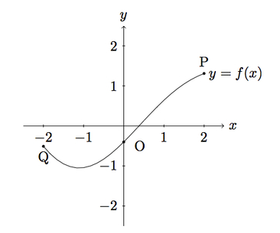In (i)–(iii), sketch the graph of the given function and compare with the graph of f . Explain what you see.
  - g(x)=f(x)+2
  - h(x)=−f(x)
  - p(x)=f(x+2)

- The points labelled Q, O, P on the graph of f have coordinates Q=(−2,−0.509), O=(0,−0.4), P=(2,1.309). What are the coordinates of the points corresponding to P, O, Q on the graphs of g, h, and p ?
For solutions and more discussion of this task, go to the Illustrative Mathematics website at illustrativemathematics.org/illustrations/742

In this unit students will only be expected to solve equation of this form f(x) = c. Students are finding x when given f(x) which leads to the general idea of inverse functions ^{F-BF.4a} . An example of this would be in the radical function lesson exercises of the form f(x) = x² will be used. When solving for x when f(x) = c would be x = which will be used to discuss when exact answers and decimal approximations are appropriate (MP 6). Another example will be when studying linear functions, the equations relating the F° and C° temperatures will be used to study inverse functions.

F-BF.4a Find inverse functions.
a Solve an equation of the form f(x) = c for a simple function that have an inverse and write an expression for the inverse.

