1. Level 1
Prove that quadrilateral A(1,2), B(2,5), C(5,7) and D(4,4) is a parallelogram by using slopes. complete the missing information
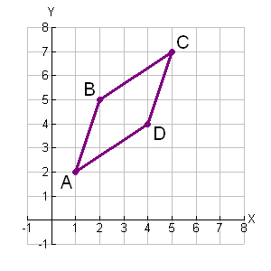 | Slope formula:  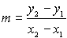  slope of slope of  slope of slope of  Parallel lines have equal slopes.  ABCD is a parallelogram because ____________________________  QED.

2. Level 2
Prove that quadrilateral LEAP with the vertices
L(-3,1), E(2,6), A(9,5) and P(4,0) is a parallelogram.
3. Level 3
The coordinates of three vertices of a parallelogram are (0,0), (8,5) and (15,7). Which of the following is not a possible fourth vertex?
a) (-7,-2)
b) (-3,-8)
c) (23, 12)
d) (7, 2)

4. Level 3
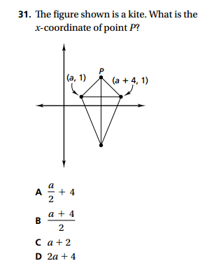
5. Level 3
Prove that quadrilateral A(1,-2), B(13,4),
C(6,8) and D(-2,4) is a trapezoid, but is NOT an isosceles trapezoid.

