**Learning Progression**

**Intro:**

One of the most difficult standards for the students to understand in the Geometry classes at our school, is coordinate proofs. One of our rubrics is "Classify quadrilaterals given the coordinates of its vertices". This rubric is aligned with G-GPE 4 from the CCSS.

Since it is already aligned what I expect to gain by writing the learning progression is having a better understanding of what the students will need to be proficient in this rubric.

**R 11**

Classify Quadrilaterals given the coordinates of its vertices.

**G-GPE 4**

Use coordinates to prove simple geometric theorems algebraically

Previous knowledge:

* Know how to solve equations

* Be able to classify polygons by sides and angles

*Know simple geometric theorems

* Know the properties of polygons, specifically quadrilaterals (given in previous rubrics)

*Be able to plot coordinate points to draw shapes

*Identify slopes of lines in a coordinate graph to be able to identify parallel and/or perpendicular lines

1. To start this rubric we review how to find slopes, midpoints and distances in a coordinate graph since these are standards from algebra.

Example of entry task as a review:

1. Find A and B given that A(1, 2) and B (4, 4) and find the slope.

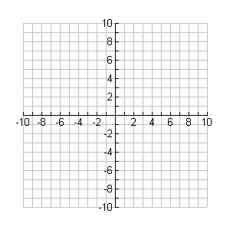

2. ABCD is a parallelogram, identify the properties:



**Steps to identify quadrilaterals in a coordinate graph:**

1. Graph the points.

2. Find distances between points.

3. Check for parallel lines or perpendicular lines using slopes.

4. Determine what type of quadrilateral the shape is by using the properties ( i.e. diagonals).

Example of application:

1. Jeannie went on a bike ride around town which was mapped onto a grid where each unit represented one meter in real life. She started at home, which was located at (400, 1500). She biked to the library at (400, 100). Then she went to her friend’s house at (1600, 100) where she stayed the night. How far did she bike in all?

2. A lifeguard rotates between four stations on the beach. The beach is laid out on a grid where each unit represents a yard and the four station chairs are located at (30, 100), (30, 180), (100, 180) and (100, 100).

a. What quadrilateral is formed by the four lifeguard chairs? How do you know?

b. When the lifeguard does a full rotation of all four chairs and ends up at the chair he started at, how far has he walked?

The students will benefit from hands on activity with something as simple as a geo-board to explore quadrilaterals and other polygons . There are also apps to download for i-pads. If the math department in our school can make a "bank" of questions and activities for this and other rubrics, our students will be more interested in learning them and not be so frustrated.