Learning Progression
Geometry Honors
Ellensburg High School

- This Learning Progression will be used for a high school Geometry class. The textbook that syncs with this learning progression is: Geometry by McDougal Littell. Specifically, Chapter ten will be used for this progression.

- The CCSS Math domain: Circles G-C

Circles HSG-C Cluster:
- Prove that all circles are similar.
- Identify and describe relationships among inscribed angles, radii, and chords. Include the relationship between central, inscribed, and circumscribed angles, inscribed angles on a diameter are right angles, the radius of a circle is perpendicular to the tangent where the radius intersects the circle.
- Construct the inscribed and circumscribed circles of a triangle, and prove properties of angles for a quadrilateral inscribed in a circle.
- Construct a tangent line from a point outside a given circle to the circle.

- Math Activities/Benchmark Assessments:
- Using the Circle Tool (http://illuminations.nctm.org/ActivityDetail.aspx?ID=116) together, as a class, we will investigate similarities between circles. Students will then do homework out of the book which will be used as their benchmark assessment. This activity aligns with the first standard under the G-C cluster because the program is allowing students to see the similarities between circles as the circle changes sizes.
- Together as a class we will go through notes and re-discuss angles, angles on a diameter, tangents to a circle, ect. Students then will work on solving the question:

An audio CD spins at a rate of 200 rotations per minute. If the radius of a CD is 6 cm, how far does a point on the outer edge travel during the playing of a 57-minute CD?

This question allows students to apply this standard to real life practice. Students will then create a problem of their own, similar to the one above, and switch with a partner and solve another question. These questions and answers will be turned in and used as a benchmark assessment.
- For this standard students will be given notes, and then students will work on constructions and a worksheet.
- For this standard students will be given notes and then students will work on homework provided from the book.

4.
HSG-C.1 - prove that all circles are similar. Using an awesome online tool (Figure 1), as a class we will investigate the relationship between circles. The activity allows students to play with different sizes of circles, while providing them with the values of the radius, diameter, circumference, area, ect. By allowing students to interact with this tool, they should start to see similarities within those properties every time they change the size of the circle. Throughout this investigation, I will be asking questions, such as “What is the relationship between the radius and the diameter?” “What about the relationship between the radius and the area?” These questions will prompt students to think about the relationship between circles no matter how small or big of a circle we make. These informal questions will be used as a benchmark assessment. After investigating this, we will then go over some short notes, and then students will be given a worksheet that they will complete. This worksheet will also be a benchmark assessment used. An example of a question is provided to the right (Figure 2). Depending on how well the students do on this worksheet will determine whether or not students understand the standard and are ready to move on. | Provided below is a snapshot of the online tool we will be using. Students can drag the circle, allowing the circle to change sizes.  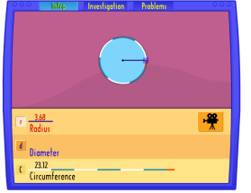  Figure 1  Provided below is a problem from the worksheet that the students will be completing. This worksheet will also be used as a benchmark assessment:  Figure 2:  Use the relationship of $\frac{C}{C'}=\frac{d}{d'}=\frac{r}{r'}$ to solve the following problems. Round decimals to the nearest tenth place.  $$Given \frac{C}{C'}=0.25 and r=3.0cm, find r'$$
HSG-C.2 -identify and describe relationships among inscribed angles, radii, and chords. Include the relationship between central, inscribed, and circumscribed angles, inscribed angles on a diameter are right angles, the radius of a circle is perpendicular to the tangent where the radius intersects the circle. Together as a class we will go over notes and some example problems. Some of the things that will be included in notes will be the definitions of the angles, a diameter, a radius, and a chord. We will then discuss a specific problem that allows students to see how this standard is connected to a real-life situation. This question is listed to the right (Figure 3). After discussing this question, students will create a problem of their own and switch with another person. This allows for students to really show their understanding by having them make up their own problem. This aligns with the standard because it is allowing them to see the relationship between the radius as well as inscribed angles. These will be turned in as a benchmark assessment. Students will also be assigned some problems from the book for homework. An example of a question that they will be completing from the book is listed to the right (Figure 4). This assignment will also be used as a benchmark assessment. | Listed below is the question that we will go over as a class. Students will make a question similar to this (while also having an answer) and switch with someone.  Figure 3:  An audio CD spins at a rate of 200 rotations per minute. If the radius of a CD is 6 cm, how far does a point on the outer edge travel during the playing of a 57-minute CD?  Below are some of the problems that students will be doing on their homework.  Figure 4:  1. What is the measure of a central angle with an arc measure of 45?  2. What is the measure of an inscribed angle with an arc measurement of 150?  3. What is the measure of the angle  formed between a tangent and the diameter of a circle?
HSG.C.3- Construct the inscribed and circumscribed circles of a triangle, and prove properties of angles for a quadrilateral inscribed in a circle. We will be doing notes during the beginning of class. During this we will be going over the definitions of an inscribed angle, intercepted arcs, circumscribed polygons as well as the theorems involving inscribed angles, and inscribed polygons. Student will then describe how they would construct a circle that circumscribes a triangle, and then they will do the actual construction. This will be turned in and used as a benchmark assessment. Students will also answer questions out of the book. Some of the questions have them finding the measure of arcs and angles, as well as finding the value of angles in a triangle that is inscribed in a circle. Students will also answer questions about what type of quadrilaterals can be inscribed in a circle. An example question from the book is provided to the right (Figure 5). This homework set will be used as a benchmark assessment | Below is a figure provided in the book.  Figure 5:  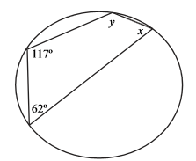  Using this image, students need to find the value of the angles.
HSG.C.4- under the cluster I have chosen if for students to Construct a tangent line from a point outside a given circle to the circle. We will start off by going over notes. Some of the main points that will be discussed includes: Tangents drawn to a circle are perpendicular to the circle's radius at the point of tangency.  Two tangents drawn to a circle from the same point outside the circle are equal, two tangents drawn to a circle from the same point outside the circle make an angle that, when bisected, includes the circles center, tangents to a circle at either end of a diameter are parallel.  As a class I will have students do some of these constructions and measure the segments from the point of tangency to the shared point.  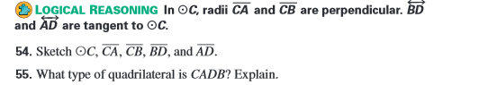  This aligns with the CCSS because students need to know the concepts dealing with tangent lines as well as having students construct.  After notes students will be assigned homework which will be used as a benchmark assessment. Some example questions from the homework are listed to the right (Figure 6, Figure 7, & Figure 8). | One of the problems from the book has students copying a diagram (two circles) and listing how many common tangents the two circles have. Then they need to sketch the tangents.  Figure 6:  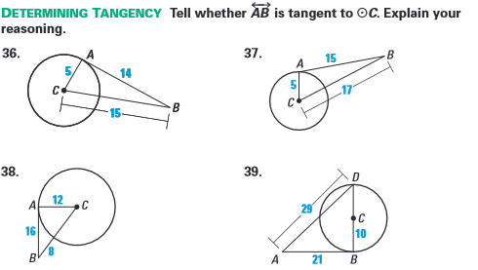  Figure 7  Figure 8  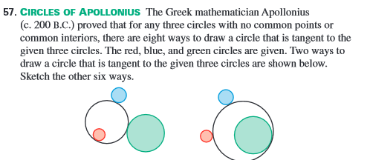

6. a. The formative assessment technique I will use will be a quiz.
b. This formative assessment technique will be used to support student learning of the CCSS because the formative assessment will be made up of problems that align with the Common Core Standards

c. Students will know two days prior that a quiz will be coming up. Students will know that anything they have learned in this past section is fair game. When this announcement is made, I will also tell the students that they can use notes, a compass, and a straight edge for the quiz.
d. Adjustments can be made for students who need special support. For example, more time can be given for students to take the quiz, or for those who need a space where they can concentrate, can take the quiz in the library. However, I do not see any other problems arising.
e. The assessment will be graded on a four point scale. Students can receive a four if all work is shown and the answer is right. Points will be lost for wrong answers, no work shown, conceptual errors, arithmetic errors, ect. I will then discover what the class average was on the test. From there I will decide if we need to go back and review some of the concepts or if we are safe to continue. Students are allowed to make up their quizzes for potential of full credit.

