Reasoning with Equations  Represent and Solve Equations and Inequalities Graphically  Introduction:  This learning progression is designed for a high school precalculus class (10th or 11th grade). The textbook used in the class is Precalculus with Limits: A Graphing Approach, 3rd edition, by Larson, Hostetler, and Edwards. The CCSS Math cluster focused on in this learning progression is “Represent and solve equations and inequalities graphically”^{A-REI.D} under the algebra domain.  The mathematical concepts in this learning progression are inexorably linked to solving systems of equations and inequalities algebraically, thus the progression of how to represent systems graphically would not be presented on its own. It would be integrated along with a progression that teaches the algebraic steps required to solve systems of equations and inequalities. Because most of the applications that utilize systems of equations and inequalities are usually done algebraically, students do not always understand the graphical interpretations of the solution set which can deepen their understanding of the concepts. This learning progression will help students understand how graphically visualizing systems of equations and inequalities can provide a deeper understanding of what the solution(s) to a system mean.  At the beginning of the progression, students have the mathematical skills to manipulate and solve a function of one or two variables. As they learn the skills to algebraically solve systems of linear equations, and then nonlinear systems, including inequalities, they will learn how to both interpret and create a graph of the system and how to deduce solutions from the graphs. |  | Domain: Algebra  Cluster: Reasoning with Equation and Inequalities: Represent and solve equations and inequalities graphically.  Standards:  CCSS.Math.Content.HSA-REI.D.10:  Understand that the graph of an equation in two variables is the set of all its solutions plotted in the coordinate plane, often forming a curve (which could be a line).  CCSS.Math.Content.HSA-REI.D.11:  Explain why the x-coordinates of the points where the graphs of the equations y = f(x) and y = g(x) intersect are the solutions of the equation f(x) = g(x); find the solutions approximately, e.g., using technology to graph the functions, make tables of values, or find successive approximations. Include cases where f(x) and/or g(x) are linear, polynomial, rational, absolute value, exponential, and logarithmic functions.  CCSS.Math.Content.HSA-REI.D.12:  Graph the solutions to a linear inequality in two variables as a half-plane (excluding the boundary in the case of a strict inequality), and graph the solution set to a system of linear inequalities in two variables as the intersection of the corresponding half-planes.

A-REI.D.10  Many students categorize themselves as visual learners, so a graphical approach to a mathematical concept, especially when it can be directly connected to a relatively difficult algebraic concept, gives students an opportunity to solidify their understanding of the concept.  Previously, students have learned how to graph linear and nonlinear equations on a coordinate plane, and they are already aware that the graphed line (or curve) of the equation represents all of the possible solutions to that equation. But in this learning progression, students will be dealing with multiple equations on a single set of axes. The graph of an equation in two variables (usually $x$, $y$) is the foundation upon which students can build up skills of solving systems of multiple equations.  An important concept that students should understand prior to moving forward is that equations that use other variable than $x$, $y$ can still be graphed. Students should be given the opportunity to graph equations with many different variables, and label the respective axes accordingly.  Still, before students can begin solving systems of equations, they should learn that they can graph multiple equations on a single plane. To illustrate this skill, the students could first be given a set of familiar linear equations in the form of $y=mx+b$ or even quadratics of the form $y=ax^{2}+bx+c$ graph them all on the same coordinate plane. To make the practice more engaging, and since students have already covered graphing shifts in linear and nonlinear equations,^{A-CED.A.2} students may be asked to spell out their names or a given set of words using the graphs of equations. Before this Words with Graphs* activity, the teacher should first model this activity for the class, but prompt students to think critically about how a line might need to be horizontally or vertically shifted to acquire the desired result. Also, the teacher should use the term “system of equations” introduce and encourage students to use brackets to indicate what equations are on a given set of axes. This will familiarize them with some of the notation of systems of equations.  Once students have had practice graphing multiple equations that are already solved for $y$ on a coordinate plane, the next step is for them to be tasked with solving the equations first, then graphing. This will give students their first glance at a system of equations, and they will be graphing their solutions, though they may not be aware of it. This can be integrated into the Words with Graphs* activity as well.  By having students graph multiple equations on in a single coordinate plane, they will further understand that the graph of an equation in two variables is the set of all its solutions plotted in the coordinate plane, often forming a curve (which could be a line).^{A-REI.D.10} |  | *Words with Graphing:  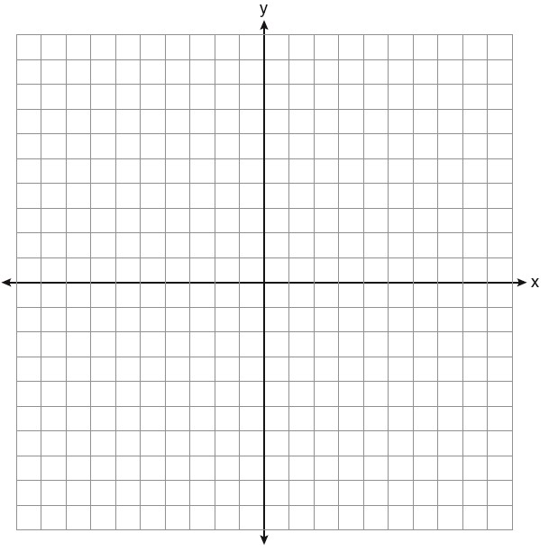  Graph the word “MATH” on a single coordinate plane. Write the system of equations you used to spell the word. Highlight the parts of the graph that spell the word to make it clear.  $$\left\{\begin{aligned}y=22x-209 \\ y=-8x-66 \\ y+7=22\left(x+4\right) \\ y=-5.75\left(x+2.5\right)+6 \\ x=2 \\ y=6.5 \\ y=-1.5\end{aligned}\right.$$
Standard Addressed
CCSS.Math.Content.HSA-REI.D.10
Benchmark Assessment
By completing the Words with Graphing* assignment, students will be able to demonstrate their ability to meet standard A-REI.D.10. This activity can be done as a group assignment or a mini-project to be formally assessed. Successful completion will justify moving on to the next math concept.

A-REI.D.11  Once students become familiar with graphing multiple equations on a single coordinate plane, they will be formally presented with the procedures to algebraically solve a system of linear equations.  Initially, students will learn substitution and elimination methods to solve systems of two linear equations. This will solidify the concept that the points where the graphs of $y=f(x)$ and $y=g(x)$ intersect are the solutions of the equation (system) $f\left(x\right)=g\left(x\right)$. ^{A-REI.D.11} Then, once systems of more than two linear and nonlinear equations are introduced, students will be able to relate the same basic concept with the more complex systems. It is important that students recognize that the intersecting points on a graph represent the same solutions that they will solve for algebraically. This helps illustrate the consistency in mathematics where more than one approach is acceptable when solving a problem, but regardless, the same solution will be produced.  One activity that can illustrate this standard involves using a city map*. Given a map of some city (preferably the one in which students reside), the students can assume the role of a police detective trying to catch bank robbers. With some given information, students use critical thinking and problem solving techniques to decide where a bank robber might meet up with a getaway car. Then, students can superimpose a set of axes and find the Cartesian coordinate that translates to the intersection. This activity works well because it is a real life situation that can easily model the math concept; roads are relatively straight, and thus can act like lines on a graph. To extend the activity, students can then find the equations of the lines being used, or a more complex city map can be used. Also, more variables can be added – two robbers and a getaway car, for a system with three equations.  To connect this activity directly to the math concept being taught, it should be stressed that, as in the activity, where the two lines (roads) intersect (the intersection on the map), there is a solution to the system of equations. ^{A-REI.D.11} No only does this activity present an easy connection to the main concept of graphical solutions of a system of equations, it also requires students to think outside of strictly mathematical procedures and incorporate real-life problem solving skills of working with ambiguous, nonmathematical information.  Lastly, the teacher should model and provide students with practice for inputting and interpreting systems of equations with technology such as a graphing calculator and with tables. This is best suited as an in-class activity so that students can verify their findings with others. Include a variety of functions (linear, quadratic, exponential, etc.). This will give students the skills they need to quickly visualize and approximate a solution, as well as a way to check their work. |  | *City Map Activity  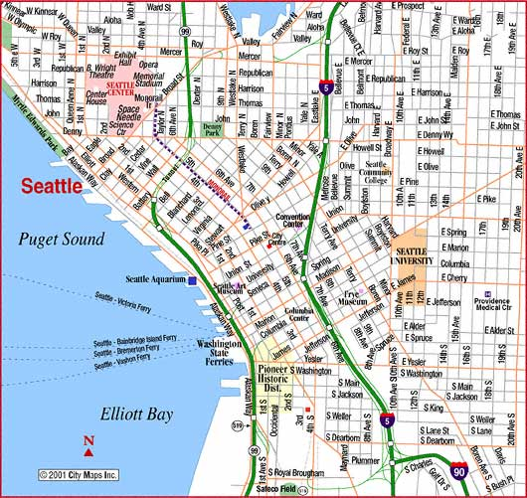  Example problem:  - Seattle Police Department are following up on a lead about a possible bank robbery plot. Based on their informants, the target bank is on the corner of E. Yesler and E. Alder. The perpetrator will be leaving on foot, and the suspected getaway car will leaving the Seattle Aquarium up Pike St. to meet the robber at the meet up point. Where should the SPD send officers to intercept the duo?  - Drawing a set of $x$, $y$ axes with the origin at the Seattle Community College, what are the coordinates of the meet up point?  - What are the equations of the lines that represent the robber’s and getaway car’s path?
Standard
CCSS.Math.Content.HSA-REI.D.11
Benchmark Assessment
To demonstrate their understanding of the intersection of lines on as a solution to a system of equations, students should accomplish a homework problem set from Precalculus with Limits that involves graphing a system of equations, interpreting the intersection points, and checking solutions. (example problems: chapter 7.2, pp. 506, #33-40)

A-REI.D.12:  The last concept in this learning progression is the graphing of linear inequalities in two variables as a half-plane, and representing the solution set of a system of linear inequalities as the intersection of the corresponding half planes.^{A-REI.D.12} Similarly, but separate from this learning progression, students will also be learning how to algebraically solve and represent the solution set of a system of inequalities. So, as with the other standards represented in this learning progression, the graphical approach will help students to learn visualization skills of algebraic solutions.  Usually the most challenging concept for students to grasp is the first skill of graphing solutions to a single inequality. The teacher can be straightforward in their instruction about how students can know whether or not to use a dotted or solid line. But the connection should be made that a dotted line (corresponding to $>$ or $<$) does not include points on that line, and that the solid line ($≥$or $≤$) does. Students often struggle with which side of the line to shade to represent the solution. To teach this skill, the best-practice procedure is to have students pick a convenient point such as (0,0) or (1,1) when applicable, to plug into the inequality. If the point results in the inequality remaining true, then it is in the solution and that side of the line should be shaded; if not, then the other side of the line is the solution set and can be shaded. This should be modeled by the teacher first through direct instruction, then students can have independent practice through homework or other assignments.  Once students understand how to graph the solution sets of inequalities, it is not a big step for them to understand that the overlapping half-planes will represent a solution set to the system of inequalities. To translate this skill into an activity, students can use colored pencils (or crayons) to shade in the solution sets of each of the inequalities in a solution. In this coloring activity*, students should preferably use primary colors (red, blue, yellow) so that the overlapping solution sets will be a unique color (green or purple, for example). The teacher should initiate which colors should be used for each inequality, ensuring students should have the same results, thus making it easier for them to verify their work. While this does not require any more work than the traditional method of graphing systems of inequalities, it provides students with a stronger visual representation. Instead of the solution set being just a darker shade of pencil-lead grey, it can be a vibrant color.  To go into more depth than the standard,^{A-REI.D.12} the teacher can use more than just two systems of inequalities, or include some nonlinear examples. In this case, it should be noted to the students that the same procedures of choosing a value and plugging it in work for nonlinear inequalities as well. |  | *Coloring Activity  - Use a different color to shade the solutions to the inequalities in this system  - What is one solution to the first two inequalities, but not the whole system?  - What is a solution to the second two systems of inequalities?  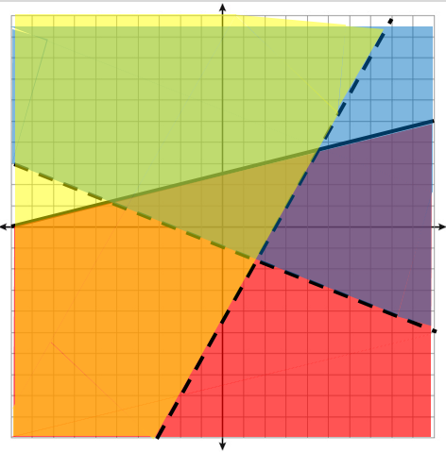  - What is the solution set to the system of inequalities?  $$\left\{\begin{aligned}y≤4x+3.5 \\ y-\frac{5}{3}x>4.5 \\ y>-\frac{1}{4}x-1\end{aligned}\right.$$
Standards
CCSS.Math.Content.HSA-REI.D.12

Benchmark Assessment
The benchmark assessment for this part of the learning progression can be informal and formative. During the coloring activity*, the teacher can ask students what color represents the solution set to the system of inequalities. If students are able to show or answer the same color, then it can be presumed that the students can meet the requirements of the standard. This would ideally be done as a class or small group activity using worksheets or provided problems.

