High School Statistics and Probability

Conditional probability and the rules of probability
CCSS.Math.Content.HSS-CP.B.6 Find the conditional probability of A given B as the fraction of B’s outcomes that also belong to A, and interpret the answer in terms of the model.
CCSS.Math.Content.HSS-CP.B.7 Apply the Addition Rule, P(A or B) = P(A) + P(B) – P(A and B), and interpret the answer in terms of the model.
CCSS.Math.Content.HSS-CP.B.8 (+) Apply the general Multiplication Rule in a uniform probability model, P(A and B) = P(A)P(B|A) = P(B)P(A|B), and interpret the answer in terms of the model.
CCSS.Math.Content.HSS-CP.B.9 (+) Use permutations and combinations to compute probabilities of compound events and solve problems.

The following segment of the learning progression for high school statistics and probability utilizes Precalculus Ninth Edition (Michael Sullivan, Prentice Hall, Boston, MA 2012) as the textbook for instruction. For this class of 16 junior and senior high school students, the lessons and homework problems herein provide a tool for the teacher to help their students’ reach the four Common Core State Standards contained in this math cluster.
Use the rules of probability to compute probabilities of compound events in a uniform probability model. The four CCSS in this math cluster will be the focus of lessons taught over the necessary interval of time needed to complete all activities associated with the standards. A comprehensive test covering all material will serve as a tool to summatively assess student understanding of the standards. The following is an outline of activities for the cluster:
An introduction to the topic by the teacher, an activity for the class to participate in together, followed by a homework assignment from the text book will be the general outline for each learning segment for each of the four standards.
Conditional Probability
S-CP.B.6 Of all snowfall in Buffalo New York, 5% are heavy. After a heavy snowfall, schools are closed 67% of the time. After a light snowfall, schools are only closed 3% of the time.

1.) Find P(school is open given light snowfall)
2.) Find P(school is closed given heavy snowfall)
3.) Find P(school is open)
4.) Find P(light snowfall given school is open).

Have students work together in small groups to answer the questions about the probability model to the right provided by the teacher. After an allotted amount of time, each group will pick a speaker to present their answer to the class and explain how they reached their conclusion. This type of example is one way to review information on conditional probability. For example, defining events:
Using a tree diagram to help visualize what is going on would be a helpful tip to give students when they are thinking of ways to start answering the questions. Having students make a tree diagram similar to the following would be a good suggestion for the teacher to make.

0.97
School is closed
School is open
School is open
School is closed
Light Snow
0.03
0.95
0.33
0.05
Heavy Snow
0.67

Question 1 asks the students to find P(school is open | light snowfall). Students are to use the formula for finding conditional property which states
S-CP.B.6 Find the conditional probability of A given B as the fraction of B’s outcomes that also belong to A, and interpret the answer in terms of the model.

$$P\left(B | A\right)= \frac{P(B∩A)}{P(A)}$$
Using the context of the probability model, students should use the formula as shown below
$$\frac{P(light ∩ open)}{P(light)}=\frac{(0.95)(0.97)}{(0.95)}=0.97 or 97\%$$
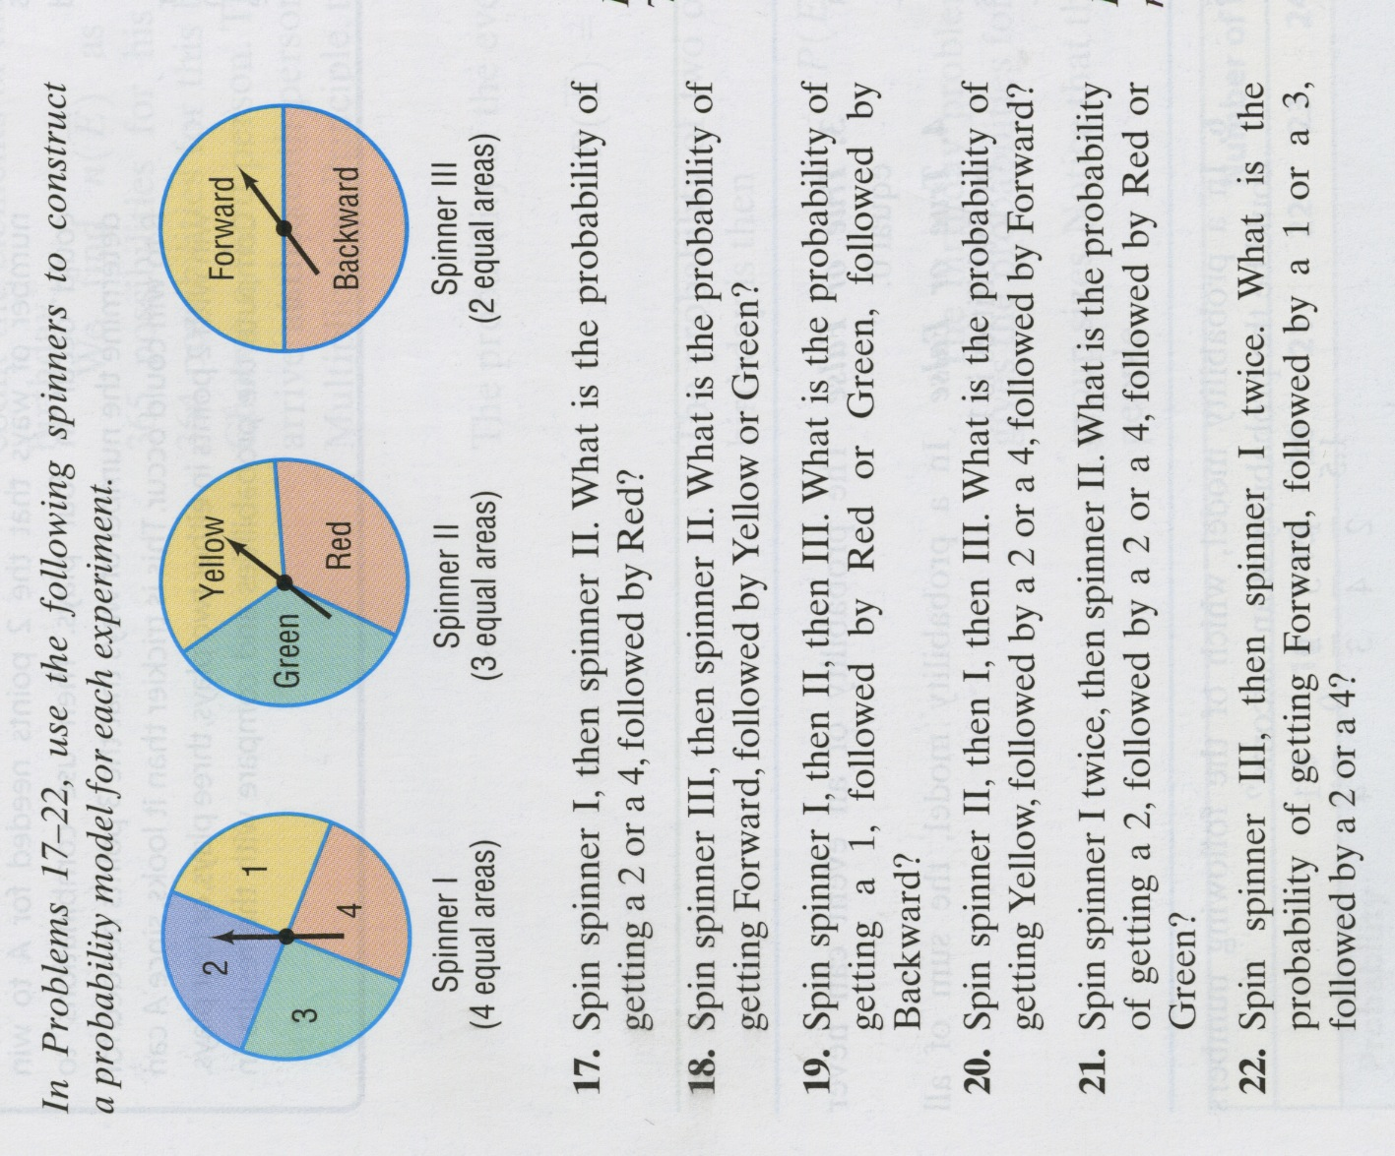
After each group has presented their way of answering the questions, it is crucial for the teacher to demonstrate the proper way and to connect the conditional property formula to conceptual understanding. For instance, the teacher should describe that the formula takes the probability of both events happening and divides by the probability of the given event. Also emphasize the importance of writing the final answer in terms of the questions asked. In this activity, the final answer to question 1 should read similar to: The probability that school will be open given light snowfall the night before is 0.97 or 97%.
As a benchmark assessment, assign the following homework problems from the textbook:
Homework Page 858 #’s 17-22.

Addition Rule
The teacher should first do an example problem on the board similar to the story problem to the right. Once finished, proceed with the lesson similarly to the one for the conditional property. Again, have students work together in small groups to answer the question to the right. However, this time have groups of 4 students and have each group solve the question using 4 steps (they should know the steps from following the example given by the teacher). Once finished, each group will pick one person to present the group’s work. One group should have the task of presenting the first step they took to solve the problem, another should present the second step, and so on. After each group has presented, the class should know all of the steps necessary to solving a story problem using the addition rule of probability.
The question asks for n(students registered in college algebra or computer science). Students are to use the addition rule to find the answer, which states
S-CP.B.7 Apply the Addition Rule, P(A or B) = P(A) + P(B) – P(A and B), and interpret the answer in terms of the model.

S-CP.B.7 In a survey of 100 college students, 35 were registered in College Algebra, 52 were registered in Computer Science I, and 18 were registered in both courses. How many students were registered in College Algebra or Computer Science I?

$$n\left(A∪B\right)=n\left(A\right)+n\left(B\right)-n(A∩B)$$
(Step 1) Using the context of the question, students should identify the variables as follows

A B
17 18 34

Let A= set of students in College Algebra
Let B= set of students in Computer Science I

(Step 2) Then the given information tells them that
n(A) = 35 n(B) = 52 n(A$∩$B) = 18

(Step 3) Students should use the addition rule formula as follows

$$n\left(A ∪B\right)=35+52-18=69$$

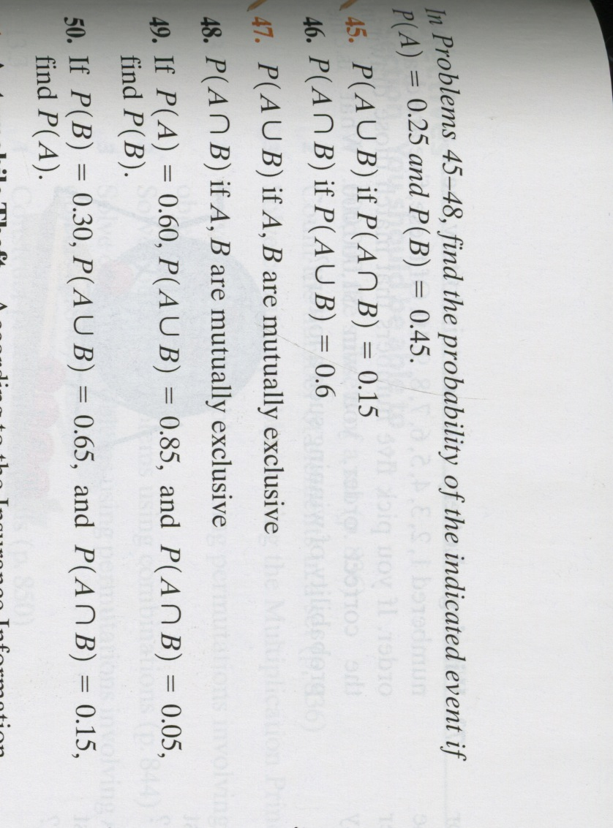
(Step 4) After using the addition rule, students should conclude that 69 students were registered in College
Algebra or Computer Science I. It is encouraged for
the teacher to use a Venn diagram to demonstrate the
concepts being used when solving problems using the
addition rule. A Venn diagram gives a visual
representation of the intersection of the two events
being taken away to avoid a “double count” of
information. As a benchmark assessment, assign the
following homework problems from the textbook:
Homework Page 859 #45-48

Multiplication Rule
To introduce the multiplication rule, the teacher should perform an example problem on the board similar to the question to the right. The teacher should focus the discussion on identifying the variables and given information in overly “wordy” problems like the example. Then, have students work together in small groups to answer the question to the right. Try to let students problem solve on their own and only assist if they are having a hard time understanding the language used in the problem and what it is asking for. After an allotted amount of time, each group will pick a speaker to present their answer to the class and explain how they reached their conclusion.
S-CP.B.8 Seventy percent of students getting an A, B, or C in an introductory statistics course study at least 6 hours a week. Forty-five percent of student in introductory statistics courses who study at least 6 hours a week belong to a study group. Find the probability that an introductory statistics student who gets an A, B, or C studies at least six hours a week and belongs to a study group.

This type of example is one way to introduce the multiplication rule of probability using a question heavy in vocabulary. Based on student performance during the last two activities, using this type of question may be too difficult for an introductory problem.
The question asks for P(student studies 6 hours a week and belongs to a study group). Students are to use the multiplication to find the answer, which states
$$P\left(A∩B\right)=P\left(A\right)*P\left(B | A\right)=P\left(B\right)*P(A|B)$$
Using the context of the question, students should identify the variables as follows
S-CP.B.8 (+) Apply the general Multiplication Rule in a uniform probability model, P(A and B) = P(A)P(B|A) = P(B)P(A|B), and interpret the answer in terms of the model.

Let A = students who study at least 6 hours/week
Then P(A) = 0.7 or 70%
Let B = students who belong to a study group
Then P(B|A) = 0.45 or 45%
Note: P(B|A) is given

Then, students are to use the multiplication rule to find the answer as follows
In a statistics class there are 18 juniors and 10 seniors; 6 of the seniors are females and 12 of the juniors are males. If a student is selected at random, find the probability of selecting the following:
a) P(a junior or a female)
b) P(a senior or a female)
c) P(a junior or a senior)
$$P\left(A∩B\right)=0.7*0.45=0.315 or 31.5\%$$
After using the multiplication rule, students should conclude that the probability that an introductory statistics student who gets an A, B, or C studies at least six hours a week and belongs to a study group is 31.5%. Although it is given in the question, a note should be given that P(B|A) is the same thing as the conditional property which is what the students learned during the first lesson of this progression.
As a benchmark assessment, assign the following homework:
Multiplication Worksheet (problems similar to the one at right)
Combinations and Permutations
S-CP.B.9 Suppose that we wish to establish a three-letter code using any of the 26 uppercase letters of the alphabet, but we require that no letter be used more than once. How many different three-letter codes are there? Suppose that repetition of letters is allowed. How many different three-letter codes are there now?

Have students work together in small groups to answer the two part question to the right. After an allotted amount of time, each group will pick a speaker to present their answer to the class and explain how they reached their conclusion. This type of example is just one way to introduce combinations and permutations. There are several story problems with different contexts provided in the textbook. Based on student performance in the past few activities, it may be beneficial to choose an alternate question to use as an introduction to combinations and permutations.
For questions similar to the first one provided to the right, the following notation should be used
$$P\left(n,r\right)= \frac{n!}{\left(n-r\right)!}$$
This notation represents the number of ordered arrangements of r objects chosen from n distinct objects, where $r≤n$ and repetition is not allowed. The question posed asks for the number of ways that the 26 letters of the alphabet can be arranged in order using three nonrepeated letters. Students work should look similar to the following:
S-CP.B.9 (+) Use permutations and combinations to compute probabilities of compound events and solve problems.

$$P\left(26,3\right)=\frac{26!}{\left(26-3\right)!}=15,600$$
For questions similar to the second example question, the following notation should be used
$C\left(n,r\right)=\frac{n!}{\left(n-r\right)!r!}$
Find the number of possibilities (you must show the set up).
1. The ski club with ten members is to choose three officers captain, co-captain & secretary, how many ways can those offices be filled?
2. Microsoft has ten members on its board of directors. In how many different ways can they elect a president, vice-president, secretary and treasurer?
3. For a segment of a radio show, a disc jockey (Dr. Jams) can play 4 songs. If there are 8 to select from, in how many ways can the program for this segment be arranged?

This notation represents the number of ordered arrangements of r objects chosen from n distinct objects, where $r≤n$ and repetition is allowed. The question posed asks for the number of ways the 26 letters of the alphabet can be arranged using three letters. Students work should look similar to the following:
$$C\left(n,r\right)=\frac{26!}{\left(26-3\right)!3!}=2,600$$
Students final answers to both questions should be answered in complete sentences.
As a benchmark assessment, assign the following homework:
Combinations and Permutations worksheet (first 3 problems shown to the right)

