Statistics and Probability According to the
Common Core Standards:
"Prentice Hall Mathematics: Course 2". By: Charles, Branch-Boyd, Illingworth, Mills, Reeves (2004)
Grade level 7
D. Cardenas
March 4, 2014

Content
Preface………………………………………………………………2
Grade 7: Statistics and Probability.C7………..…………………….4
Grade 7: Statistics and Probability: C.7……….………………….....4
Grade 7: Statistics and Probability: C.7……………………………..4
Grade 7: Statistics and Probability: C.7a…………………………....5
Grade 7: Statistics and Probability: C.7a…….………………………5

Preface
This learning progression is a focused on statistics and probability in a 7th grade middle school mathematics classroom. There are many ways probabilities can be taught, this progression will use models and data collection. There are three levels of functions that are taught at the high school level: Compare probabilities from a model to observed frequencies, Develop a uniform probability model by assigned equal probability to all outcomes and use the model to determine probability events, and Develop a probability model by observing frequencies in data generated from a chance process. Probabilities describe the extent to which something is probable; the likelihood of something happening or being the case. In the progression of Interpreting Statistics and Probability students learn how to understand and develop probability events, how to observe and interpret collected data, and formulating questions, designing studies, and collecting data about a population through random sampling allow us to make inferences and compare data.
In high school mathematics the study of statistics and probabilities focus primarily Finding a valid, representative sample will enable valid inferences to be made about a population.. In modeling situations, knowledge of the context and statistics are sometimes used together to find algebraic expressions that best fit an observed relationship between observations.
This learning progression will be focused on the Investigating chance processes and developing, using, and evaluating probability models cluster of grade seven statistics and probability. In this progression students learn how to investigate chance processes and develop, use, and evaluate probability models. In order to successfully teach this concept there are three standards that need to be taught:
- 7.SP.C.7: Develop a probability model and use it to find probabilities of events. Compare probabilities from a model to observed frequencies; if the agreement is not good, explain possible sources of the discrepancy.
- 7.SP.C.7a: Develop a uniform probability model by assigning equal probability to all outcomes, and use the model to determine probabilities of events. For example, if a student is selected at random from a class, find the probability that Jane will be selected and the probability that a girl will be selected.
- 7.SP.C.7b: Develop a probability model (which may not be uniform) by observing frequencies in data generated from a chance process. For example, find the approximate probability that a spinning penny will land heads up or that a tossed paper cup will land open-end down. Do the outcomes for the spinning penny appear to be equally likely based on the observed frequencies?

Statistics and Probability is a difficult concept for students to understand. Being able to find an activity that incorporates a relatable subject will make the concept less scary for students. Thus, allowing students to give the concept a chance rather than quickly block it out.

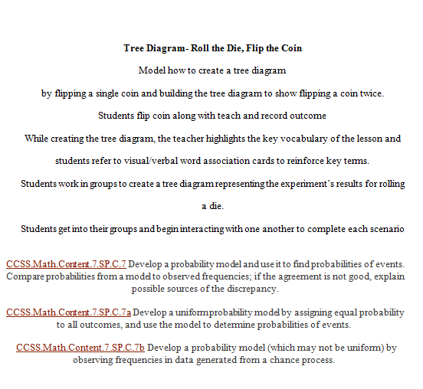
7.SP.C. 7, 7.SP.C. 7a, 7. SP. C. 7b.

One of the best uses for probability is to help us understand whether or not events are truly random. This way, we can ensure that there is no bias on the part of any individuals involved, no bias on the part of the device being used, and therefore a "clean" and "fair" decision is being made.
Students should know that we use dice, coins, random number generators, lots, and many other things in order to ensure fairness. Still, there will always be deviation (and those people who claim they can roll double sixes with two fair dice ten times in a row).
Students should understand the factors that make decisions fair and random and be able to identify when such decision-making methods are biased or skewed. Students should also know that fairness and randomness are not necessarily synonymous, depending on specific situations. In the classroom these questions can be demonstrated, simulated, and answered with many different examples. Such as coming up with an example or a decision that needs to be made, then proposing ways by which it can be made.

The activity on the right would be an introductory lesson of understanding probability outcomes and how to express them in ratios. By drawing a tree diagram it gets the students out of their chairs and has them writing down their observations. The tree diagram will serve as a visual to allow students who do not understand the calculations to visually see what is happening in the data collection.
The students will be divided into groups to conduct their data. They will flip a coin 20 times and write down their observation on the tree diagram. They will then roll a die 20 times and write down their observation on the tree diagram. Working together allows me to pair up the students according to their levels of understanding. There are several different ways students can learn, and allowing them the opportunity to learn from each other and see how their classmates are understanding the material allows them the opportunity to see the concept in a different level.
When the class discussion begins, students will be able to construct viable arguments and critique the reasoning of others while at the same time allowing me to summatively assess them. The grouping and re-grouping of students for different tasks

provides options for physical activity. Sources of information are in an authentic, student-centered context. The task allows for active participation, exploration and experimentation, and also invites personal response, evaluation and reflection.
The students will be assessed with a benchmark assessment that incorporates being able to interpret a function in three different ways. Moving the students away from their groups and assessing if they are able to successful represent functions individually is best done through a benchmark assessment. They will be asked the following questions: What would happen to our diagram if we roll the die twice? What is the probability of ________? Show me ____on the tree diagram, it gets the students thinking and interacting and sharing their conclusions with one another. This opens the floor for discussions and allows me to assess the students understanding of the randomness or bias, and fairness or unfairness. Being able to interpret probabilities and understand the statistics behind it is essential for passing high school mathematics, thus students will need to be able to analyze the meaning of it.

