Learning Progression:
AGS Publishing: Algebra 2 by Siegfried Haenisch;
10th grade
February 25, 2014

Introduction
The following learning progression is based on meeting the cluster on High School: Functions under ‘Understand the Concept of a Function and use Function Notation’ standard under the Interpreting Functions math domain. This cluster has been taken from the Common Core State Standards for Mathematics. The full standard cluster is shown on the right. The book where some of the activities or homework problems were taken from is called AGS Publishing: Algebra 2 by Siegfried Haenisch. The activities are focused on assuming this is a 10th grade class; however, this may vary.
CCSS.Math.Content.HSF-IF.A.1: Understand that a function from one set (called the domain) to another set (called the range) assigns to each element of the domain exactly one element of the range. If f is a function and x is an element of its domain, then f(x) denotes the output of f corresponding to the input x. The graph of f is the graph of the equation y=f(x).

CCSS.Math.Content.HSF-IF.A.2: Use function notation, evaluate functions for inputs in their domains, and interpret statements that use function notation in terms of a context.

CCSS.Math.Content.HSF-IF.3: Recognize that sequences are functions, sometimes defined recursively, whose domain is a subject of the integers. For example, the Fibonacci sequence is defined recursively by f(0)=f(1)=1, f(n+1)=f(n)+f(n-1) for n≥1.

CCSS.Math.Content.HSF-IF.A.1
The math standard that I will be discussing is ‘understand that a function from one set (called domain) to another set (called the range) assigns to each element of the domain exactly one element of the range’.
The following are ideas and activities that students could use for successful achievement of the standard.
For this lesson it is important for students to understand the following vocabulary:
- Function
- Domain
- Range
- Input
- Output
CCSS.Math.Content.HSF-IF.A.1: Understand that a function from one set (called the domain) to another set (called the range) assigns to each element of the domain exactly one element of the range. If f is a function and x is an element of its domain, then f(x) denotes the output of f corresponding to the input x. The graph of f is the graph of the equation y=f(x).

Using this terminology, we need to ensure that students understand what a function is such that for every set (domain) there is another set (range) that assigns to each element of the domain exactly one element of the range. For example, students should be able to identify if the following represents a function,

Domain | Range
5 | -13
9 | -13
9 | 2
CCSS.Math.Content.HSF-IF.A.1: Understand that a function from one set (called the domain) to another set (called the range) assigns to each element of the domain exactly one element of the range. If f is a function and x is an element of its domain, then f(x) denotes the output of f corresponding to the input x. The graph of f is the graph of the equation y=f(x).

To ensure that students become fluent in this material, beginning with a short lesson is necessary. One way to help students understand this process better is by thinking of it as a set of ordered pairs where no two have the same first elements.
In order to introduce functions to students, a modeling activity could be used. The activity is called ‘Number patterns from cutting string’. The activity is shown on the right. It consists of having students fold a piece of string in half and making one cut. Students then have to record on a table the number of pieces they end up with for every cut they make. They follow the same process with 2, 3, 4, and 5 cuts. The idea is to have students describe the patterns they observe and predict the number of pieces with 6, 7, and 8 cuts. Thus, the teacher should then introduce the concept of function using the informal language used by students and putting it in terms such as$P=2c+1$, where P is the number of pieces and c the number of cuts. Once the symbolic function has been identified, the teacher could ask students for the number of pieces given 50 cuts or vice versa. Students can work individually when filling in the chart and then in groups to compare their answers. The teacher can then have a whole class discussion where students write their thought on a chart on the board to explain their reasoning. This is a great activity for all students, especially for English Language Learners (ELL) since they get to experience and see how mathematics is embedded in problems that involve real world models. Students can use their own language or informal language to come up with the symbolic notation. Also, it will be easier for students to learn the new vocabulary as the teacher introduces it within the context of the lesson.
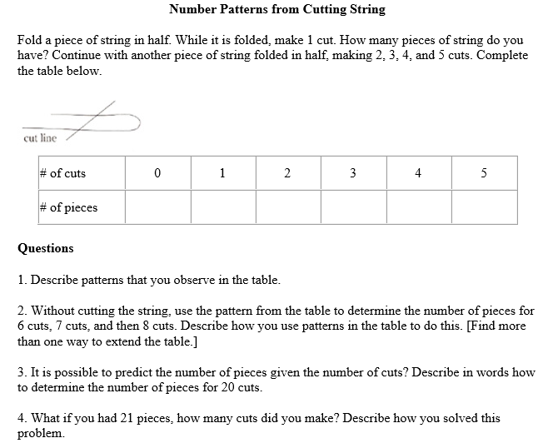

Cramer, K., (2001) Using Models to Build Middle-Grade Students' Understanding of Functions. Mathematics Teaching in the Middle School. 6 (5), .

Another great activity for students, for procedural understanding, is to have them apply their knowledge, which will also help them gain practice, by going on to the IXL website for some practice problems. This is an interactive website that teachers can use as formative assessment.
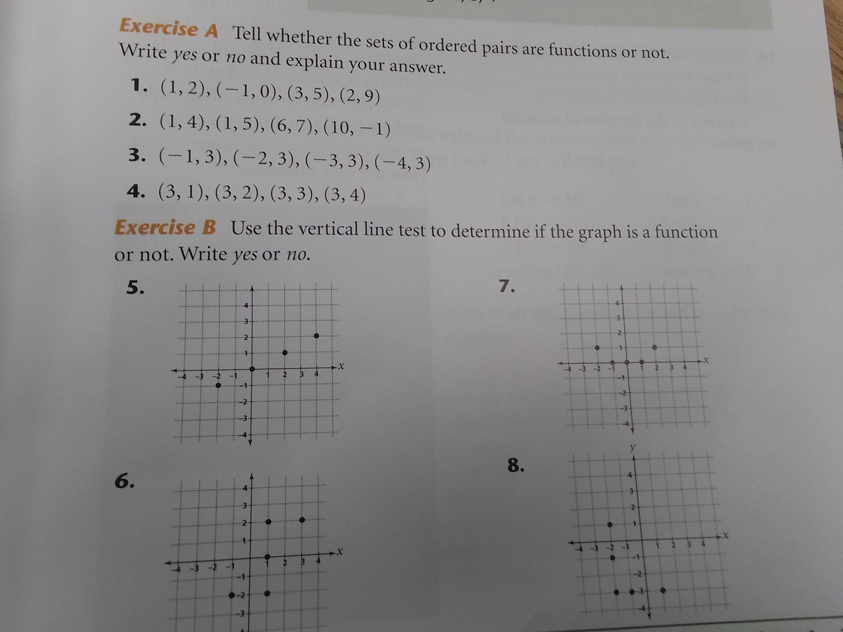
http://www.ixl.com/math/algebra-1 Students will practice under ‘functions’ D.1 and D.2. Students will go on, type in the answer, and their score and time elapsed will be recorded on the right-hand side. A sample question could ask students to look at a set of ordered pairs and determine the domain and range of a function or determine if it is a function in the first place. Teachers can walk around and peek over at each student’s computer screen and see how they are doing. For practice problems at home, I would give students numbers 1-12 on page 37 in the book to apply some more of their knowledge.

CCSS.Math.Content.HSF-IF.A.2
The following are ideas and activities for the next standard in the cluster (shown on the right):
CCSS.Math.Content.HSF-IF.A.2: Use function notation, evaluate functions for inputs in their domains, and interpret statements that use function notation in terms of a context.

For this lesson, it is important that students understand the following vocabulary
- Function notation
- Evaluate
Students need to have previous understanding of and know what domain and range means. Using this terminology, we need to ensure that students are able to use function notation, evaluate functions for inputs in their domains, and interpret statements that use function notation in terms of a context.
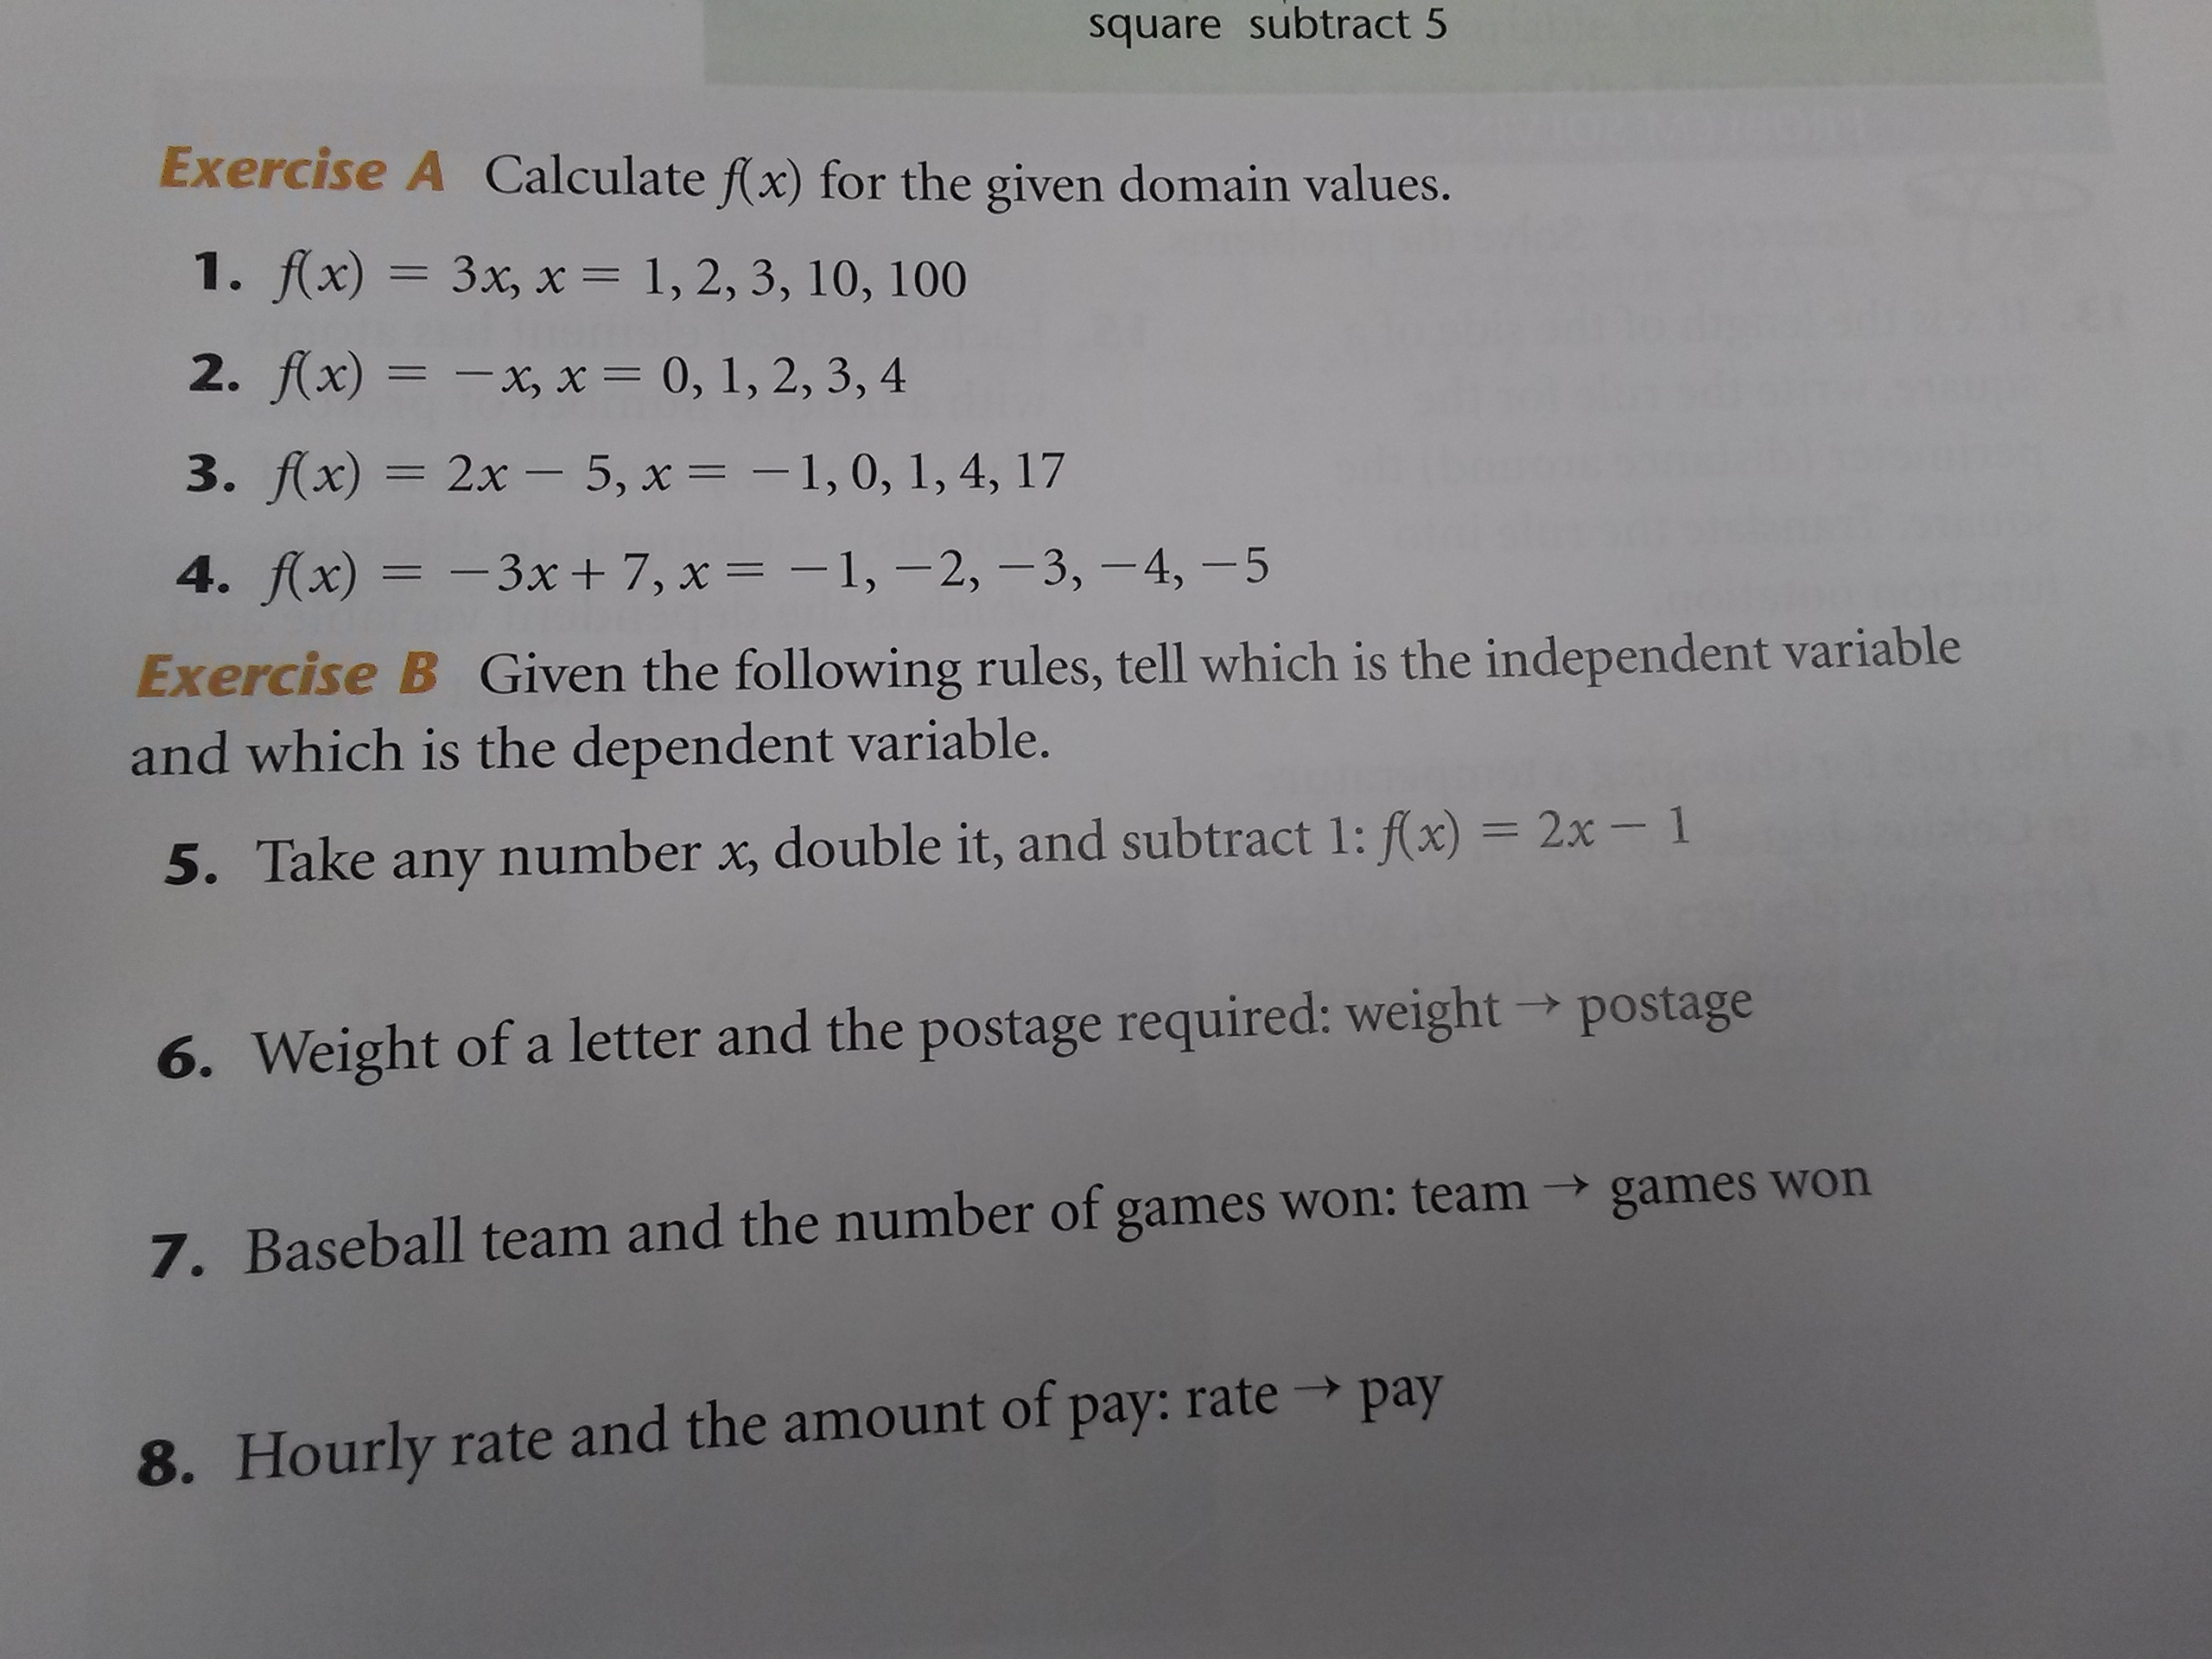
First, there needs to be a lesson on evaluating functions using function notation. This standard aligns to section 2.2 in the book on page 39. Students will need to evaluate problems such as: given
$$f\left(x\right)=3x$$
evaluate for $x=1, 2, 10$. Students should be reminded of domain and range. This will allow for students to remember previous material and make connections to the new material being introduced. The teacher could have students work individually on Exercise A (shown on the right) on their paper. Then, distribute individual whiteboards, ask them to write their answers on it, and put it up for everyone to see. The teacher can then proceed by asking students to share the process used and compare their answers to that of a shoulder buddy. This provides formative assessment for the teacher and proper accommodation for students with special needs or English language learners (ELL) since they are also listening to the vocabulary being used with their partner. Thus, students share their reasoning and procedural fluency.
For more formative assessment and practice for students, the teacher can give students practice problems in Exercise B and C in the book. The teacher can walk around and assess how students are doing. The rest of the problems that students do not finish can be given as homework problems for practice outside of school.
CCSS.Math.Content.HSF-IF.3: Recognize that sequences are functions, sometimes defined recursively, whose domain is a subject of the integers. For example, the Fibonacci sequence is defined recursively by f(0)=f(1)=1, f(n+1)=f(n)+f(n-1) for n≥1.

CCSS.Math.Content.HSF-IF.A.3
This is the last standard under the cluster.
For this lesson, it is important that students know and understand the following vocabulary:
- Functions
- Sequences
Students need to have previous understanding of what functions are and how to evaluate them. They will need to recognize that sequences are functions, sometimes defined recursively, whose domain is a subject of the integers.
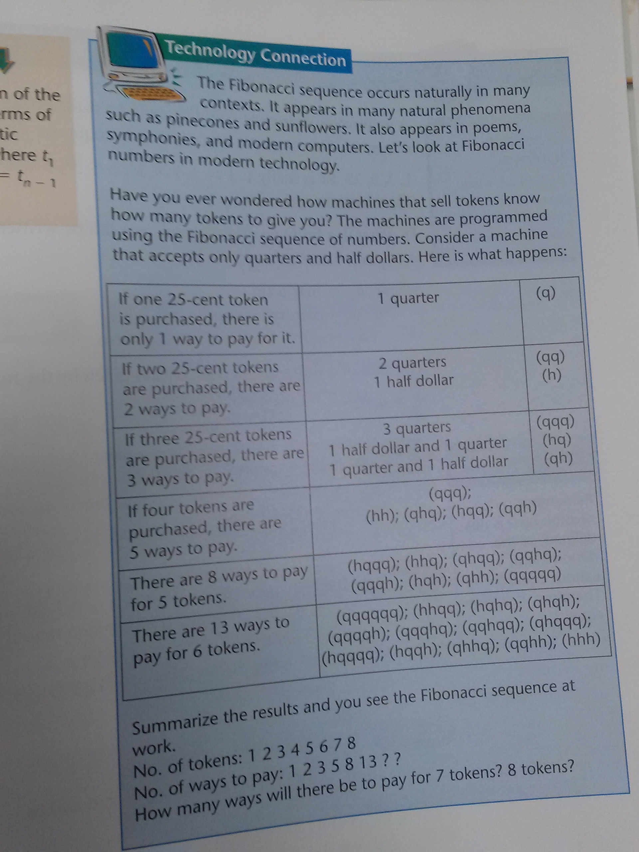
First, there needs to be a short lesson on how sequences are functions. A good activity for teachers to do with students is the ‘Technology Connection’ on page 387. This activity consists of understanding how the Fibonacci sequence occurs naturally in many contexts. Students will understand how it appears in natural phenomena. This activity shows students how the Fibonacci sequence is used in real world settings, such as technology. Examples are provided in the section of the activity. At the end of the activity, there are also some follow-up questions as shown on the right. The teacher can have students discuss in pairs first and then as a whole class.
Another activity that will help students very much is doing practice problems on IXL, the interactive website http://www.ixl.com/math/algebra-1 under AA.4. For formative assessment, the teacher can walk around and peek over at the students screen and see on the top right corner how students are doing. The teacher can then assign some homework practice problems for students to practice outside of class. I would suggest giving students problems 1-10 on Exercise A of page 386 in the book.
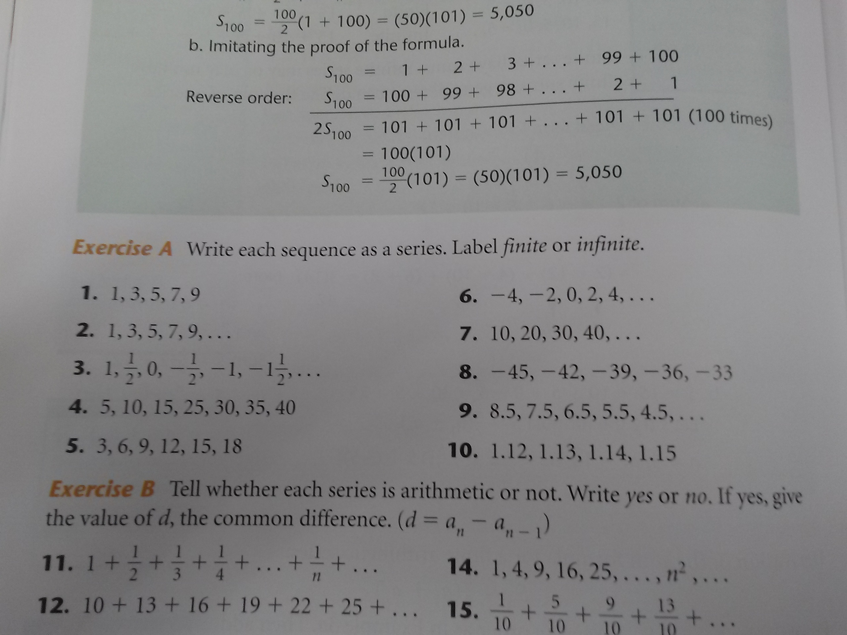
At the end of finishing teaching the cluster, the teacher could give students a short quiz or test covering everything seen to use it as a benchmark assessment in order to assess their understanding of the standards under the cluster.

