Rick Erdman
Grade 10-12
Text: No text
(Elmer B. Mode: Elements of Probability and Statistics resource)

High School: Statistics and Probability: Use Probability to Evaluate Outcomes of Decisions

Most students don’t realize that on a daily basis, they discuss probability. They may talk about the chance it will rain tomorrow, or even more uncertain, whether there will be a pop quiz in math class. This discussion about the uncertainty of what could happen is at its core a discussion about probability. Students begin talking about probability at a young age, however they begin first with statistics. Schools start teaching children about statistics in elementary and younger. Students in kindergarten compile data of lengths and widths of items and compare them to each other to see which is longer or wider. They also separate objects by quantity and arrange them in a particular order. This is the beginning of students working with statistics, a key concept that arises from probability. As students move through elementary school they continue to work with statistics, compiling more data, and interpreting meaning from the data. Who is taller? Students will find the largest data point, and that data point represents the tallest student. They move onto creating graphs of the information they find to better visualize their data. As they move into middle school they begin finding means, medians, and modes of their data along with patterns of the distribution. This helps to lead into finding the chance of an event occurring evaluating between 0 and 1. The larger the number the more likely it will occur while numbers near 0 are unlikely to occur. This leads the students into computing various simple probabilities through compiling data, and compound probabilities through tree diagrams with fractions to represent each chance of the event occurring in the tree. This helps students to see how each simple probability influences the next in the tree to get the compounded probability. It is no surprise then that in high school, students continue with this study of probability, working towards real world games of chance, and situations that need probability to find an acceptable solution.

Use probability to evaluate outcomes of decisions

Some real world problems that require probability to find an acceptable solution are similar to the one below.
A friend comes to you and tells you about this new game a local store is doing. He said the store was holding a game for costumers to participate. The store has 5 different tickets that can be purchased for the same cost; however the chance of winning and the payout differ. Each tickets winning give the participant points that can be used in the store for different items. Each ticket cost $1. Below is a table of the different tickets, their chance of winning, and their payout. Your friend wishes to know if it a good idea to participate in, and if so what would be the best choice? Your friend had been looking at getting a new hat that costs $4.99 at the store or you could get it for 25 points. Should your friend play the game to get the points or buy it with money? Which would be the better option?
At this point students begin to see that it is not about describing the outcome but about giving an interpretation of the outcome that is important. Simply telling his friend that there is a 60% chance of getting 2 points for his dollar means nothing to him. He wants to know if playing the game is cost efficient. By taking a estimate of the chances of winning and their payouts we see that:
$$.6*2+.25*5+.1*10+.04*20+.01*50=4.75$$
This outcome is still rather arbitrary to your friend. Does 4.75 points per dollar mean it is worth playing? Well if we look at what he wishes to get, a hat, it costs $5 or 25 points, which is cheaper $5 or 25 points? Now that we have context, the 4.75 makes more sense, seeing that for every dollar he would average about 4.75 points, at $5 he would probably have 23.75 points, just shy of the hat, and in points it would take an average of $6 or more to get the points for the hat. Assuming no value for the fun of playing buying the hat for $5 is

Ticket | Chance of winning | Points won
Green | 60% | 2
Blue | 25% | 5
Yellow | 10% | 10
Orange | 4% | 20
Red | 1% | 50

CCSS.Math.Content.HSS-MD.B.5 (+) Weigh the possible outcomes of a decision by assigning probabilities to payoff values and finding expected values.

The chances of winning are based on the number of colored tiles on the wheel. The wheel contains 100 little wedges of 1 of 5 colors. There are 60 green wedges, 25 blue wedges, 10 yellow wedges, 4 orange, and 1 red wedge. The chances of landing on any given wedge are represented in the table above.

the more cost efficient way to get the hat, not playing the game. Another way to use decision making with probabilities is through a game involving dice, otherwise known as Yahtzee.

In Yahtzee different values are assigned to different combinations of 5 dice. Each player gets up to three rolls in one round. The player can choose to keep any dice of their choice per roll, and at the end of their roll’s they decide which category they will use their score for. So it becomes a question of which values to aim for, and which to scratch out to make room for other values. The values associated with the combinations are either based on the combined value of dice, the combined value of specific dice, or a preselected value. A few questions that can be asked then is, how is the value decided for the different combinations? Could it be based on the difficulty of getting the combination in one roll? Two rolls? All three? From here students can begin looking into the probability of a given combination in one, two, and three roll’s and that combinations associated value. This allows students to work with simple and compound probabilities as the combinations can be obtained in three different categories. In one roll the probabilities are based out of 7776 different combinations.
One of the most sought after probabilities is the elusive yahtzee, or 5 of a kind. For this we can look at a transition matrix for the different probabilities from a 1 of a kind, through a 5 of a kind in one roll. To find the second roll we can compose this matrix on itself to see changes in the second roll, and again one more time to see the changes in probability for each transition given a third roll. This reveals that the total probability of getting a 5 of a kind after three rolls, assuming a smart player who keeps the best combination each time, is only 4.6029%! Not very likely, which makes sense why it is the highest valued combination.

Talking about games of chance lead many people to wanting to establish strategies from the probability for established payoffs. This comes into important use when deciding

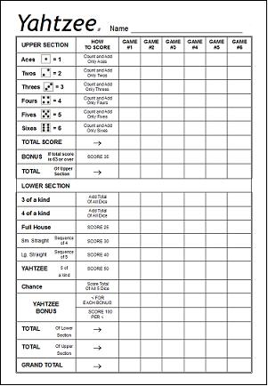

CCSS.Math.Content.HSS-MD.B.5a Find the expected payoff for a game of chance. For example, find the expected winnings from a state lottery ticket or a game at a fast-food restaurant.
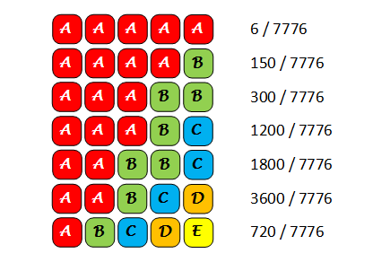
Probability associated with each combination of 5 dice, given in one roll.
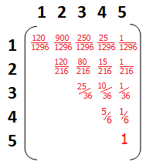
Matrix representation of probability to move from 1 of a kind through 5 of a kind from first roll, given on first roll got 1 of a kind through 5 of a kind.

deductibles’ for a health care plan.
Which would you rather use a high deductable health care plan or a low deductable? Compare these two plans, the low deductable plan has a deductable of $250 and the high deductable is $1000. Thus given a procedure that costs $5000 the first plan pays $4750, $5000-$250, while the second plan pays $4000. Given this which is the better plan? What would happen if the cost went up to $5300, an increase of 6%? What is the new amount paid for the low deductable? The high deductable? Which is the better plan? What if this growth continued annually? Does the better plan ever change? Given a period of 20 years with an increase of 6% on the previous year would it be better to have a low deductable or high deductable at the end?
Given the first 6% increase in the cost of the procedure, the low deductable would be $5300-$250=$5050, which is a 6.3% increase over $4750 from the previous year. The high deductable would be $5300-$1000=$4300, which is a 7.5% increase over the $4000 from the previous year. This makes It seem that the high deductable has a higher premium growth given the first year with a total 1.5% over the 6% increase in cost. This appears to show the low deductable is preferred over the high deductable, however as each year progresses, the high deductable premium difference begins dropping as each year passes getting closer to the lower deductable plan.

Another important aspect of probability is using it to make fair decisions. There are 6 players that wish to be captain of their team. They each are qualified so they decided that for the next game they are going to pick randomly who gets to be captain. Two players come up with a different way they could chose fairly who gets to be captain.
Tom decides to assign each player a number 1-6 and then roll a 6 sided dice to determine who gets to be captain.
James decides that flipping a coin would work better, so he decides to flip a coin 3 times

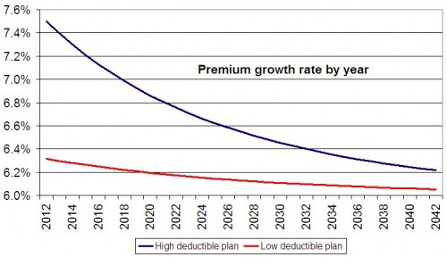

CCSS.Math.Content.HSS-MD.B.5b Evaluate and compare strategies on the basis of expected values. For example, compare a high-deductible versus a low-deductible automobile insurance policy using various, but reasonable, chances of having a minor or a major accident.

and assigned each 6 players different outcomes to determine who would get to be captain. Are they fair? Which is the better choice to make a fair choice? How could either one or both be changed so that they are fair in choosing a captain?
In Tom’s plan he decides to give each player a number 1 through 6 and rolling a 6 sided dice to decide who gets to be captain. In this way each player has a 1/6 chance of being chosen as captain, since each player has the same probability this is considered a fair decision.
In James choice each player is assigned an outcome of the given three flips of a coin. So for players 3-6 they have a 1/8 chance of being selected. For players 1 and 2 however, they have a 2/8 chance of being selected which is greater than 1/8 chance. Since not every player has an equal chance of being selected this probability is not considered a fair decision.
For Tom’s plan nothing would need to be changed in order to make it fair, it already is. For James plan however no number of coin flips would get him a combination that would be divisible by 6. So one way he could make it fair is by eliminating TTH and TTT as options. So if those two combinations appear, then he restarts all the flips. In this way he would give each player a 1/6 chance of being selected, thus being fair.
Each section above leads to the same point, developing strategies using probability concepts. In this way students develop the skills they have been working on, by creating strategies for when they would use them and how they would be helpful. Consider a simple game that students can play with a deck of cards. Two students are given a 36 card deck of cards that number 1-9; they are tasked with shuffling the deck and each drawing 5 cards. The purpose of this game is to have each player choose 3 cards that total as close to 20 as possible. Each student takes a turn, after both students go, they sum their three cards and take the difference between that number and 20. They shuffle all the cards together and draw again.

Player | Coin flips
1 | HHH
2 | HHT
3 | HTH
4 | HTT
5 | THH
6 | THT
1 | TTH
2 | TTT

CCSS.Math.Content.HSS-MD.B.6 (+) Use probabilities to make fair decisions (e.g., drawing by lots, using a random number generator).

Player 1 | Difference | Player 2 | Difference
5+5+9=19 | 20-19=1 | 6+4+9=19 | 20-19=1
8+7+6=21 | 21-20=1 | 9+7+4=20 | 20-20=0
9+9+3=21 | 21-20=1 | 9+8+5=22 | 22-20=2
6+5+7=18 | 20-18=2 | 7+7+8=22 | 22-20=2
6+5+9=20 | 20-20=0 | 6+6+8=20 | 20-20=0
4+4+9=17 | 20-17=3 | 8+7+5=20 | 20-20=0
7+8+4=19 | 20-19=1 | 9+8+5=22 | 22-20=2
Total | 9 | Total | 7

CCSS.Math.Content.HSS-MD.B.7 (+) Analyze decisions and strategies using probability concepts (e.g., product testing, medical testing, pulling a hockey goalie at the end of a game).

Each player has 7 turns like this they then take the sum of their totals and the player with the lowest score wins. After this first game each student then decides a strategy they wish to employ upon the next game. The students write down their strategy and the corresponding totals and total sum on this next game. They then compare their first and second game. Did their strategy work? Did they do better or worse than their first game? If they did worse than their previous game did they still win? These questions can help students to look at their strategies and employ different probability concepts to find a winnable strategy.
This game is then played again with the same deck however the rules change. This time the students receive 6 cards and are choosing four cards from their hand. They arrange them to create two two digit numbers. These numbers are then added together to try and sum to 100. Then the students take the difference between their number and 100. Afterwards they sum the totals from each turn and whoever is lowest wins. From this game the students again develop a strategy for the next game that they write down and compare that game to their previous. Asking the same questions as the first two games they played. Did their strategy work? Did they do better or worse than their first game? If they did worse than their previous game did they still win?

Player 1 | Difference | Player 2 | Difference
75+24=98 | 100-98=2 | 49+52=101 | 101-100=1
33+66=99 | 100-99=1 | 49+51=100 | 100-100=0
47+53=100 | 100-100=0 | 26+73=99 | 100-99=1
81+16=97 | 100-97=3 | 34+64=98 | 100-98=2
51+51=102 | 102-100=2 | 49+51=100 | 100-100=0
49+52=101 | 101-100=1 | 57+46=103 | 103-100=3
Total | 9 | Total | 7

