High School Pre-Calculus

Summarize, Represent, and Interpret Data on a Single Count or Measurable Variable

Introduction
The cluster used to analyze a statistical model consists of four standards. The first standard, S-ID.1, occurs after the sampling process and requires students to analyze the data that has been collected graphically. The analysis can occur by putting the data into a dot plot, histogram, or box plot.
S-ID.2, the second standard in this cluster, has the students perform algebraic calculations on the data. During this process, they will need to calculate a mean, median, standard deviations, etc. The goal is to recognize the patterns and spread that exist within a set of data points.
The students are required to analyze the numerical data and determine any abnormalities that might exist. This interpretation of the data and determination of outliers is required of the third standard, S-ID.3.
Lastly, the students will be required to normalize the data and represent the normal curve. Further, students will need to understand the properties of the normal curve with respect to a general population and the sample that has provided the data. Completion of this step will show mastery of S-ID.4 and complete the standard cluster.
The students will move through this cluster using two different instructional methods: modeling as well as traditional bookwork. The modeling will occur through a research project the students will be required to do. During this research, students will be required to collect data, graphically represent the data, explain the patterns in the data, and normalize the data.
The class demographic will be a high school pre-calculus class. The textbook that is being used is Advanced Mathematics by Richard G. Brown.
S-ID.1
S-ID.1: Represent data with plots on the real number line (dot plots, histograms, and box plots)
Students will be required to know how to use a set of data and represent this data graphically. The graphical representations they will need to know how to use will consist of a dot plot, histogram, and a box plot. Examples of each are as follows:

Dot Plot:

For the modeling activity, students will be required to collect data from their school to use as a statistical model. The question at hand will ask what the production of certain sizes of shoes should be to maximize production while limiting excess. Students should collect data and represent using one of the three graphical models that are presented. The students will be required to turn this section in individually to assess. In this assessment, the dotplot, histogram, and box plot will be analyzed for correctness and understanding. Depending on the presentation or work, the teacher then decides to continue instruction or reteach these concepts.
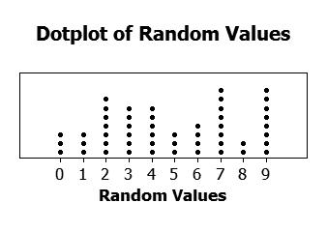

Histogram:

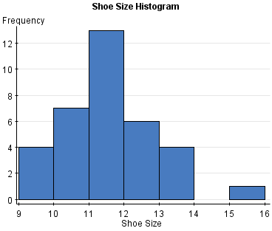

Box Plot:

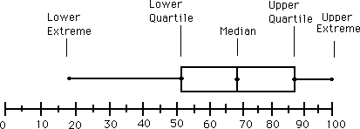

Additional assignments for this standard:
p. 652 (5-8) Create each graphical model for the d data given.

S-ID.2
Once students have organized the data graphically, they need to determine patterns that exist within the data. These patterns can be recognized algebraically by calculating the mean, median, and standard deviations within the sample set of data. The following are the equations for each:
S-ID.2: Use statistics to appropriate the shape of the data distributions to compare center (median, mean) and spread (interquartile range, standard deviation) of two or more different data sets.

Mean: The class will be using the sample mean.

$$Mean=\frac{\sum{x}}{n}$$
Where numerator is sum of data set and n is number of sample size.
This portion of the modeling task will involve algebraically analyzing the data that was collected and represented graphically. The students will be required to determine the mean, median, and standard deviations of all the data that is collected. They will then turn the newly analyzed data in, along with previous work for assessment. Students will be assessed on mathematical correction of statistical analysis. Further, the previous section will be reassessed for improvement.

Median: The number exactly in the middle of the sample set. If there is an even number, take the two numbers in the center and average.

Standard Deviation:

$$\sqrt{\frac{\sum{{(x-\overline{x)}}^{2}}}{n-1}}$$

X=each score
$$\overline{x}=mean$$
n=number of values

Additional Assignments:
p. 643-644 (1-13) and
p. 658 (3-6)

S-ID.3
S-ID.3: Interpret differences in shape, center, and spread in the context of data sets, accounting for the possible effects of extreme data points (outliers).
This standard requires that students analyze the effects that extreme data points (outliers) might have on the shape of the curve presented by the data given. Are there any changes that occur? What would those changes look like? Examples of this analysis are as follows:

Students will be required to use the same data that was collected and analyzed previously and conduct analysis given this new material. They will need to determine if there are any outliers, how these outliers affect the distribution curve, and what should be done with these outliers. This analysis will need to be done within context of production of shoe supply and how this will ultimately affect business. Again, this aspect of the project will be turned in for assessment and clarification of concepts. The students will be assessed on the presentation of the normal curve properties.
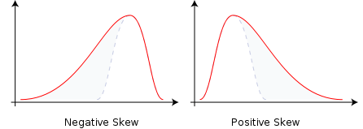

In order to understand the skewed graphs and how outliers affect them, students will need to understand what a mode is, and can be defined as the most frequent number represented in the data.

S-ID.4
Statistical inference is dependent upon the standardized curve. This standard requires students to be able to take a sample set of data and normalize it. Further, they will be required to understand the properties of a normal curve and what these properties mean. In order to do this, students will need to know how to calculate a z-score, what a z-score means, and how to determine the data point when given a z-score, mean, and standard deviation. Examples of how to do each are given below.
S-ID.4: Use the mean and standard deviation of a data set to fit it to a normal distribution and estimate the population percentages. Recognize that there are data sets for which such a procedure is not appropriate. Use Calculators, spreadsheets, and tables to estimate areas under the normal curve.

Z-score:
Students will be required to use the data collected and produce a normalized curve for distribution. The data will be presented through a portfolio presentation that will be turned in and summatively assessed. The students should be able to estimate the amount of shoes that need to being produced in each size in order to maximize production and minimize waste.

$$z=\frac{x-\overline{x}}{σ}$$

The only new symbol should be the z which is self-explanatory. This equation will be used to determine either z or x when a mean and standard deviation are given. To determine x, the students will need to be given a chart to determine what the z score is and the distribution percentage. The chart looks like the following:
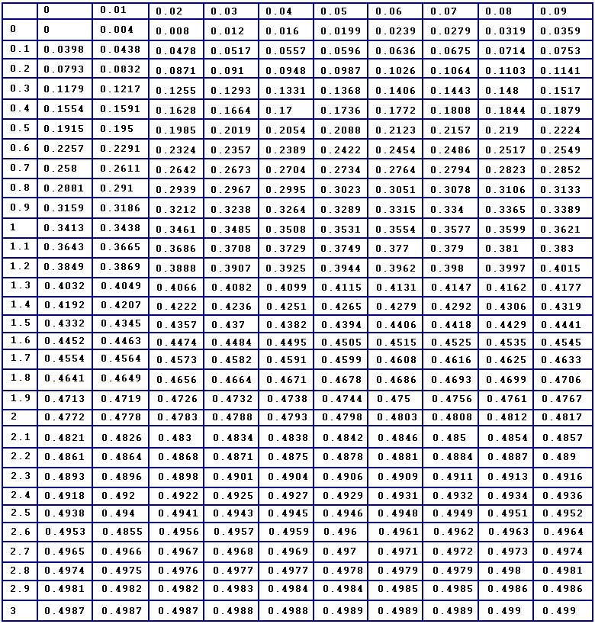

The vertical columns are the whole z-score values, while the horizontal rows are the percentage of whole scores. The numbers that determine the score are the percentages in the chart. For example, a person scores in the 85th percentile on a test. The student should determine that the 85th percentile will equate to 35% on this chart and correlate to a 1.03 z-score.
Additional Assignments:
p. 667-669 (1-17).

