Carli Sowder

**Overview**

This Learning Progression is for the CCSS domain “8th Grade Geometry” and the cluster is “Solve real-world and mathematical problems involving volume of cylinders, cones, and spheres.” This progression is written for the Ellensburg High School’s alternative program, Excel. The textbook which aligns with this progression is *Geometry”* by Siegfried Haenisch. For this progression I will focus on students using a model to demonstrate learning.

**Standards:**

* [CCSS.Math.Content.8.G.C.9](http://www.corestandards.org/Math/Content/8/G/C/9) Know the formulas for the volumes of cones, cylinders, and spheres and use them to solve real-world and mathematical problems.

**CCSS.Math.Content.8.G.C.9**

Students need to understand volume and know the formulas whether they are going on to college or the work force. Volume is used everywhere and it is very important that students understand how common and useful these formulas are. They will do hands on activities to help them see the value and engage them. They will also solve equations using the formulas. Because of its importance, it is important that this standard is fully met by each student. Students must first see the formulas for volume of a cone, cylinder, and sphere. They will get practice using the formulas with basic problems. They need to be able to apply them to the real world so it is crucial we do an activity where they can be applied. Students have already learned about area so they understand solving for an unknown space. However, they need to understand the difference in volume and area and what the difference truly means in words and in an equation. They will be asked to model how they came to their answers by explaining the model below in terms of the question asked.



By using this model, they will know if they are following the correct process to finding a solution. By following this model, they can ensure that they understand why they are getting their answers and not just practicing procedural fluency. Mathematical reasoning is strengthened by students explaining the model in terms of a problem. This model comes directly from the Common Core.

**Plan to Teach This Standard:**

The first lesson will consist of students writing down the equations in a worksheet given by me. They will walk through an explanation of the formulas as a class. We will do a few practice problems on the board to help them with their procedural fluency. They will be given the worksheet “additional practice 69” in the textbook to focus on understanding the concept of volume and their procedural fluency. They will finish this worksheet for homework.

The second lesson will begin with a warm up on the board of problems from the previous lesson. The students will then break up into groups. They will be given different sized containers, rice, and a worksheet with the different dimensions of the containers. They will begin by solving for the volume of these containers. An example of what the dimensions might be is

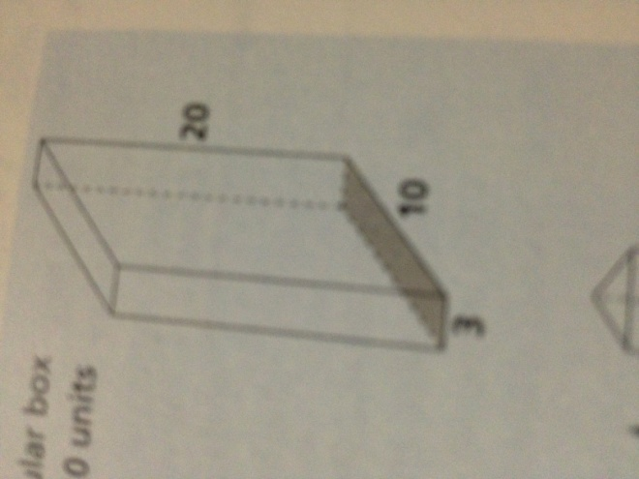

Once they solve the equation on paper, they will take the amount they got and put that amount of rice in the container. If it fits, they know they got the answer write. They will then take the model given above from the Common Core and put the steps into bullet points and explain how they used each step for that specific problem. They will do this with a sphere shaped container, cone shaped container, and cylinder shaped container. After everybody finishes this activity, we will review their answers they got and I will ask volunteers to explain their model. As assessment I will ask them to turn in their work from the activity and they will be graded on their analysis of the model.

**Lesson Title:** Volume in the Real World

**Unit Title:** Volume

**Teacher Candidate:** Carli Sowder

**Subject, Grade Level, and Date:** Math, 8th grade, 2/25/14

**Placement of Lesson in Sequence**

This lesson is done after the first lesson where the students will learn the formulas and practice solving equations.

**Central Focus and Essential Questions**

The central focus of this lesson is to have the students understand the value of using volume in the real world. The students will be able to practice their procedural fluency and master their mathematical reasoning by applying the formulas to a real world application. The focus will also be to have students compare the different volumes and see which ones are larger or smaller. By using the model, the students will understand how they are getting their answers. They will also get practice using a model to come to a conclusion.

**Content Standards**

[CCSS.Math.Content.8.G.C.9](http://www.corestandards.org/Math/Content/8/G/C/9) Know the formulas for the volumes of cones, cylinders, and spheres and use them to solve real-world and mathematical problems.

|  |  |
| --- | --- |
| **Learning Outcomes** | **Assessment** |
| Students will be able to:   * Solve for the volume of a cone, cylinder, and sphere. * Use real life objects to analyze volumes. * Use the model to analyze the process of solving the questions. | I will assess their explanation of how they used the steps in the model to formatively assess how well they understand the reasoning. I will walk around while they are doing the activity to make sure they are following along and working with their group. |

|  |  |
| --- | --- |
| **Learning Targets** | **Student Voice** |
| I will be able to:   * Solve for the volume of a cone, cylinder, and sphere. * I will be able to solve for the volume of the given containers. * Use the model to explain how I got to my conclusion. | Students will use their voice when they are explaining their reasoning of their use of the steps in the model. They will also use their voice when I am walking around and ask them what the different dimensions in the figure are. |

**Prior Content Knowledge and Pre-Assessment**

Students need to know how to multiply and understand area. They need to know how to take a formula like the area and apply it.

|  |  |  |
| --- | --- | --- |
| **Academic Language Demands** | | |
| **Vocabulary & Symbols** | **Language Functions** | **Precision, Syntax & Discourse** |
| * Volume * Height * Length * Width * Model | * Describe * Explain * Demonstrate * Anaylze | **Mathematical Precision:**  **Syntax:**  **Discourse:**  Students will be able to accurately explain their reasoning out loud with proper vocabulary and usage of academic language. |

|  |  |  |
| --- | --- | --- |
| **Language Target** | **Language Support** | **Assessment of Language Target** |
| Students will be able to explain the model in correct context and solve for the volume of the given containers using a formula. | I will support them by assisting with the vocabulary as they say their explanations. Also, when they are doing their activity I will walk around and ask them questions that require responses with correct vocabulary. | Language will be assessed formatively when they turn in their explanations of the model. Also, I will assess how they are learning the vocabulary as I walk around and listen when they are doing their activity. |

**Lesson Rationale (Connection to previous instruction and Objective Standards)**

This lesson follows the initial lesson where I give them the formulas and they solve basic problems. Therefore, they are ready to apply it to real world problems. The standard requires them to know the formulas and apply them so this lesson Is important in the students meeting this standard fully.

**Differentiation, Cultural Responsiveness and/or Accommodation for Individual Differences**

Students who are struggling will be successful because I have everybody in a group. This way, since there is only one of me, they can help each other before asking me for assistance. Different cultures and individual differences will be handled individually if being in a group is not enough of an accommodation. Students who speak a different language can see how the volume can be analyzed using the containers.

**Materials – Instructional and Technological Needs (attach worksheets used)**

Materials needed by the students are their notebooks, pencil, rice, containers, sheet of dimensions for containers.

|  |  |  |  |
| --- | --- | --- | --- |
| **Teaching & Instructional Activities** | | | |
| **Time** | **Teacher Activity** | **Student Activity** | **Purpose** |
| 10 min | Put the warm up on the white board and walk around and assist students. | Do the warm up individually | Refresh on the formulas before moving onto the application of them. |
| 30 min | Explain the activity and hand out sheet, rice, and containers. | Work on activity and explanation of the model | Have students see the real world connection and use the model to understand their process. |
| 10 | Get students back to their seats and ask volunteers to explain their usage of the model | Volunteer or listen to volunteers | Students can listen to other people’s explanations and compare theirs. |

Name: ­­­_________________________

**Directions:** Solve the problems below and use the containers to compare each answer.



6

3

 

5

5

7

3)

2

4.

 

4

4

3

5.

**Name: __________________**

**Directions:** Review the model below and fill in how you used each individual step using the bullet points.



**Problem:**

**Formulate:**

**Compute:**

**Interpret:**

**Validate: Did you need to reformulate?**

**Report:**