Interactive Assessments Using Technology:
Khan Academy

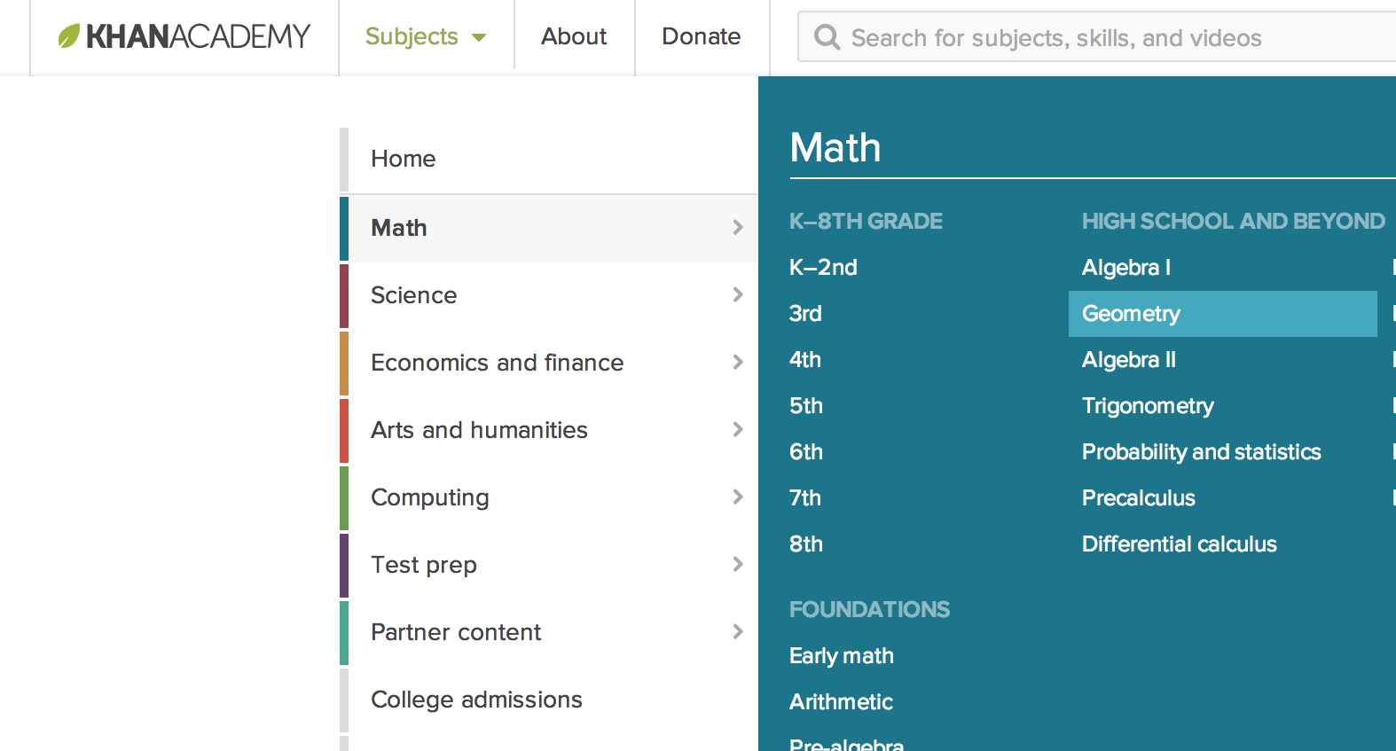
As a teacher, guaranteeing that your students meet all of the standards in the Common Core can be a very stressful task. Khan Academy is a great way to assess students’ learning and allowing you to guide them towards meeting the standards. Khan Academy is a free online class full of information, quizzes, videos, and tests that can be used by teachers, parents, and students alike covering a variety of topics. Users of this great resource can work on tasks focusing on a specific common core standard until they have shown they can master this standard and can then move on to another topic. Subjects range from levels starting at kindergarten all the way up to high school and beyond!

Khan Academy is a free for anyone to use. You can sign up by visiting www.khanacademy.org and creating an account or by creating a profile through your regular classroom. It is not necessary for someone to create an account to use this online resource but for a teacher or parent to track the students’ work and progress, an account must be created. There are many topics to choose from, ranging from science and math to arts and humanities. Once a topic is chosen, you can select the specific grade level. For an educator using this program, you can “recommend” specific lessons within your desired topic to the class. The class will then complete those tasks and receive a grade. All of the assignments on Khan Academy are directly aligned with the Common Core State Standards so whenever a student successfully completes an assignment, they are working towards meeting the State’s requirements.

Using Khan Academy To Guide Student Learning

The reason why Khan Academy should be utilized in a classroom is that it will provide the teacher with a resource to formally assess the students. For example, the teacher can give their traditional lesson about a specific math skill followed by group work. When the teacher is ready to pass out homework or a quiz, they can simply use Khan Academy instead. The teacher can assign problems to the students that will act as an assessment to determine whether they are learning or not. From there, students can either watch videos that give another explanation of the new skill or skip the video and go straight to the problems. Once the students have completed the assignment, their data is recorded to their profiles and the teacher can access that information to assess and then guide the students’ learning.

Let’s look at a specific example of how you could use Khan Academy for the Common Core State Standard:

CCSS.MATH.CONTENT.8.G.A.3: Describe the effect of dilations, translations, rotations, and reflections on two-dimensional figures using coordinates.

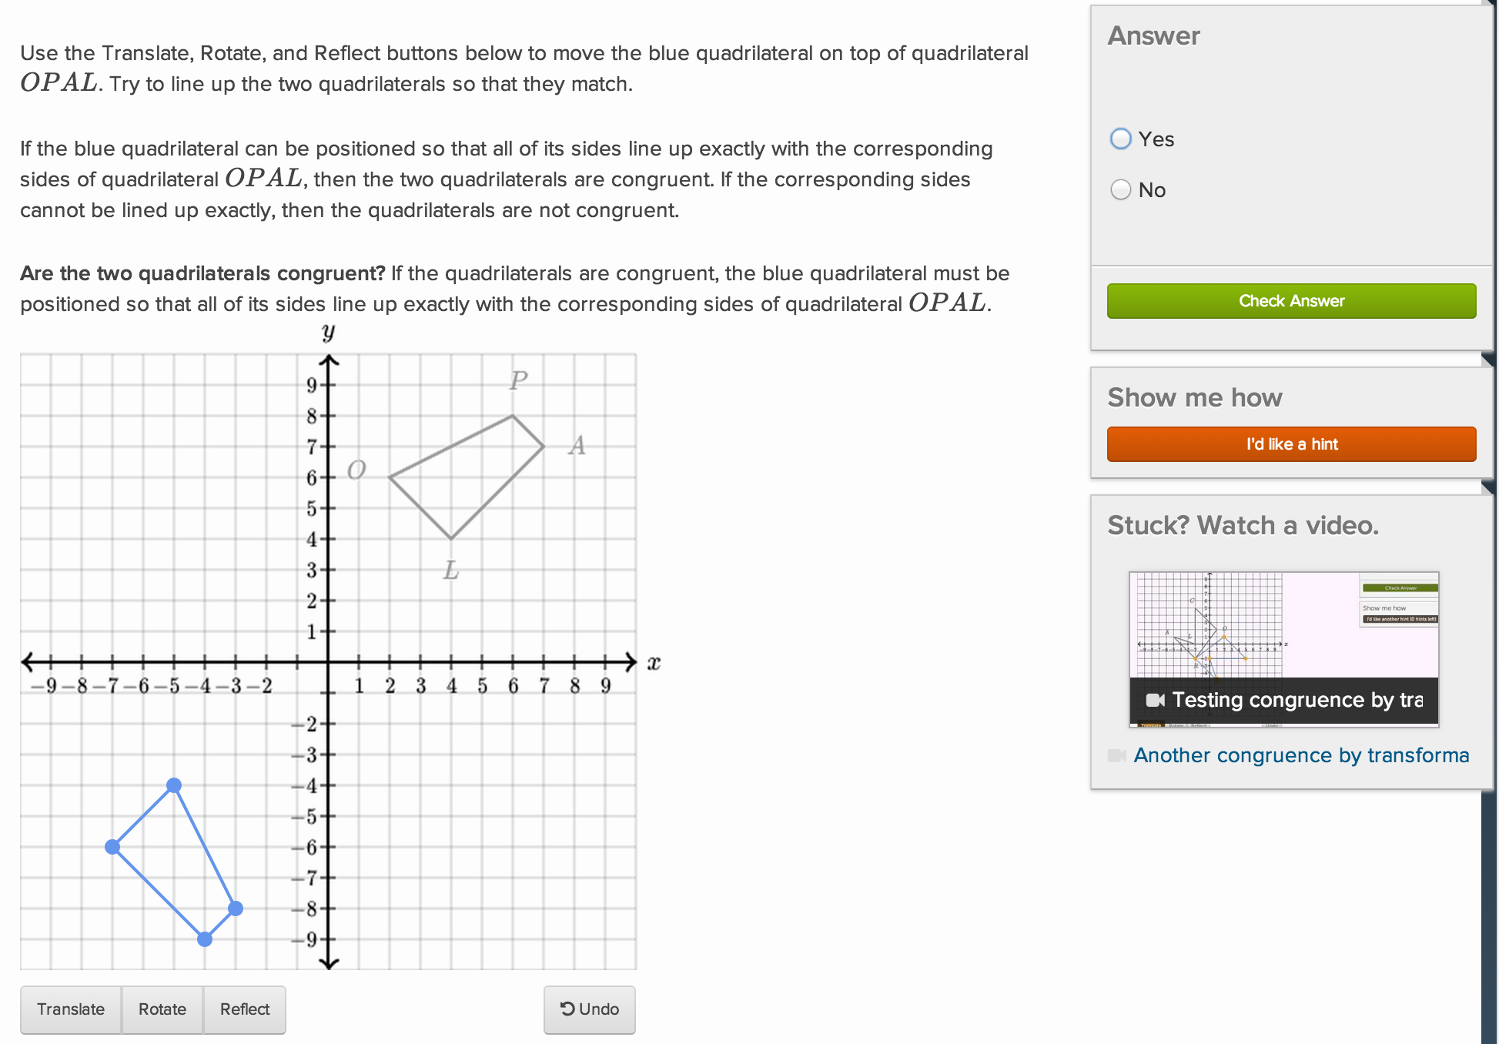
The students have just been given a lesson describing the different types of geometric transformations and then worked in groups to practice their skill using geometric transformations. The teacher now wants to see what the students have learned so far so that the class can either move on to the next topic or further improve their knowledge of transformations. The teacher then requires that the students complete the “Transformations and congruence” section of high school geometry for homework. The students watch the videos provided to improve their understanding and then attempt to complete the assignments. They must correctly answer five questions in a row before successfully completing the assignment. When the students have all completed the task, the teacher can look at the results and see how many problems it took before the students got five in a row and ultimately decide if the class is ready to move on. After students get practice on Khan Academy, they must be able to complete hand written homework that night. In doing this, the teacher is able to have both electronic and paper evidence of student comprehension.

For a comprehension check that aligns with the standard, the teacher may give an entry task the next day that uses a pencil and paper. The CCSS above states that the students need to “describe the effects”. To do this, the entry task could be that the students solve a couple of problems then have to describe the effects of the shape given the transformation, reflection, dilation, and rotation.
In addition, at the end of the unit there would be a summative assessment that would prove that they could solve the problems without the help of the technology. The technology is there to help aid the students learn the information in a new and different way that is interactive. It gives the teacher results for how the students are doing that is quick and easy form.

Why Use Khan Academy?

Khan Academy is great for both the teacher and the student because of the amount of problem it has already created complete with answers and hints. You do not necessarily want to only use Khan Academy but it is still a great program to use for assigning homework to formatively assess your students. It also guides student learning because the teacher has access to the students ‘data in regards to how well they did on an assignment. Khan Academy can also act as an extra resource for struggling students. For example, if a student is struggling in the class and staying after school to receive help isn’t an option, the teacher can recommend problems to the student through the website and the student can access them at home, given that student has internet access. Khan Academy has videos that will help explain the math process along with numerous practice problems. Also, using Khan Academy as a test could cause trouble with the students because of the occasional complexity of the program. Students may understand how to do the transformations but have trouble using the buttons on Khan to complete the transformation. However, Khan Academy, when used correctly, can help keep the students and the teacher all on the same page.

Adaptations and Accommodations

Khan Academy can help students with IEP’s and 504’s with ease. IEP students that are having problems because of disciplinary issues, they are able to work independently and focus on themselves. It gives their work-time structure and discipline. For learning issues either with the IEP or a 504, students are fully immersed in the program. They are watching the videos, reading the text, analyzing the information, and able to listen to all of this. It is using as many senses as possible. So whatever is their strength intelligence, it is being met. For all IEP and 504 students, they are able to work at their own pace. For students that need extra help for when they are at home, they are able to also work on this program from their house computer. So the students can use Khan Academy to help go through the different problems to help them with their homework or go back and watch videos. For students that need motivation, there is a badge system in place. So when students meet certain criteria, they get a badge to highlight their hard work. So there are several ways to help a variety of students.

