For years it has been a challenge to get students to interact in class. Teachers have had a difficult time getting students to apply themselves and sparking their interest in mathematics. Student motivation has been decreasing significantly throughout the years. Teachers have tried multiple tactics to make learning mathematics more enjoyable and get the students more motivated to participate in class. Education is constantly advancing as is technology. Technology has become a huge part of education the last couple years. One of the most popular piece of technology that has entered the classroom is the 800 series SMART Board.
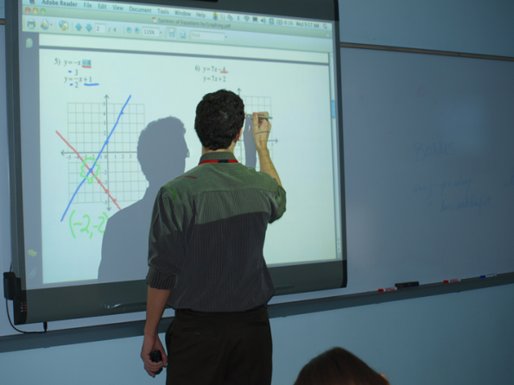
The 800 series SMART Board is essentially an electronic white board that teachers and students can interact with in order to achieve learning targets. The SMART Board has many useful features, including “multi-touch” which allows up to four students, or the teacher and three students, to interact with the board simultaneously. Another feature is “object recognition” which recognizes the difference between pens, palms, and fingers. Lastly, SMART Exchange is a website that comes with the SMART Board and has countless educational resources that are free, accessible, and ready to use. SMART Exchange allows teachers to pick lessons and activities that best suit his or her students’ needs.
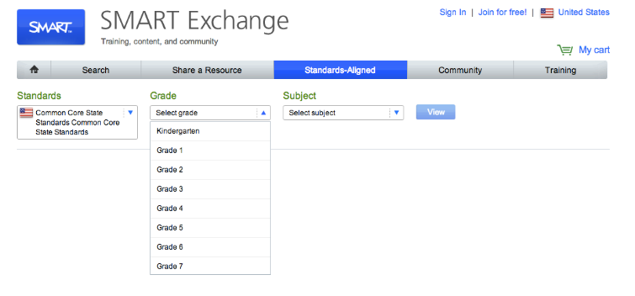
It is very simple to access information about the SMART Board because it is on the website: education.smarttech.com/en/products/, which is also where teachers can find a reseller of the product near them. Moreover, the aforementioned SMART Exchange is also very accessible on the smarttech.com website.
1. Plan to teach mathematical understanding.
I will use the lesson template from SMART Exchange for solving systems of equations. The Common Core State Standard that will be met is CCSS.Math.Content.HSA.REI.C.6
Solve systems of linear equations exactly and approximately (e.g., with graphs), focusing on pairs of linear equations in two variable. During instruction, I will demonstrate how to create a system of equations by graphing two intersecting lines on the board’s graph and then create the equations for the two lines. Next, I will use the smart board to show students how to estimate a solution to a system of equations using the graph I have previously created. Students will understand that where the lines intersect is the solution of the system of equations. I will also demonstrate that the solution is written as an ordered pair. Lastly, I will solve the system of equations by using substitution and/or elimination.
The students will build off of the lecture given to them about how to solve a system of equations using the graphing method in order to reach the learning standard. Students will then complete a activity using the SMART Board. This a hands on activity that allows the students to practice solving system of equations and fufill the standard.
SMART boards are a great way for teachers to clearly demonstrate how they want their students to reach the learning tasks. In this specific lesson, the teacher can create clear instructions of how to graph linear equations and solve system of equations. The students could use the SMART boards to graph in an organized way.
2. Planning to support varied students’ needs.
Since the class size is small, all students will have an opportunity to work the problems out at their desk, then come and solve it on the board (4 students at a time). Currently there are no students who cannot physically walk up to the board and work the problem out. Some days, students do not want to participate in activities like this, so I will encourage students to participate by giving points for correct answers and by telling them that this activity is not meant for getting only correct answers, but also for eliciting class discussions to reason their answers and address misconceptions/errors. There are a couple of students in class that often need clarification of directions and/or instant feedback on their answers. This activity using the SMART Board addresses their needs because it allows the class to swiftly go from the lesson to practicing problems of their own, and it allows me to clarify any initial misconceptions or misunderstandings of directions since we are working together.
SMART boards help teachers be organized and the teacher can provide a clear lesson for the students to understand. They will be clear and easy to read. Students will be able to clearly see what the teacher is talking about. Also, SMART boards can help kinesthetic learner by the student being able to physically touch the board.
3. Using knowledge of students to inform teaching and learning.
The SMART Board allows me to use knowledge of students’ conceptual understanding as I get to see their work and hear their reasoning afterward. This informs me of what I need to teach students next, and what they learned from the initial lesson/activity.
SMART Exchange helps teachers find lessons that are appropriate for their groups of students and age group. If the students are not yet ready to move onto the next section, then the teacher will be able to find another lesson to expand the students’ learning on solving equations.
4. Integrating technology in the mathematics curriculum.
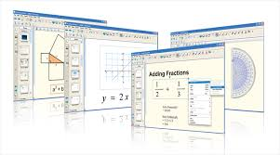
Using SMART boards are a creative way to display mathematical artifacts. It is a way for the students to interactively learn. Ultimately, students’ interest is sparked simply because they are using technology, so they are more willing to participate and therefore reach the learning targets.

Sources
SMART Exchange info from website: smarttech.com
SMART Board info from website: education.smarttech.com/en/products/smart-board-800
Common Core State Standard website: http://www.corestandards.org/Math/Content/HSA/REI/

