Using a Smart Board for Interactive Warm-Up Activities

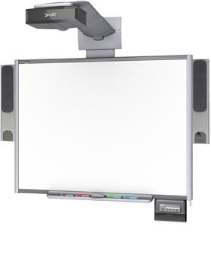
Using a Smart Board in math class is beneficial for the students and the teacher. Writing and interacting with the Smart Board is a lot of fun for students. It gets the students participating during class instead of just taking in information. A Smart Board is an interactive white board that projects images onto a screen that can be written right on to. The Smart Board is also a touch screen that can have the computer images projected right onto. There are different activities that can be run through a slide show program that students can interact with. Teachers can find applications that accompany the Smart Board on the Smart Exchange website. The Smart Board helps students stay engaged and focused in class. While there is no big difference between writing on a white board and writing on the Smart Board, students are more willing to write on the Smart Board and enjoy it.
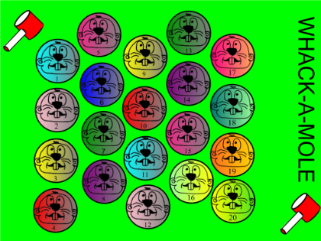
Using Whack-A-Mole Activity to Review Topics
Whack-A-Mole is an activity that can be found on the Smart Exchange website. The application can be downloaded for free using the following web address:
http://exchange.smarttech.com/details.html?id=3b2ef28c-e709-4ff0-8925-2c65832642a0

This game is one involving the smart board and a ball. The students are able to interact with the screen by tossing a koosh ball to select the math question that they will work on individually or in a small group. The Whack-A-Mole game gets the class to participate actively by including a kinesthetic element. On that screen there is a question that the teacher can edit for the content area. The students can answer the problem using a smart clicker or just on their own. When students are done answering there is a button that takes you back to the original screen. This program is vary customizable and can work for a lot of subjects. It enables students who are bored, tired, or who need to get rid of excess energy. The application makes it so that the teacher has the questions and answers readily available, rather than writing on the document camera or white board. A tutorial for the Whack-A-Mole app can be found at: https://www.youtube.com/watch?v=lgBY5c5JqK4

Whack-A-Mole is designed with the ability to be customized to any mathematics content the teacher chooses. A few topics include; probability and statistics, order of operations, solving single variable equations, and decimals. The accessibility of questions makes for efficient time management and therefore more learning can take place. Examples of possible statistics and probability questions are seen in figure 1 and figure 2.
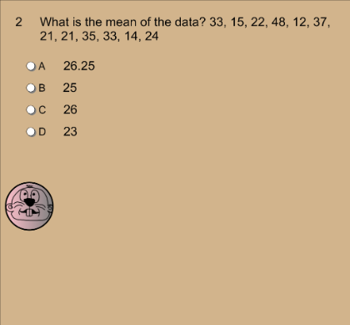
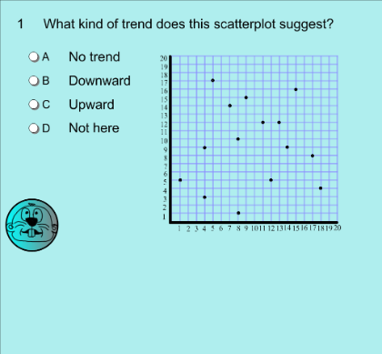

Figure 1 Figure 2

The questions are set up to be multiple choice questions. This is to help the students to practice the format that they will encounter on the end of the year exams. Teachers may use a Smart board and the Whack-A-Mole app to complete the objectives of the Common Core State Standards for Mathematics,

Giving quantitative measures of center (median and/or mean) and variability (interquartile range and/or mean absolute deviation), as well as describing any overall pattern and any striking deviations from the overall pattern with reference to the context in which the data were gathered.
CCSS.MATH.CONTENT.HSS.ID.A.2
Use statistics appropriate to the shape of the data distribution to compare center (median, mean) and spread (interquartile range, standard deviation) of two or more different data sets.
CCSS.MATH.CONTENT.HSS.ID.B.6
Represent data on two quantitative variables on a scatter plot, and describe how the variables are related.
CCSS.MATH.CONTENT.HSS.ID.C.7
Interpret the slope (rate of change) and the intercept (constant term) of a linear model in the context of the data.
Math Activity Using Whack-A-Mole App
The Whack-A-Mole application is a great source for warm-up problems and entry tasks. It takes little to no time to set up, allowing the students to get started right away. The students will work out the problem individually, but are allowed to ask the student next to them for help when needed. Selected at random, one student will be given the ball and toss it at the Smart board. Once the ball makes contact with the “mole” a math problem will appear for the students to start working on. The students will show their work in their journals and put their pencils down when they are finished. After the students have completed the problem, the teacher will ask for one person to show their work on the smart board and explain their mathematical reasoning. To meet the Common Core State Standards the student must be able to work through the problem numerically and graphically and use correct math syntax to explain their process. An example of a of probability question the students might be:

Jimmy has a bag of marbles. In his bag he has 7 white marbles, 5 red marbles, and 3 blue marbles. What is the probability that Jimmy will select a blue marble?

The problem above addresses the probability and statistics portion of the Common Core State Standards.

The teacher will facilitate by choosing student to take turns throwing the ball and to correct any misconceptions in the problems. Using the Smart Board with this app allows the teacher to discover if the students are ready to move on to a new topic or if they need more time reviewing. The teacher assumes that the students have reached the learning objective for the specific topic and assesses this using the activity. After each of the warm-up problems the teacher asks the students if anyone needs any further explanation before moving on to the next problem. To help the students who struggle in class, the teacher can use the think, pair, share method. The students attempt the problem on their own and then compare their answers with a neighboring classmate and explain their reasoning. As the teacher moves through the room, they must notice if there are any misconceptions and common errors in understanding material. If there is, the teacher must gather the attention of the class as a whole and correct the mistakes before letting the student move on.

It is the teacher’s responsibility to keep track of the students who have not gotten the chance to throw the koosh ball. This gives each students an equal opportunity to participate in the activity.

