A Free Graphing Calculator at Your Fingertips

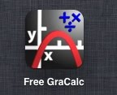
There are many tools that are available to students in a regular math classroom that are very useful like measuring tools and calculators. In a high school setting there may be financial challenges that would prevent students from obtaining a graphing calculator in school or at home. A piece of technology that can be used to give students the tool of a graphing calculator is a free graphing calculator app that can be downloaded onto any smart phone, iPad, or tablet.

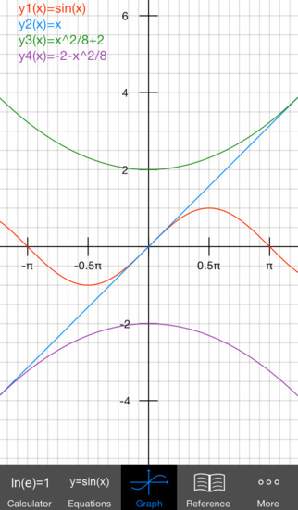
The Free GraCalc app is free graphing calculator app that can be downloaded from any AppStore. It enables the user to input graphing equations, and graphs them for you. On the graph page, the user is able to use their fingers to zoom in and out on the graph, which helps if you’re trying to find intersecting points; for example. The app also has a reference tab which helps support student definitions, laws, and rules for all different types of math. For a video overview of the app and some of the things you can do with it, visit http://1597381.mediaspace.kaltura.com/media/Free+Gracalc/1_wwbda3vs.

Here’s an example of how teachers can use this app to enhance teaching of the Common Core State Standard for Mathematics:
CCSS-Math.8.EE
- Graph proportional relationships, interpreting the unit rate as the slope of the graph. Compare two different proportional relationships represented in different ways. For example, compare a distance-time graph to a distance-time equation to determine which of two moving objects has greater speed.
- Use similar triangles to explain why the slope m is the same between any two distinct points on a non-vertical line in the coordinate plane; derive the equation y = mx for a line through the origin and the equation y = mx + b for a line intercepting the vertical axis at b.
CCSS-Math.8.F
3) Interpret the equation y = mx + b as defining a linear function, whose graph is a straight line; give examples of functions that are not linear. For example, the function A = s2 giving the area of a square as a function of its side length is not linear because its graph contains the points (1,1), (2,4) and (3,9), which are not on a straight line.

The following math activity is one example of how the Free GraCalc can be used to help students find the slope of an equation, and graph that equation. To meet the standard for this activity students must be able to understand the connections between proportional relationships, lines, and linear equations. As well as define, evaluate, and compare functions.

Math Activity:

Each student will be given a worksheet that asks them to work through problems to determine linear functions, slopes of equations, and compare proportional relationships through graphs. Students will be paired into groups of two, one with an iPad containing the app, and one with a pencil and a paper. Together the students will swap back and forth between working their problem in the app and on a piece of paper, compare their answers and work together to get the correct answer, or help explain to each other how the answer was found.

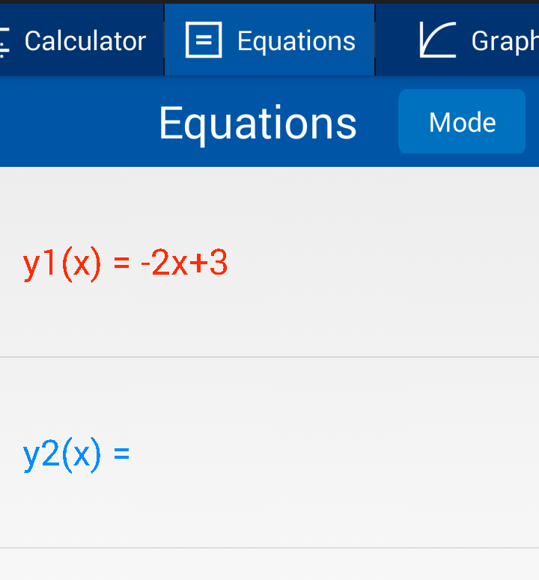
The teacher will begin the activity by pairing up the students, giving one student from each group an iPad with the app on it, and show the students some examples to show them how to use the app. One example the teacher could use would be 3y+6x=9. The teacher could then ask the students to turn the given equation into a y = equation. The students would work together to determine that y = -2x+3. Students will then be asked to graph this equation, students with the iPad will input the equation into the Equations tab, click SAVE to save the equation into the app, and then press the Graph tab to see the graph. Students without the iPad will create a graph on the piece of paper. Then students will compare the app graph with the graph drawn on the piece of paper.

Reasons for using an iPad:

With giving students iPads you sometimes run the risk of them getting off task with wanting to play games or do other things on the iPads, but if the school is the one providing the iPads, faculty members can set passwords so that students can only get into apps that the school has provided for them. Allowing students some time to practice with the Free GraCalc app will likely help students to stay on task and actively participate in the class activity. One reason for letting students use an iPad is because the screen is a nice size to be seen across the classroom, so if students have a question about their graph the teacher can see what they have input into the app and either use their question as a classroom example to get the students involved in a discussion about what the students did and what they could have done. Not only is the Free GraCalc app a great tool to use in classroom activities but it is also a tool students can easily access on their smart phone, iPad, or tablet. This app allows students to have a graphing calculator available to them anywhere to help them complete their math work.

