Solution
- C(k)=0.12k+20
- Complete the table below.
k (kilowatt-hour) | C(k) (dollars)
0 | 20.00
15 | 21.80
35 | 24.20
47 | 25.64
89 | 30.68
125 | 35.00
260 | 51.20

- Sketch a graph of C for 0≤k≤280.
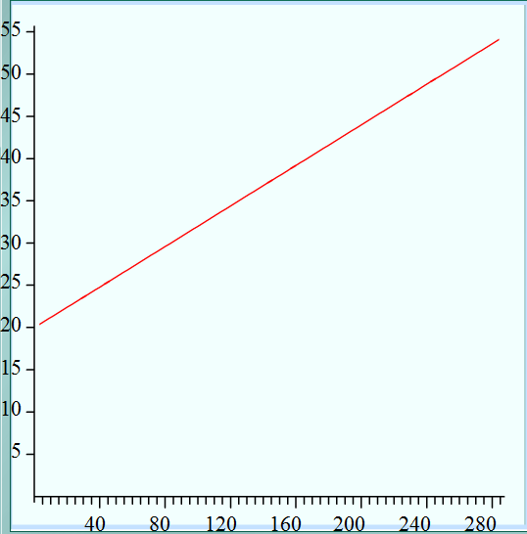
Cost (dollars)
K (kilowatt-hour)

- Domain: The domain is 0≤k≤280. In other words all the inputs of the function.
Range: The range is 20≤C≤53.60. In other words all the outputs of the function.
- C is a function of k because for every kilowatt-hour there is only one cost.

