G-SRT The Ladder

Alignments to Content Standards:
- Alignment: G-SRT.C.8
- HSG: Geometry
- Domain: HSG-SRT: Similarity, Right Triangles, and Trigonometry
- Cluster: Define trigonometric ratios and solve problems involving right triangles
- Standard: Use trigonometric ratios and the Pythagorean Theorem to solve right triangles in applied problems.

Task:

A six-meter-long ladder leans against a building. If the ladder makes an angle of 60° with the ground, how far up the wall does the ladder reach? How far from the wall is the base of the ladder? Round your answers to two decimal places, as needed. Draw a diagram to help find the missing lengths.

Commentary

This task combines two skills, being able to correctly draw a diagram to help visualize a problem and use trigonometric ratios to solve right triangles in applied problems. The problem requires students to at least use one trigonometric ratio, sine or cosine, to find one missing length and use another trigonometric ratio or the Pythagorean Theorem to solve for the other missing length.

To complete this task, students will need to draw an accurate diagram to know which trigonometric ratios to use in order to solve for the unknown sides.

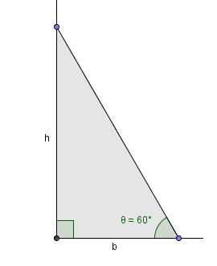
Solution:

6m

To determine how far up the wall the ladder reaches, we must find “h.” To do so, with the information given we need to use the trigonometric ratio of sine because we know the measurement of the hypotenuse and need the opposite measurement of the angle given. So we input the information we know, $\sin{60°=\frac{h}{6}}$ and solve for “h.” We then round the answer to the nearest tenth and find that the ladder reaches 5.2 meters up the wall.

After finding “h” we have two methods to find “b.” The first is using the Pythagorean Theorem to find the third side of the triangle given. We know the length of the hypotenuse and one of the legs so we use the formula $6^{2}={5.2}^{2}+b^{2}$ and solve for “b.” After doing so, we find that the ladder is 3 meters away from the base of the wall. The second method, would be to use the trigonometry ratio of cosine because we know the measurement of the hypotenuse and need the adjacent measurement of the angle given. After inputting the information we know, $\cos{60°=\frac{b}{6}}$ and we solve for “b.” Just like when using the Pythagorean Theorem we find that “b” equals 3 meters.

Regardless of the order in which we solve for the missing lengths we use trigonometric ratios to solve at least one of the sides and then can choose the method we prefer to find the other missing length.

