Illustrative Mathematics
Hybrids and Saving Money
Alignment: HSA-CED.3, HSF-BF.1, HSF-LE.5
Your family wants to buy a new Honda Accord and is considering buying the hybrid version (pictured below) if money saved on gas will be enough to pay the extra cost for the hybrid when making the daily commute. How many years will it take from the amount saved in gas money to pay for the extra cost for the hybrid?
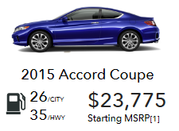
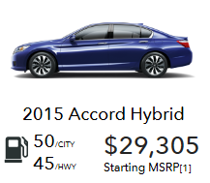

Commentary
This task combines three skills from A-CED.3: represent constraints by equations or inequalities, and by systems of equations and/or inequalities, and interpret solutions as viable or nonviable options in a modeling context. It also requires students to write a function that describes a relationship between two quantities (F-BF.1). Also, requires the students to interpret the parameters in a linear or exponential functions in terms of a context (F-LE.5).
The purpose of this task is for the students to figure out which vehicle would be a better choice with looking at equations and the relationships between miles per gallon and the overall price of the car. This can help prepare the students later on in life when they are trying to save money when car shopping. The students will be able to compare and calculate the amount of money they will have to pay up front and how much they will save in the long run.

In solving the tasks there are assumptions that need to be defined. Such as how many miles will the car be driven each year, what is the car’s miles per gallon, and what does a gallon of gas cost.
Students should begin this problem by focusing on what information they will need. They will need to know:
- The price of the cars
- The distance (in miles) the cars are driven
- The miles per gallon (mpg) each car gets
- The cost of gas

Solution
For systems of equations, the cars’ prices will be the y-intercepts ($29,305 and $23,775). To find how much money needs to be saved in the end to break even, the students subtract the two prices ($29,305-$23,775=$5,530).
Next the students will need to find out the car’s annual gas cost. These will be agreed upon as a class:
- Miles the cars are driven each year: The chart below shows the average miles per driver by age group. In this case the students will be working with the average of all which is in the bottom right cell which is 13,476.
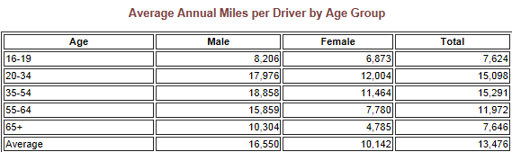

- Miles per gallon: The students will calculate each car’s miles per gallon with being given the percentage of the car’s time being on the freeway and in town. It will be chosen that 50% will be freeway and 50% will be in town. So for the Honda Accord Hybrid, will be calculated as follows: (.5*50(city) + .5*45(hwy)) this equals to 47.5mpg. For the Honda Coupe, (.5*26+.5*35) which equals to 30.5 mpg.

- Price per gallon of gas: as of right now the average gas price in WA State is $3.10. This will be the price used consistently throughout the calculations. Both cars use regular unleaded gas and we will assume the cars have the same maintenance cost.

Now for the calculations:
Take the mpg for each car (47.5 for Honda hybrid and 30.5 for Honda Accord Coupe). Divide 13,476 by the mpg to find the number of gallons the car would use in a year. Then take this number of gallons and multiply it by the cost of the gallons of gas. This will give the yearly cost for each vehicle.
Honda Accord Hybrid: 284 is the number of gallons that would be used each year. The yearly gas cost was calculated to be about $880.4.
Honda Accord Coupe: 442 is the number of gallons the car would use in a year. The yearly gas cost was calculated to be about $1,370.2.
The average yearly savings would be $489.8 if the family chose the Honda Accord Hybrid. To find how long it would take for the amount extra paid for the hybrid to even out in gas expenses: divide the car price difference ($5,530) by the amount of money saved with the hybrid per year ($489.8) which is 11.29 or about 11 years.

