Manufacturing Furniture
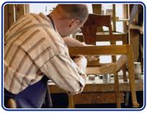
Your furniture company is expanding business! Instead of just selling sofas, you are going to be producing tables and chairs.
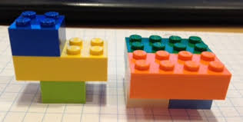
Today we are going to use Legos to represent the materials needed to produce each piece of furniture. Because of budget constraints, your company can only afford to buy a certain amount of materials. You have 12 large Legos and 16 small Legos. To make a table it will take 2 large Legos and 2 small Legos. To make a chair it will take one large Lego and 2 small Legos. The table will make the company a profit of $16 and the chair will make the company a profit of $10.

Find possible combinations for the number of tables and chairs you can make with the given materials. For each combination, calculate the total profit that it would produce.
# of tables | # of chairs | Total profit

Which combination would produce the most profit?

What is a constraint? Were you faced with any while building the furniture?

We often express constraints using inequalities in mathematics. Complete the table below to write the constraints algebraically.
LEGO PIECE | Tables  (Blocks per table “multiplied by” tables) | Chairs  (Blocks per chair “multiplied by” chairs) | Pieces Available
Large
Small

Four constraints (as inequalities):

Graph each of the inequalities, shading appropriate regions.

