Elizabeth Huff
Math 499E
Chapter 5 Learning Progression
This series of lessons is to be taught to the Algebra A class at Ellensburg High School. Algebra A consists of students who are in a slower track for algebra. The Algebra A is equivalent to one semester of Algebra 1. The unit progression is for the lessons in chapter 5 of the Algebra 1 book published by McDougal Littell. The lessons include ones on plotting points on a Cartesian coordinate system, slope, point-slope form, slope-intercept form, graphing equations of lines, and perpendicular and parallel lines. The lesson progression involves some revisiting of previous material because the students need to refresh their math skills constantly. These students need hands on activities to keep from getting off task. Also, the structure of the Algebra A class allows for more time to be spent on certain content or revisiting common misconceptions. The students need a more stimulating environment, so the lessons are structured to be hands on in addition to the work done in the book. The focus of chapter 5 is to introduce the students to graphing equations and learning about the different ways to graph an equation with various unknowns. The lessons done out of the course textbook are meant to gauge how to students are picking up the material being taught. The lessons involve the students taking down notes on new content, example problems, and completing homework problems assigned from the textbook that align with the Common Core State Standards. The purpose of this learning progression is to give the students a variety of examples, book work, and activities to practice the material in chapter 5. The benchmark assessment will involve a quiz on the Cartesian coordinate system, plotting points, and graphing equations using point-slope form and slope-intercept form. After the quiz the students will revisit point-slope form and slope-intercept form before moving on to parallel and perpendicular lines. The unit progression will end with a review before the assessment for the chapter, which will be a cumulative exam over the chapter 5 material.

Fox Worksheet:
The first lesson in the learning progression teaches the students about the Cartesian coordinate system. The students will take notes for reference when completing their homework and activity. The teacher will instruct on the quadrants of the coordinate system as well as give examples of points that lie in each section. For example, the teacher will give 4 points such as (2,3), (-1,5), (6, -4), and (-2,-5), and the students will name the quadrants in which these points fall and then graph them on a coordinate system. The students will learn how to make and label a coordinate system as well as how to plot points. The teacher will show the students how to connect two sets of points with a ruler. Once the notes are given to the students they will begin working on the plotting points worksheet.
Assessment:
In this worksheet the students will each get a ruler and begin with the first set of points. When the directions say to stop the students will end the connection and start a new set of points. This worksheet helps students learn how to plot points on a coordinate system by repetition. For homework the students will have the task of creating their own design and answer key with no more than 50 points. The students will then exchange their designs with another student for homework the next day. The students will be assessed on their ability to complete the picture on the Fox worksheet with all of the correct points. Obtaining the correct picture will show the teacher that the students have achieved the learning objective. Having the ability of creating their own picture by plotting point will allow the students work backwards. Instead of having the points then plotting them they will have the point that lies on the graph and then discover its location from there. Doing this will solidify their content knowledge on plotting points on a coordinate system. The Fox worksheet will help the students prepare for the next lesson in graphing equations of lines.
The Common Core State Standard for this lesson is:
CCSS.MATH.CONTENT.7.RP.A.2.D
Explain what a point (x, y) on the graph of a proportional relationship means in terms of the situation, with special attention to the points (0, 0) and (1, r) where r is the unit rate.
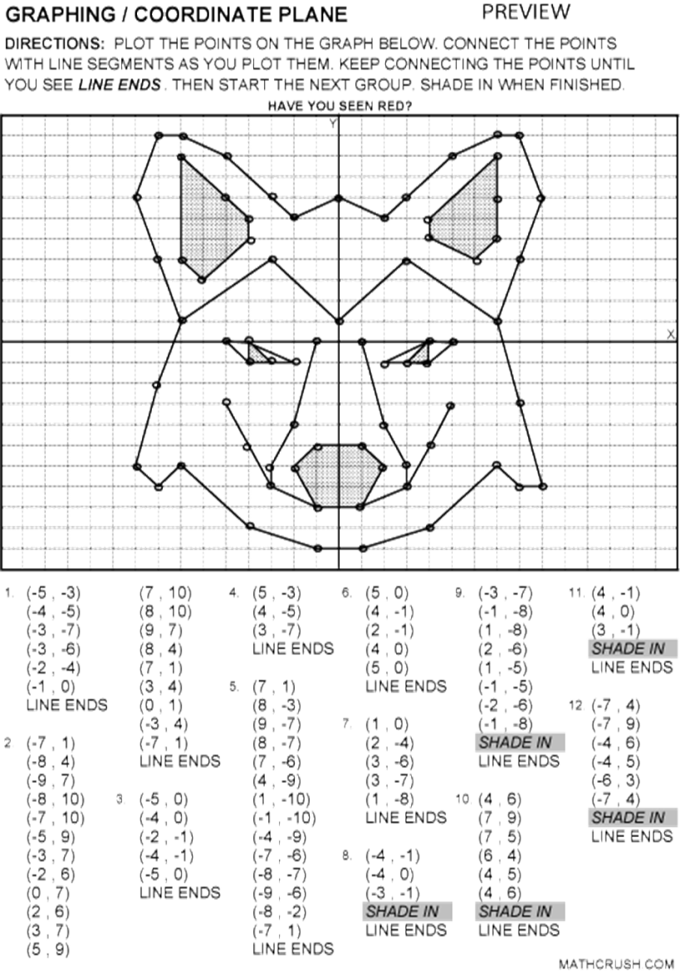

Slope Worksheet:
The next lesson will involve the students finding the slope of two points that are given to them. The class will take notes on the formula m = (y2-y1)/(x2-x1). The teacher will show an example of finding slope using two given points. For example, if the points were (1, 6) and (3,8) the slope would be (8-6)/(3-1) =1. The teacher will introduce the concept of rise over run to the students. The teacher will demonstrate how to start by plotting points and counting from left to right to find the slope of a given line. They will practice plugging in points to find slope and then graphing the line with that slope through the two given points. The students will be given different problems aligning with the Common Core State Standard. To evaluate slope they will use the slope formula, plot two points on a graph and use rise over run to find the slope, and be given slope and two points and be asked to find an missing coordinate variable. For example, given m = 2 and (x, 2), (5, 6), the students will be asked to find x.
Assessment:

The activity will include two worksheets for finding slope. One uses the formula m = (y2-y1)/(x2-x1) and the other worksheets asks the students to find a missing coordinate given the slope. The students will get practice using the slope formula as well as working on their skills on division and reducing fractions. The purpose of this assessment is to introduce the meaning of slope to the students given them practice finding it in given different variables. In this chapter the students are expected to be able to using different formulas to solve and graph linear equations. On this worksheet the students are working to find slope which is essential for graphing an equation of a line. Doing this allows the students to find slope using a variety of different techniques. They are able to find it pictorially by determining rise over run and numerically by using the formula m = (y2-y1)/(x2-x1).
The Common Core State Standard for this lesson is:

CCSS.MATH.CONTENT.8.EE.B.5
Graph proportional relationships, interpreting the unit rate as the slope of the graph. Compare two different proportional relationships represented in different ways. For example, compare a distance-time graph to a distance-time equation to determine which of two moving objects has greater speed.

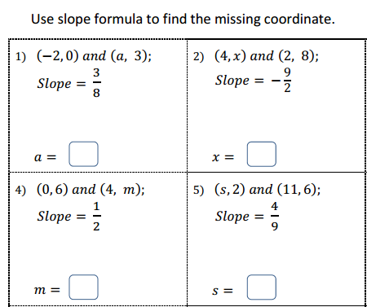

Slope-Intercept Form:
Students will take notes on slope-intercept form y=mx+b. The teacher will give example problems on how to simplify the equation with a variety of given variables. The students will graph these equations on a coordinate system. For example, the students will be asked to find and graph the equation for the line with a slope m= -1/2 and y-intercept of 5. After the students take notes they will work on a problem set from the book on point-slope form and slope-intercept form. Doing this exercises will give the students the chance to practice both ways of graphing equations and to choose which form is the best to use. After, these lesson the students will be given a benchmark assessment on graphing equations of lines. This assessment is necessary because following lessons build off of the core concepts of graphing. If the students struggle to understand slope-intercept and point-slope form then they will struggle with it on the exam if the material is not reviewed. The teacher will use this assessment as a tool to gage if graphing needed to be retaught, and if so what sections.

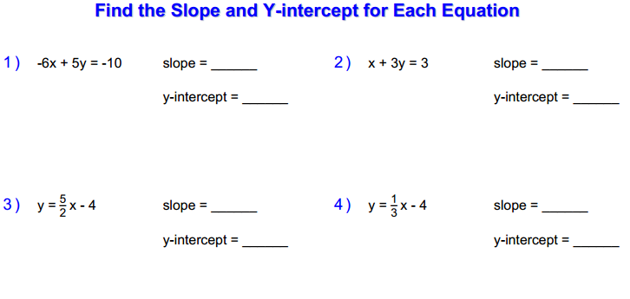

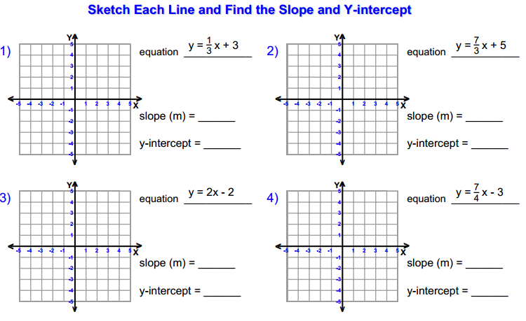

Point- Slope Form:
Students will take notes on point-slope form, y-y1=m(x-x1) similar to those in the book. The teacher will give example problems on how to simplify the equation with a variety of given variables. Then the students will graph the equation on a coordinate system. For example, the students will be asked to graph the equation given the slope m= 4 through the point (2,2). The teacher will demonstrate how to set up the equation as y-2=4(x-2). Then the teacher will show the students how to put the equation in function form to graph. The students can either graph the equation using function form or plotting the Cartesian coordinate and then applying the slope to that point to make a line. After the students take notes they will work on a problem set from the book on point slope form.
Assessment:
The purpose of this lesson is for students to learn various ways to solve and graph equations of lines given different parts of equations. They will be equipped with multiple tools when asked to graph and solve linear equations. In this assessment students will only work with point slope form to commit it to memory. The reason why it segregated from the other methods is because when the students are presented with it on an exam they will have gotten practice just using this formula. The students will have repeatedly solved and graphed linear equations and are now able to depict what formula to use based on the question’s content. For example, on a quiz the students will be asked to find the equation of the line and then graph. The students will know to use point slope form when they are given a point, (1,0) and slope, m= -2. If the students are able to do this then they have reached the learning objective and passed the assessment.

The Common Core State Standard for this lesson is:

CCSS.MATH.CONTENT.8.EE.C.8.C
Solve real-world and mathematical problems leading to two linear equations in two variables. For example, given coordinates for two pairs of points, determine whether the line through the first pair of points intersects the line through the second pair.

Parallel and Perpendicular lines:

Lesson Title: Slope of Perpendicular and Parallel Lines in Geogebra
Unit Title: Slope of Linear Equations
Teacher Candidate: Elizabeth Huff
Subject, Grade Level, and Date: Algebra 1, 9th Grade, 1/21/2015

Placement of Lesson in Sequence
This is the lesson after the students learn about slope and graphing linear equations. The students have just learned how to find slope by counting out the units for rise over run and using the y-intercept. They know how to get an equation into function form y=mx+b. In the previous lesson, the students learned how to pick out the slope as m and the y-intercept is b, and then graph using that information.
Central Focus and Essential Questions
In this activity the students will be able to practice plotting more y-intercepts and slope and then find out if the slopes of two equations are perpendicular, parallel, or neither. The students will use the online technology Geogebra to further their understanding of perpendicular and parallel lines. The central focus of the lesson is to have the students get more practice in manipulating equations into slope-intercept form, and with that learning about the properties of lines. The students will work together to determine whether two lines are perpendicular or parallel by graphing their lines in Geogebra.
Content Standards
- Develop definitions of rotations, reflections, and translations in terms of angles, circles, perpendicular lines, parallel lines, and line segments.
- Students use linear equations and systems of linear equations to represent, analyze, and solve a variety of problems. Students recognize equations for proportions (y/x = m or y = mx) as special linear equations (y = mx + b), understanding that the constant of proportionality (m) is the slope, and the graphs are lines through the origin.
Learning Outcomes | Assessment
The students will need to be able to apply their knowledge of using the slope-intercept form to graph an equation of a line. They will learn the definition of perpendicular and parallel lines and graph them on a single coordinate plane. Students will use the online program Geogebra to model their understanding of slopes of a system of linear equations. | The formative assessment will be assessed using the Geogebra program and the worksheet that accompanies the activity. The teacher will move around the classroom to check on the pairs of students to confirm that they understand the properties of perpendicular and parallel lines. The teacher will ask inquiring questions about how they know if lines are parallel or perpendicular and ask the students to justify their answers. Students will do work in pairs, each taking turns controlling the Geogebra program to get practice using the technology. Each student will have their own worksheet to turn in with their own justifications. During the last few minutes of class the students will turn in an exit slip that asks them to create their own system of equations. They will need to create a set of perpendicular lines and a set of parallel lines. The students creating their own equation shows that they are able to put their knowledge of linear equations together rather than just looking at something already in front of them. The exit slip will determine if the students are ready to move on to the next section of the chapter.

Learning Targets | Student Voice
I can find the slope and y-intercept of a linear equation. I can use technology to graph a linear equation using slope and a y-intercept. I know what parallel and perpendicular lines are. I can create my own equations for parallel and perpendicular lines. | The teachers will state the learning target on the classroom’s white board. Students will confirm that they have met the learning target by having their Geogebra graphs checked off by the teacher and printed; their worksheets will turned in to be graded also. When the teacher comes around to check on the pairs, they will ask facilitating questions to give the students the chance to use student voice. The students should be able to explain their reasoning for how they know if lines are parallel or perpendicular. The worksheet will give the students the opportunity to justify their reasoning of whether they think what kinds of lines they are graphing. This gives them the chance to use mathematical syntax.

Prior Content Knowledge and Pre-Assessment
The students have worked on graphing slope and y-intercepts by hand in the previous lesson. They know the slope-intercept form for linear equations as y=mx+b. They know that the slope is m and the y-intercept is b. In the introduction of this lesson, the students will get the chance to learn how to graph linear equations in Geogebra. The linear equations will be in slope-intercept form to assess their knowledge of the previous content.
Academic Language Demands
Vocabulary & Symbols | Language Functions | Precision, Syntax & Discourse
- Slope  - Y-Intercept  - Parallel  - Perpendicular  - Coordinate Plane  - Linear | - Be able to explain verbally how they know a system of equations is parallel  - Be able to explain verbally how they know a system of equations is perpendicular  - Justify by writing reasoning using correct mathematical syntax | Mathematical Precision: Students must be able to correctly apply their mathematical knowledge. Students will first get the linear equations into function form and then find the slope and y-intercept. The students will make sure to plot the points correctly on the coordinate plane in Geogebra. The system of linear equations is graphed on one coordinate plane.  Syntax: Students must be able to use the correct mathematical terminology in their verbal and writing explanations. Discover the definitions of perpendicular and parallel and relate them to a graph.  Discourse: Discuss what each pair found out about each system of equations. Explain their reasoning of why they think that the lines are parallel, perpendicular, or neither.

Language Target | Language Support | Assessment of Language Target
I can justify why two lines are parallel, perpendicular, or neither. | I can share my why I think two lines are parallel, perpendicular, or neither. I can explain the difference in the slope of parallel lines and perpendicular lines. | I can explain how I know two lines are parallel, perpendicular, or neither by telling the teacher and my partner and writing it on the worksheet.

Lesson Rationale (Connection to previous instruction and Objective Standards)
In the previous lesson the students were introduced to the slope-intercept form, y=mx+b. Since the next units in the book rely heavily on graphing linear equations, a good knowledge base is needed. The students in Algebra A are low achieving in mathematics, so they need more time working on certain topics. Using Geogebra will give the students the chance to do something different in class besides just taking notes and doing homework. Working on the computers will keep them from being bored. The students will be able to add to their previous knowledge of slope by learning about parallel and perpendicular lines. Graphing linear equations on a computer will make the graphing process faster and they will solidify their concept knowledge by getting to do more problems.
Differentiation, Cultural Responsiveness and/or Accommodation for Individual Differences
The lesson is for the Algebra A class. Algebra A is constructed at a slower pace to give low achieving students the chance to better learn math concepts. One year of Algebra 1 is spread out over two years in Algebra A and B for these students. The students have the opportunity to spend more time on certain concepts. The students need to be reminded of definitions and core concepts constantly. The students gravitate to working on homework in pairs, so when working on the computer, they will also work in a pair. Directions need to be explicit and written on the board. Students get distracted easily and it will help the teacher to not have to keep repeating the activity’s directions. To keep the students on task the teacher needs to visit each pair of students to make sure they are working on the appropriate assignment. The parent of one of the students has asked for more individual attention because they have a hard time focusing. So, to help this student, it would be beneficial for them to sit at the front of the room.
Materials – Instructional and Technological Needs (attach worksheets used)
For this lesson, the teacher must have access to a computer lab. There must be enough computers for each pair of students. The computers must have the mathematical program, Geogebra, installed on them. The computer lab needs to have access to a printer. Each student needs a worksheet and a pencil.
Teaching & Instructional Activities
Time | Teacher Activity | Student Activity | Purpose
10 Mins | Entry Task | The students will work individually to solve these problems by finding the slope and y-intercept. The teacher will then show the students how to graph the equation using the slope and y-intercept using Geogebra. The students will work along with the teacher on graphing the line in Geogebra.  - y= 2x + 4  - 4x – 3 = 2y | To review previous material.  The teacher will go over each problem and explain the steps on how to do each problem after asking if the students know the steps and answers. The teacher also will have the students follow along in Geogebra, learning how to plot points and connecting them with line tools.
5 Mins | Directions to activity and getting into groups | The students will move into pairs while the teacher passes out one worksheet per student. The teacher will explain the activity to the students and have them print out all of their Geogebra constructions to turn in. Each student must work with a partner, but have their own worksheet and justifications to turn in. | To prepare for the activity and explain what the groups will be doing.
20 Mins | Geogebra Activity:  Perpendicular and parallel lines worksheet | Students will work in Geogebra to complete the worksheet while the teacher moves around the room to facilitate groups.  Part 1:  - 2x + 2y = 8  y = -x +4  Slope: -1  y-intercept: 4  - -3y = 6 – 12x  y = -2 + 4x  Slope: 4  y-intercept: -2  - 2/3x = y – 5  y = 2/3x + 5  slope: 2/3  y-intercept: 5  Part 2:  - 4y = 2x + 4  -1/2x = 3 – y  Parallel: The slopes of the two lines are the same.  - 3y -1 = -12x  1/4x –y = 2  Perpendicular: One slope is the negative reciprocal of the other slope. The graph shows that the lines intersect at a 90 degree angle.  - 5x + 3y + 7 = 0  -x + 6 = y  Neither. The slopes cannot be compared and do not have the properties of perpendicular or parallel lines. | To practice graphing linear equations and determining whether two lines are parallel, perpendicular, or neither. They also get more practice using Geogebra.  The teacher must move around the room to facilitate groups while they use Geogebra. With the students the teacher will ask the students what they have found out about the pairs of lines. This is to get them to explain their process and what they know about the properties of parallel and perpendicular lines. They must relate the numeric equations and the graphic representation to make connections.
5 Mins | Exit Slips | The students will be asked to create their own pairs of perpendicular and parallel lines on their own sheet of paper. | The students will work individually on the exit slips, which will not be graded. The purpose is to see how many students know how what the properties of parallel and perpendicular lines. The teacher will be able to know if the students have achieved the learning objective fully.

Perpendicular and Parallel Lines
Put the equation into function form and graph the linear equation by finding the slope and y-intercept. After you graph by hand, graph the equation using Geogebra.
- 2x + 2y = 8

- -3y = 6 – 12

- 2/3x = y – 5

Graph the linear equations on the same coordinate system using Geogebra. Are the lines perpendicular, parallel or neither? Justify your answer.
- 4y = 2x + 4
-1/2x = 3 – y

- 3y -1 = -12x
1/4x –y = 2

- 5x + 3y + 7 = 0
-x + 6 = y

Perpendicular and Parallel Lines
Put the equation into function form and graph the linear equation by finding the slope and y-intercept. After you graph by hand, graph the equation using Geogebra.
- 2x + 2y = 8
y = -x +4
Slope: -1
y-intercept: 4

- -3y = 6 – 12x
y = -2 + 4x
Slope: 4
y-intercept: -2

- 2/3x = y – 5
y = 2/3x + 5
slope: 2/3
y-intercept: 5

Graph the linear equations on the same coordinate system using Geogebra. Are the lines perpendicular, parallel or neither? Justify your answer.
- 4y = 2x + 4
-1/2x = 3 – y
Parallel: The slopes of the two lines are the same.

- 3y -1 = -12x
1/4x –y = 2
Perpendicular: One slope is the negative reciprocal of the other slope. The graph shows that the lines intersect at a 90 degree angle.

- 5x + 3y + 7 = 0
-x + 6 = y
Neither. The slopes cannot be compared and do not have the properties of perpendicular or parallel lines.

*For the student to have met the learning objective they must be participating in the Geogebra activity and completed the worksheet. The student will receive a grade for their worksheet based on the answer key above and a completion grade for their exit slip that is turned in at the end of class.

Formative Assessment:

The formative assessments will come in a variety of formats. The students will be formally assessed through homework assignments. The students will be given homework at the end of each lesson to given them time to practice new material. The students will turn in the homework to be graded. If the students do poorly on their homework grade then they are able to correct their mistakes and turn it back in for points before the chapter exam. There will also be a quiz given to the students to show the teacher if they need more review or are ready to move on to the next lesson. The students are also able to retake the quiz if they do not pass. If there are common misconceptions they will be apparent when the students take the quiz. Common misconceptions will be revisited before moving on to the next lesson. This learning progression building upon itself and if there is something that the students are just not understanding then they have no reaching the CCSS learning objective. Worksheets are necessary for every student as well as a computer for every pair of students. The formative assessments are the homework assignments and worksheets, which will be given out every night. The students have an opportunity to show what they have learned every day in class and then the teacher will assess their work. The students must achieve at least a 70% on the assessments to show that they have met the learning objective. For the students in Algebra A most of the activities and assignments need to be hands on to prevent distractions. These students tend to learn best when the lesson requires active participation. For the Geogebra activity the students will be placed in pairs to prevent distractions. Also, pairing the students will help the ELL students and those students who may not know a lot about computers. The students with IEPs or behavioral problems will be seated near the front of the room that way the teacher is easily accessible.

