Algebra A: linear Equations and Graphing
Overview
This learning progression is for an Algebra A class at Ellensburg High School. Algebra A is for students who struggle in middle school math and have failed algebra before. This class goes half the speed of a regular freshman algebra class and goes two years instead of one. This gives students extra time to learn the important ideas and skills needed to succeed in mathematics. The material used for the curriculum at Ellensburg High School is the algebra 1 textbook. (Algebra 1. McDougal Litell Inc., published in 2001) The Common Core State Standard clusters that this learning progression deals with is CCSS.MATH CONTENT.8.F.A.1-A.3 and CCSS.MATH CONTENT.8.F.B.4-B.5. These standards in Algebra address:
- Understanding functions and the graphs of functions in terms of its inputs and outputs. Also comparing properties of two functions that are represented in different ways (algebraically, graphically, numerically in tables, or by verbal descriptions).
- Interpreting the equation y=mx+b and being able to identify the slope and y-intercept. Also manipulating equations so they are in standard from and being able to graph the equation using the slope and y-intercept or finding ordered pairs.
- Interpreting different graphs and being able to generalize what each element of that particular graph means. Also describing the relationship between two quantities by analyzing a graph (where the function is increasing or decreasing, linear or nonlinear).
Linear equations and graphs are the basics to all of algebra and will be referred to again and again. So it is important for students to be able to understand and interpret different graphs in order to understand most concepts in algebra and higher mathematics. By introducing functions, fist it gives students an idea of what the concepts of a function and linear are. This is important to understand that a linear equation is some sort of a straight line. From there students will learn about the structure of a linear graph and what a linear equation is in standard from. By building this knowledge students will be ready to graph and interpret more complex equations, linear and nonlinear. After that students will find different relationships with linear equations and graphs and be able to generalize about all linear equations and graphs. All of this will help students move slowly through these crucial ideas and concepts so they will have a solid base moving forward in mathematics.
Defining a Function
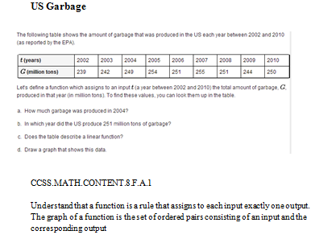
The function is the basis of all of algebra and many students have a hard time describing what a function is. This is why it is important to extensively teach students about functions and their characteristics. For an introduction to functions, students will be dealing with linear equations and identifying them as functions or non-functions. Students will be able to correctly identify functions (equations, graphs, and tables).
The basics of a linear function are that each input has exactly one output. That means for each x value, the equation has exactly one y value that corresponds to it. For the problem to the right, US Garbage, students must identify key relationships in the table in order to answer the questions. This question satisfies 8.F.A.1 because students must demonstrate that they are able to read and interpret a table of values. Students also demonstrate that they know how to identify and graph a function by looking at the table of values. This problem is a good assessment for common core standard 8.F.A.1 because it will test their ability to read a table of values and interpret the meaning of a function. The students will also be able to draw a graph of the function to get a better idea of what a function is. The graph will help the struggling students visualize what a function is and show them a different representation. This problem will test students and prepare them to proceed onto the next standard.
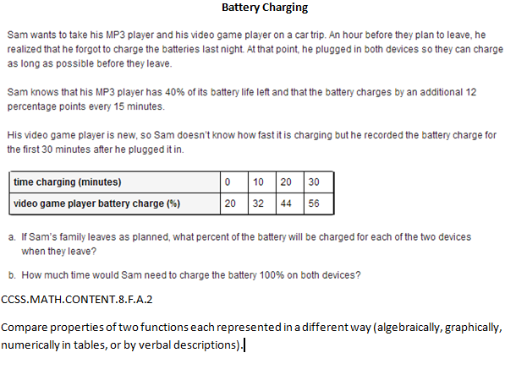
Another part of functions is comparing properties of two functions that are represented in different ways. For example you could have an equation that is represented algebraically and compare that with a graph. This helps students understand all aspects of the function and its characteristics better. After comparing the different functions students will come to a conclusion about the differences. For example, given a linear function represented by a table of values and a linear function represented by an algebraic expression, determine which function has the greater rate of change. All of this addresses 8.F.A.2. and will be assessed with the problem to the right, Battery Charging. In this problem students will be using CCSS.MATH.PRACTICE.MP4 modeling with mathematics, where students solve mathematical problems and problem solve about real world situations. Students will identify a pattern in the chart to find the missing numbers. To do this students must identify the linear relationship between the charging time and the battery charge percentage. They will also have to compare the two different devices and their charging rates which will satisfy 8.F.A.2. This problem will show me that my students know how to read a table of values and compare the two properties to find the answers. By doing this problem students have shown that they have satisfied 8.F.A.2.
Solving and Graphing Linear Functions
Once students have met standards 8.F.A.1 and 8.F.A.2 they have shown that they know what functions are and are ready to move onto linear equations. This is the next section that students will learn because they now know why linear equations are functions. Students will now learn about the characteristics of linear equations, how to solve and put a linear equation in function form, and how to graph a linear equation. First, a linear equation is when the x value has the power of one. A linear equation produces a straight line and produces a function. A linear equation in function form is in the form y=mx+b, where m is the slope of the graph and b is the y-intercept. Function form is the easiest way to graph the equation. When graphing a linear equation the line goes through b (the y-intercept) and has the slope of m (rise/run). Knowing how to manipulate and graph a linear equation is essential for success in algebra and in future mathematics.
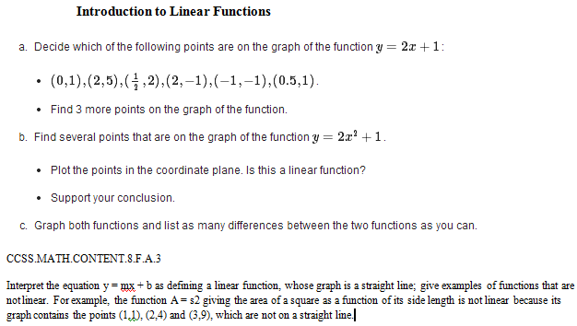
To ensure that my students understand linear equations and how to graph them, they will be assessed based upon the problem to the right. This problem has three parts about linear equations. Part a. is about determining which ordered pairs go with the function y=2x+1. This shows that students understand how the linear equation works and know how to find values that satisfy the equation. By plugging in the values for x and y, the students will show that they know what an ordered pair is and its relationship to an equation. Part b asks students about the equation y=2x^2+1. Students must identify ordered pairs that satisfy the equation and identify if the equation is a function or not. This shows that students still know what a function is, how to identify it, and how to plot points of an equation that is not linear. This problem will test my student’s ability to apply their knowledge to something that they are not familiar with. This is good for the students that like to go through the motions but don’t fully understand the material. This part will test the ability of my students to adapt. Finally, part c is about comparing the two different equations and graphs. This shows that my students know how to look ahead and make logical mathematical observations about something that they might not understand. For this problem students will use mathematical practices MP3 and MP5 about comparing two different mathematical ideas/ making observations about them and using the correct tools and strategies to graph the two equations on the same graph. These mathematical practices will help develop their skills in linear equations and help them meet standards 8.F.A.1 and 8.F.A.2.
Modeling and Understanding Linear Equations and Relationships
In this section students will be able to make a function that models a graph, describe the relationship between a graph and its equation, and analyze the differences between different graphs and identify its characteristics. This is important for students to generalize about a subject because then it shows that they know it and can apply it to anything about that subject. For linear equations it is important that students can make the connection between the slope and y-intercept and what the graph looks like. If students are able to do this then they can generalize about all linear equations and have met standards 8.F.B.4 and 8.F.B.5. To meet these standards students will use MP1 about making sense of problems and persevere in solving them. To learn this I will be conducting a lesson involving modeling different lines and what happens when the slope changes using Geogebra. This will give students an idea of the relationship between the slope of the line and the way the graph looks. Students will then do a worksheet that asks generalization questions about the attributes of a graph and what it looks like. This lesson will be good for my students because I can demonstrate what the slope looks like as lines physically change using the program Geogebra. This is helpful for struggling students so they will be able to visualize what is happening to the slope as the line changes.
To assess common core standard 8.F.B.4. students will complete the problem to the right, Downhill. This problem is about finding the slope and intercepts of the given equation and what it means in the context of the moving car. This is good for students to write about their answers in terms of the subject in the problem because it helps students generalize and understand what the answers really mean. Also my students generally struggle with story problems so this problem will challenge them. This problem assesses standard 8.F.B.4 because students will have to interpret the slope and initial value of the linear function in terms of the situation, in this case the car. By doing this students will have demonstrated that they can interpret what a linear equation is telling them and find the solution to a real life problem.
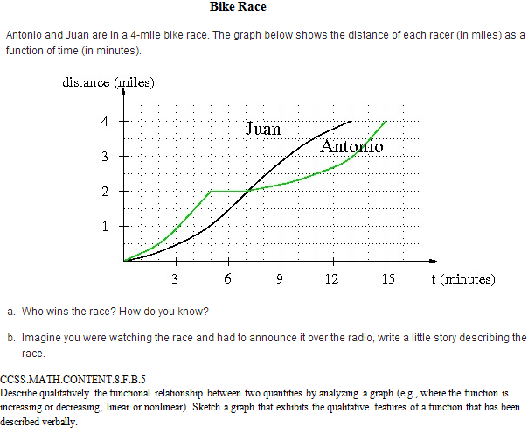
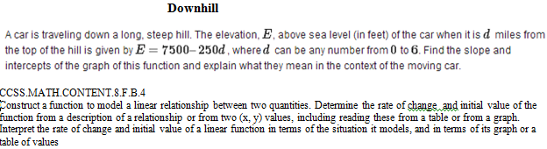
To assess common core standard 8.F.B.5 students will do the problem to the right, Bike Race. This problem asks students to analyze the graph provided and asks questions about the graph. The first question students have to figure out who won the race and how they know. This is a good question because it tests my student’s ability to read a graph and understand what the graph is saying. They will have to know that Juan won because he finished in fewer minutes than Antonio. The second question asks students to write a short story describing the race. This problem is a great for my students because it steps away from the number aspect of math and asks them to generalize what happens in the race. When students describe what is happening in words they have shown you that they know what the graph is telling them. This problem addresses standard 8.F.B.5 because it has students compare and describe two quantities by analyzing the graph. By writing the shot story students are analyzing the graph and putting it into their own words. This problem is good because it will challenge my students and put them out of their comfort zone when writing a narrative describing the graph.

