Learning Progression Formative Assessment

Complete this worksheet to show your planning and the thinking behind your learning progression. This activity is intended to help you organize your learning progression and reveal information that your instructor can use to support your learning progression writing. Prompts 1-3 must be completed by Jan. 21 and prompts 5-6 must be completed by Jan. 28.

- Identify a math textbook and grade level for your learning progression

[ We currently do not have a textbook for this class, high school geometry (11th grade primarily) ]

- Identify the CCSS Math domain and cluster for your learning progression

[ Define trigonometric ratios and solve problems involving right triangles

CCSS.MATH.CONTENT.HSG.SRT.C.6. Understand that by similarity, side ratios in right triangles are properties of the angles in the triangle, leading to definitions of trigonometric ratios for acute angles.

CCSS.MATH.CONTENT.HSG.SRT.C7. Explain and use the relationship between the sine and cosine of complimentary angles.

Understand and apply theorems about circles

CCSS.MATH.CONTENT.HSG.C.A.2. Identify and describe relationships among inscribed angles, radii, and chords. Include the relationship between central, inscribed, and circumscribed angles; inscribed angles on a diameter are right angles’ the radius of a circle is perpendicular to the tangent where the radius intersects the circle. ]

- Use the CCSS Math resources (Standards, Published Learning Progression, math textbook, and web) to write an outline of math activities and benchmark assessments for each CCSS Math in the CCSS Math cluster.

[ For the first core standard, students were given a lesson about circles, and their parts (chords, radius, diameter, arcs/arc angles, circumference, and area) and the associated equations, when applicable. {Worksheet attached}
Then, as a way to introduce the Unit Circle and trig identities, the students were taken back to Pythagorean Theorem review at which time they were introduced to what sine, cosine, and tangent are and how they relate to right triangles (S$\frac{O}{H}$ C$\frac{A}{H}$ T$\frac{O}{A}$ ). {Work packet attached}
Next, students will work with the Unit Circle to see how it relates to triangles and the trig identities described above. This will also allow the students to be introduced to complimentary angles and how that relates to the trigonometric properties from before.

As for a formative assessment, we plan on doing a project for the semester that will tie in the lessons mentioned above and see how these techniques can be applied to life outside of a worksheet for school. ]
- Write the learning progression narrative in the same format as the Published Learning Progression: The narrative is an explanation about how the conceptual understanding, procedural fluency, and math reasoning aspects of the CCSS Math will be taught in a connected way using math activities, leading questions, and benchmark assessments. The explanation should explain the purpose of the activities and how the benchmark assessment will be used in the progression of activities. Similar to the Published Learning Progression, your learning progression should have the narrative on the left –hand side and details about the math activities, benchmark assessments, and CCSS Math on the right-hand side.

- Identify one activity in your progress and write a lesson plan for implementing that activity.

[ *attached below* ]
- Steps for planning a formative assessment process in your lesson plan:
  - Select a formative assessment technique.

[ For this particular group of students, the best form of assessment found has been projects where the students are able to visually demonstrate their understanding of the material. ]

  - How will the formative assessment technique be used to support student learning of the CCSS Math?

[ Having students who are so used to passively learning and being passed through school feeling as though no one cares whether they pass or fail gives the students an opportunity to show not only the teachers but themselves what they have really learned. So many of these students are kinesthetic learners, but have seldom been given the chance to really express this, for whatever reason. Allowing the students this seemingly rare opportunity can often restore their interest and engagement in learning because they make the connection between participating in class and getting to do a fun, hands-on project rather than just another worksheet or test. ]

  - How will the formative assessment technique be implemented? (How will students be introduced to the technique and what materials are needed?)

[ At the end of this learning progression, there will be a review of the unit to clarify any final misconceptions and questions. Each lesson will have an individual quiz that will help students’ understanding of triangles, circles, and trigonometric functions.
The materials needed for this project will vary depending on each student’s (or in cases of larger classes, each group’s) visual adaptation of the unit circle. Most projects will require basic craft supplies (glue, colored paper, pens, pencils, scissors, etc.) and others may include large posters or backgrounds. All students will need to incorporate a circle in their project labeled as the unit circle. ]

  - What adjustments will be needed for special populations of students?

[ For larger groups of students the students will be broken into groups, and each group will be given the same guidelines and criteria for the project. ]

  - How will the formative assessment data be analyzed to support student learning and guide instruction?

[ This project will help to show students the various ways the unit circle can be applied to life. The data will be analyzed to help us see where the students are in their understanding of the unit circle, and the associated measurements, both in degrees and radians. ]
Excel Alternative High School, Geometry

Introduction

High school geometry is an integral mathematics course for all students, whether they wish to pursue a mathematically inclined profession or not. Geometry class is where all the seemingly random parts of math start to come together in a way that is more visually tangible to a lot of students. For example, our students were just recently introduced to trigonometry and the associated trigonometric functions i.e. sine, cosine, and tangent, as well as their inverses. From there, we will begin a lesson with the unit circle, and how the students’ new knowledge of trigonometric identities is used as the basis of the unit circle. And with this comes the introduction to Pi ($π≈$3.14…) as more than just some bizarre symbol, which is actually a never-ending useless number that crazy math teachers get so excited about on March 14th every year. It has meaning, and a purpose, and is suddenly being applied to the triangles the students just spent the last quarter mastering. In Geometry, a circle is no longer just something that is nearly impossible to draw well on a piece of paper. It’s this old idea that suddenly takes on a new identity as something that has meaning and is actually outwardly useful now. You get this “unit circle” thing and draw triangles in it, and then all at once you have trig functions, angle measurements, Pi, and arc lengths all wrapped up in this one circle. In a single unit, everything from the last two to three years of math classes comes together. There are few other classes at this level that combine so many previous classes with the introduction of a unit. This lesson brings purpose and reason to almost everything these students have been passively listening to and getting worksheets about for years.
Though the Common Core State Standards (CCSS) Math have trigonometric functions in a separate unit from Geometry, many of our students have not been in a traditional school setting in a number of years, if at all, and can greatly benefit from the review of this material. We do not currently have a textbook or a curriculum from which to follow for our lessons, so we are using the CCSS as our guidelines for now. We chose to do the lessons out of order of how CCSS has them. We decided to give the circles lesson first to give the students a visual understanding of what the trig functions will mean and how they apply to circles. Next we introduced trigonometric functions, which we will then use to apply to the unit circle.
(Find arc lengths and areas of sectors of circles: CCSS.MATH.CONTENT.HSG.C.B.5)
(Define trigonometric ratios and solve problems involving right triangles: CCSS.MATH.CONTENT.HSG.SRT.C.6; CCSS.MATH.CONTENT.HSG.SRT.C.7.)

This learning progression and associated lessons were created for alternative high school students who have had little to no experience in a traditional school setting, so their abilities vary widely from almost no mathematical background and basic understanding to knowing and enjoying the material more than they want to let on in front of their friends and peers. The lessons will show students’ understanding of how to find arc lengths; angle measure; sine, cosine and tangent given side lengths; find the missing side given an angle and a side; determine which trig function to use to find an angle measure; and basic angles (in degrees and radians) of the unit circle. Given the students’ varied learning abilities and styles, these lessons will help reach all the students with use of different visuals as well as individual work and hands-on lessons including work at the whiteboards, worksheets, GeoGebra application on the computer, and later a group poster and presentation. Many of these students want to succeed and understand the material, but choose to put up a façade for their peers that, unfortunately, negatively interfere with their learning, especially in math. For these students, it is important to have group work so they have to speak up and participate in order to get all points for the day, that way they can act as though it’s the force of the teacher that compelled them to answer questions, rather than the student wanting to complete work such as on an independent worksheet. For the quieter students, the worksheets are better because they are able to focus on the work and getting the assignment done for that day’s participation grade.
Circles
HSG.C.A.2: Identify and describe relationships among inscribed angles, radii, and chords.

Find the missing measurements using the given measurement.

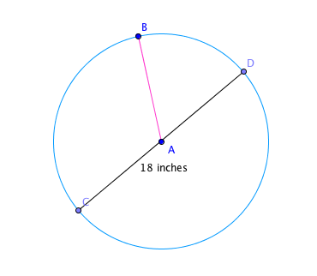
Radius: ___________________
Diameter: 18 inches
Circumference: ___________________
Area: ___________________

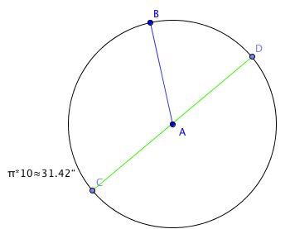
Radius: ___________________
Diameter: ___________________
Circumference: $π*10≅31.41"$
Area: ___________________

Lesson one:

Arc length, central angle, Pi ($π$), radius, diameter, and circumference, what do all these words really mean and how are they related? The radius, r, is half of the diameter, d, which is used to find the circumference. As a class, students are given the necessary definitions and equations, i.e. Circumference, C=$πD, D=r*r=r^{2},and Area, A=πr^{2}.$ Students are introduced to the material with examples at the whiteboard along with associated oral descriptions while the students take notes in their class binders. Then, they are given a worksheet which they are encouraged to work the problems out on the whiteboard either in groups or individually so we are able to see their process and reasoning through the problems. Often times, many students choose work a problem out on their worksheet and have it checked before showing the class up at the whiteboards. The first worksheet gives the students nine circles marked with a radius, and diameter, one of which is provided, and asks the students to find the remaining measurements (radius, diameter, circumference, and area). This lesson also goes back and tests students’ prior knowledge of what the area of a circle is and how it relates to the other three measurements. This allows us to see what the students know from previous classes and evaluate what material we need to review for the next lessons and what can already be incorporated to current and future lessons without review. By giving the students questions such as example two on the right, we are able to see if students can take information and a given equation and essentially work backwards to find other needed information. That is are students able to take the circumference formula, C=$π$D, and find the radius knowing that r=$\frac{D}{2}$. So taking the example on the right, if C=$π*10$ then the diameter, D=10, and r=$\frac{D}{2}=\frac{10}{2}=5.$So r=5, and therefore A=$πr^{2}=π*25≅78.54".$ Problems such as these allow us to track students’ ability to not only work backwards, but take given information and apply it to what is required to find.
This lesson was separate from finding the arc length and central angle because the students are more likely to learn and remember the material when it is slowly added to prior knowledge rather than adding entirely new material all at once.

Lesson two:

HSG.C.A.2: Identify and describe relationships among inscribed angles, radii, and chords.

Name the arc made by the given angle.
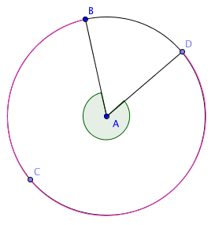

Find the measure of the arc or central angle indicated. Assume that lines, which appear to be diameters, are actual diameters.

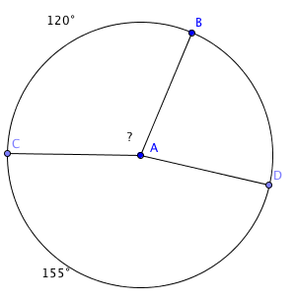
For the second lesson of this learning progression, the students take their knowledge of angle measures from the previous quarter’s lessons on triangles and the Pythagorean theorem, and apply that to their current knowledge of circles to find the arc length and central angle. This lesson allows us to see how well the students are able to identify angles and arcs based on being given an angle name, such as “name the arc made by the given angle$∠BAD$”. Students will need to be able to explain that it is not the colored arc$DCB$ but is rather the arc created by the angle $∠BAD,$ which is arcBD. This lesson will have a technological application with the assistance of the program GeoGebra. With the use of this program, students will be able to watch how the angle measures and arc lengths change but remain related to one another.
The Lesson Two Worksheet will consist of 18 angle measure and arc length problems that increase in difficulty beginning with problems similar to the two examples on the right of this page and ending with problems, which ask the students to find the measure of the arc or central angle indicated, and are given a diagram such as: “Find the measure of arcFG”
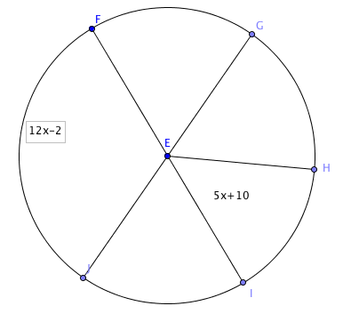
Using prior knowledge, students are to find that the measure of arcFG in this diagram is equal to 50$°$.
Trigonometric Ratios

Lesson three:
HSG.SRT.C.6: Understand that by similarity, side ratios in right triangles are properties of the angles in the triangle, leading to definitions of trigonometric ratios for acute angles.

Find the value of each trigonometric ratio:

HSG.SRT.C.7: Explain and use the relationship between sine and cosine of complimentary angles.

Find each angle measure to the nearest degree.

sinB=0.7431

Student work:
sinB=0.7431
B=sin⁻¹(0.7431)
B$≅47.996°$ => 48$°$
Lesson three takes a step back from circles and their associated parts, and goes back to working with triangles, but in a new light. But what do triangles have to do with circles and arc lengths? Well, in trigonometry, and trigonometric applications in geometry, measurements of triangles can be found using sine, cosine, tangent as well as their inverses. For this lesson, students will be introduced to three of the basic trigonometric ratios and the associated acronym S$\frac{o}{H}$C$\frac{A}{H}$T$\frac{O}{A}$. By having the students apply a new idea, namely trigonometric ratios, to a previous lesson with which they are already comfortable, allows the students a better chance of learning the new material more effectively. Providing measurements of all three sides of the triangles gives us the opportunity to make sure students understand the correct ratio for each trigonometric function, rather than simply supplying the students with only the information necessary to determine the appropriate proportion. This is demonstrated in the first two examples on the right. One triangle is oriented in standard form, with the right angle along the base. The second example, however, has been rotated to see of students are still able to identify the correct sides of the triangle without having it in standard form. These questions test students’ reasoning skills as well as proper identification of the trigonometric ratios. For example number one of the right, students would be expected to recognize tangent as being the opposite side over the adjacent side in reference to the indicated angle Z, making tanZ=21/28 and then simplifying to 3/4 by dividing both the top (the numerator) and bottom (the denominator) by 7. With example number two, the students need to recognize the hypotenuse as being the side opposite the right angle, rather than being the side that is slanted (as it is usually portrayed when in standard orientation). From there, the students need to recognize cosine as being adjacent over hypotenuse, 4/5. So, cosQ=4/5.
R
cosQ=
5
4
3
S
Q
tanZ=
35
28
21
Z
Y
X
For the second worksheet of this lesson, students are introduced to the inverse trigonometric ratios in order to find an angle measure without being given a picture as in the previous examples. This is demonstrated in the third example on the right side of this page. These exercises allow students to demonstrate their reasoning skills as well as their understanding of what the trig ratios are finding in reference to the triangles.
The Unit Circle
Introducing the unit circle:

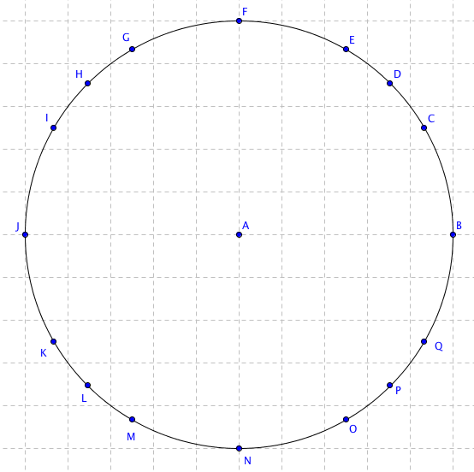

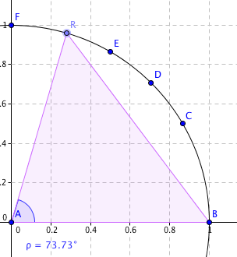
Lesson four:

The last lesson of this learning progression introduces the unit circle and finally ties all the unit of this progression together. To begin, the students will be given a blank unit circle, which they will be responsible for completing throughout the lesson (and example has been provided on the right column of this page). At first, students will be given the angle measurements in degrees, starting with 0$°$, 30$°$, 45$°$, 60$°$, and 90$°$. From here, we will go on to discuss how the four quadrants of the circle have the same basic five measurements, but after the 90$°$ mark the next “30$°$” becomes 120$°$ since it is a continuous measurement from 0$°$ to 360$°$. In order to introduce the triangles into the unit circle, we will use the GeoGebra program from before to show how the triangle fit into the circle (shown on the right). This demonstrates that you can measure any angle within the circle, not just the at the points marked. Points B, C, D, E, and F are stationary angles at 0$°$, 30$°$, 45$°$, and 90$°$ respectively. Point R, however, can be moved to any place along the circumference of the circle, and will be shown by the purple triangle and measured with the blue angle measure which changes respectively with the triangle and point R.
Conclusion:

Each lesson will get a benchmark assessment in the form of a worksheet. When each worksheet is completed, the students will turn in the worksheets for grading to receive both a participation grade for the day as well as written feedback (examples have been attached). As an overall formative assessment, students will be given a hands-on project to help demonstrate their understanding of the material. Having students who are so used to passively learning and being passed through school feeling as though no one cares whether they pass or fail gives the students an opportunity to show not only the teachers but also themselves what they have really learned. So many of these students are kinesthetic learners, but have seldom been given the chance to really express this, for whatever reason. Allowing the students this seemingly rare opportunity can often restore their interest and engagement in learning because they make the connection between participating in class and getting to do a fun, hands-on project rather than just another worksheet or test. At the end of this learning progression, there will be a review of the unit to clarify any final misconceptions and questions. Each lesson will have an individual worksheet that will help students’ understanding of triangles, circles, and trigonometric functions. The materials needed for this project will vary depending on each student’s (or in cases of larger classes, each group’s) visual adaptation of the unit circle. Most projects will require basic craft supplies (glue, colored paper, pens, pencils, scissors, etc.) and others may include large posters or backgrounds. All students will need to incorporate a circle in their project labeled as the unit circle. For larger groups of students the students will be broken into groups, and each group will be given the same guidelines and criteria for the project. This project will help to show students the various ways the unit circle can be applied to life. The data will be analyzed to help us see where the students are in their understanding of the unit circle, and the associated measurements, both in degrees and radians.
Lesson Title: Triangular Trigonometry

Unit Title: Trigonometric applications in geometry
Teacher Candidate: Anna Cockrum
Subject, Grade Level, and Date: Geometry, juniors and seniors, February 2015

Placement of Lesson in Sequence
This is the third lesson of this learning progression as well as the unit. Last quarter ended with the students working with properties of right triangles; similarity postulates, identifying the legs and hypotenuse of right triangles, learning properties of special right triangles (45-45-90 and 30-60-90). This lesson takes that knowledge and adds in three basic trigonometric ratios, namely sine, cosine, and tangent. This is the third lesson in the progression, rather than the first, to allow a smoother transition into radian measure within the unit circle. The two lessons preceding this had students working with circles and some of their properties: arc lengths, calculating circumference and area given radius or diameter lengths. This allowed for easier introduction to the use of Pi as a measurement, in preparation for taking measurements in radians.
Central Focus and Essential Questions
The central focus for this lesson is getting students acquainted with the unit circle as well as trigonometric applications within geometry lessons. That is, being able to use right triangles, a lesson learned previously in geometry, and applying sine, cosine, and tangent ratios to the triangles and later the unit circle. This lesson focuses on students’ abilities to apply new lessons to old ideas and concepts. This prepares students for using the unit circle, and taking measurements in both degrees and radians, and understanding where the measurements came from.

Content Standards
CCSS.MATH.CONTENT.HSG.SRT.C.6: Understand that by similarity, side ratios in right triangles are properties of the angles in the triangle, leading to definitions of trigonometric ratios for acute angles., CCSS.MATH.CONTENT.HSG.SRT.C.7: Explain and use the relationship between the sine and cosine of complementary angles.

Learning Outcomes | Assessment
- Students will be able to determine correct use of the trigonometric ratios given appropriate information.  - Students will be able to apply knowledge of right triangles to calculating trigonometric ratios.  - Students will be able to demonstrate understanding of proper use of each trigonometric ratio.  - Students will be able to find an approximate measure on a calculator | Students will be given a benchmark assessment in the form of a worksheet which will require them to first find the value of an indicated trigonometric ratio given a marked diagram, and then will ask them to find an indicated measurement to the nearest degree.

Learning Targets | Student Voice
- I know how to identify which trigonometric ratio to use  - I know how to calculate inverse trig functions  - I know what each trig function is being used to find.  - I can use a calculator to find a trig function | To begin class students will be told that they are going to be taking a step back from work with circle to resume and further their knowledge of right triangles from last quarter. Then, they will be given the S O/H C A/H T O/A acronym and what each part means in terms if right triangles. Then, they will be given an example of each ratio. Next, students will be asked to form groups of two or three and find the correct trig ratio based on the information provided. Finally, students will be given a worksheet to complete to assess their individual understanding of the material and learning target.

Prior Content Knowledge and Pre-Assessment
Students are able to correctly identify the legs and hypotenuse of a right triangle both in standard and when rotated.
Students are able to reason why a right triangle may have a 45-45-90 or 30-60-90 proportion.
Students know which sides, or angles, are opposite and adjacent, in reference to one another.
Students know where the trig functions are on a calculator.

Academic Language Demands
Vocabulary & Symbols | Language Functions | Precision, Syntax & Discourse
- Right triangle  - Acute angle  - Right angle  - Trigonometric ratio (Sin O/H, Cos A/H, Tan O/A)  - Inverse trigonometric functions (sin⁻¹, cos⁻¹)  - Opposite side/angle  - Adjacent side/angle  - Hypotenuse | - Students will be able to identify which trig ratio to use based on given information  - Students know when to use a trig function or its inverse  - Students can calculate trig functions on calculators  - Students will use their understanding of the material to complete in class examples as well as the worksheet. | Mathematical Precision:  Students must be able to determine the correct trigonometric ratio to use based on given information.  Syntax:  Students must be able to correctly set up a trigonometric ratio by hand, and then properly evaluate the function based on the question being asked. Show their understanding of which side id opposite or adjacent to a specified angle, and vise versa.  Discourse:  Students must be able to reason their way through finding and evaluating the proper trigonometric ratio.

Language Target | Language Support | Assessment of Language Target
- I know the difference between sine, cosine, and tangent and their inverses.  - I can correctly choose which ratio to use both when given a diagram and when not.  - I can use a calculator to evaluate a trigonometric ratio | Throughout the lesson, and in class work, students, and teachers, will be using their mathematical language to accurately and eloquently discuss what is being achieved. | Verbal feedback will be given to students who volunteer answers to the class and during private work time while the teacher is walking around answering questions and clarifying misconceptions.  The in class examples and board/group work will be used as class participation, and the worksheet will be turned in at the end of the day as a benchmark assessment of students’ knowledge and understanding of the material.

Lesson Rationale (Connection to previous instruction and Objective Standards)
The work with right triangles is a continuation and addition to last quarter’s work with learning the Pythagorean theorem and special right triangles. This lesson focuses on using the angle measure as an independent variable, which is why S O/H C A/H T O/A works the way it does. That is, by using theta as a variable, students are able to apply prior knowledge of solving for a variable, much like they did with linear equations. The use of the unit circle helps the students visualize what is being represented in each equation, and what the variable literally stand for in each triangle and situation.
This lesson was chosen due to its connectedness with not only mathematics, but also its application in engineering, and physics. By showing that the math lessons can be used in a more applied way, these students are much more likely to respond to the material in a positive way. As stated by

Differentiation, Cultural Responsiveness and/or Accommodation for Individual Differences
All students in this class are part of the local school district’s alternative high school. This program allows students and teachers to take more time with lessons that are causing greater amounts of frustration and proving to be more difficult, which increases students’ learning of the material.

Materials – Instructional and Technological Needs (attach worksheets used)
White boards and markers,
Scientific calculators (provided by teacher candidate)
Class notebook
Pencil
Worksheet

Teaching & Instructional Activities
Time | Teacher Activity | Student Activity | Purpose
9:00 | Teacher will introduce activity and day’s lessons. Trigonometric ratios and the acronym S O/H C A/H T O/A will be introduced. Quick review of opposite, adjacent, and hypotenuse of right triangles. | Taking notes on trigonometric ratios, ask questions, clarify misconceptions, | Get students focused and ready for the day’s lesson and getting out of working with circles and back into right triangles
9:15 | Teacher will write down 3 or 4 examples, depending on class size, and ask students to group up and choose an example to answer at the white board | Students will break into groups and answer the example they choose. Students are prepared to share their reasoning and answer to the class if asked. | Demonstrate student understanding of content and allow teacher to see where misconceptions and mistakes still lie.
9:25 | Teacher hands out the worksheet for students to being working on. | Students will begin working on the worksheet to demonstrate knowledge and understanding of the material. | Benchmark assessment
9:50 | Class dismissed. Teacher collects students’ notebooks and worksheets. | Students hand in worksheet for daily participation points and to demonstrate knowledge of the material | See where students’ understanding is after the first day of lesson. See what needs to be reviewed/corrected tomorrow for better understanding of the material.

