Allie Hernandez
Math 499E
Box Plots Learning Progression
Introduction:
This unit plan is designed for 9th grade Algebra 1 students. These students are at various levels of learning. These lessons were made so that all the students had the same learning ability and chances of understanding the concepts. Most of these activities require the students to work with a classmate or together as a class. I made the activities this way because the students work well when the activities are hands on and interactive. The central focus for this unit plan is to aid students in understanding box plots in a series of active and engaging activities.
In the first lesson the students will be introduced to data and see what would be the best representation for the data. The students will make a dot plot, histogram, and a box plot to compare. The students will be given activities to work more with box plots and organizing the data. The final activity will be involving the whole class. The students will measure their height in centimeters and create a list on the board of everyone’s height. From here, they will create a box plot for the class data as their exit slip. The following lesson is a group activity where the students will again collect their own data and find the five-number summary. The activity will be comparing each other’s reaction time. One student will drop a meter stick and the other student will catch the meter stick measuring the millimeter mark. Each student will do this test 3 or 4 times. From here the students will find their mean, mode, median, quartiles, range, minimum, and maximum. They will also create a histogram and a box-and-whisker plot. Lesson 3 is all about outliers. The students will be given a worksheet that gives them multiple situations to look at and sort the data. Then they will compare the number summaries when there is an outlier and what happens when the outlier is removed. The last lesson in this unit involves two-way frequency tables. They will be given an activity with a series of questions to work through. There will be another classroom activity where the students will take a poll of what type of music the students like out of: country, hip/hop and pop, and rock. All of these lessons will be hands-on and keep the students engaged.

LESSON 1
The Common Core Standards is:
CCSS.MATH.CONTENT.HSS.ID.A.1: Represent data with plots on the real number line (dot plots, histograms, and box plots).
The students will be introduced to box-and-whisker plots and the five number summary. There will be a discussion on what mean, median, mode, minimum, maximum, and the quartiles. The students will get into pairs and be given a worksheet that walks them through how to make a box-and-whisker plot on their calculators. After they finish this, there will be an activity where they will gather whole class data of their height. The students will record their height in centimeters on the board and create box-plots. One box plot will be for the males, one for females, and one of the entire class and compare the results.
Assessment: The students will first be assessed on their knowledge on the five number summary. This will be an oral assessment where I can hear where the students are at and if there are any confusions before they are given the activities. During the calculator box-and-whisker plot activity, I will be walking around to see if the students are following the directions correctly and will later collect this worksheet to be graded. The main assessment will be the exit slip where the students create the box-and-whisker plots for the male height, female height, and the whole class height. These will be graded and handed back to the students the next day with feedback on what they did correct and what they can do better.
LESSON 2
The Common Core State Standard is:
CCSS.MATH.CONTENT.HSS.ID.A.2: Use statistics appropriate to the shape of the data distribution to compare center (median, mean) and spread (interquartile range, standard deviation) of two or more different data sets.
This lesson will tie into the previous lesson. The students will be complete an activity, Reaction Times. Here the students will work in groups with 3 to 4 peers and record how long it takes for each person to catch a meter stick. The students will find the mean, median, mode, inner quartiles, and range of their data. With this information the students will create a box-and-whisker plot and make a quick presentation to show their data. At the very end of class the students will be given a quiz on the clickers.
Assessment
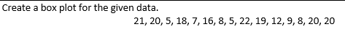
I will assess the students with the clickers as a quiz. The way the clickers work is I put in the standard with the problem and it tells me whether the student has mastered that standard or not. For the first standard from lesson one, I will put the following problem:

The problem I will put for the second standard from lesson two is:
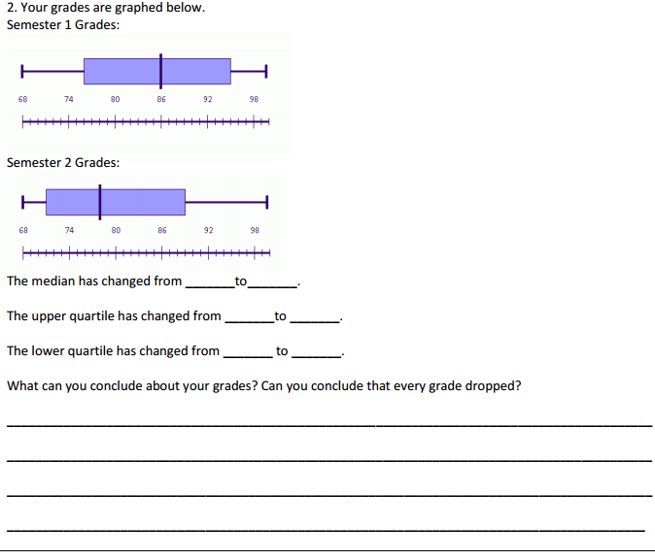
The students will be able to type in their answers and submit them quickly and easily. I will be able to have instant access to whether or not the students mastered the standard (green), almost mastered the standard (yellow), or missed the standard (red). Then using this feedback I will be able to correct mistakes and help with misconceptions.
LESSON 3
The Common Core State Standard is:
CCSS.MATH.CONTENT.HSS.ID.A.3: Interpret differences in shape, center, and spread in the context of the data sets, accounting for possible effects of extreme data points (outliers).
At the beginning of the class I will go over how they did on their clicker quiz and review the concepts that were missed. From here, I will give the students an activity where they are given two sets of data. The students will have to find the median, mean, and the quartiles for each data set. Then they will remove the outlier of each data set and see how the mean and median change. After performing these calculations, there are concluding questions where they can reflect and write their observations.
Assessment
I will assess the students with the worksheet to see if they did see the relationship with the outliers. Then I will assess them with the clickers once again with this problem that aligns to the standard:
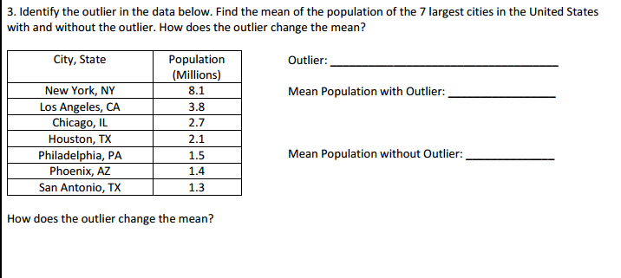

LESSON 4
The Common Core State Standards is:
CCSS.MATH.CONTENT.HSS.ID.B.5: Summarize categorical data for two categories in two-way frequency tables. Interpret relative frequencies in the context of the data (including joint, marginal, and conditional relative frequencies). Recognize possible associations and trends in the data.

This activity will begin with reviewing what has been taught already. With this it follows into the two way frequency tables. One of the problems is
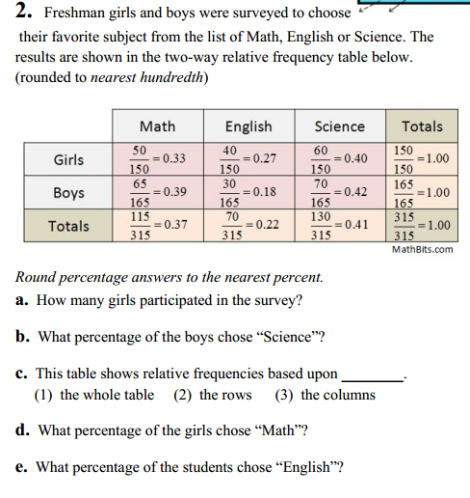
Assessment
Since this is the last lesson for the unit, I will have a test for the students that I can assess to see if they met the standards throughout the lessons.

