How Tall Is Your Teacher??
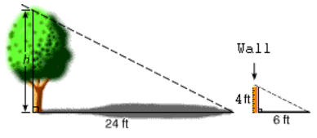
Shadows, like the ones above, can help in finding different heights. If you know at least one of the heights and can measure the two shadows, you can find the unknown height (the tree’s height in this case).

Can you use shadows and your own height to find Mr/Mrs. __________’s height??

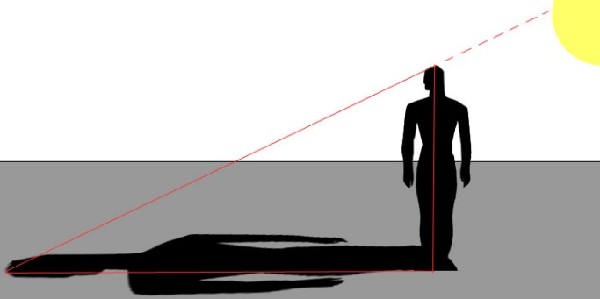

Let’s practice this process. First, measure your own height and record below. Then, measure the length of your shadow. These measurements will be used throughout this activity to find the height of objects of your choice.

My Height | My Shadow’s Length

Let’s see if you can find my height! Once you have the measurements, use ratio’s to find my height! Show your work below the data table.
(Note: Make sure your units of measure are consistent throughout the entire activity.)

MR./MRS. _____________ :
Mr./Mrs. ________’s Height:  X | My Height:
Mr./Mrs. ________’s Shadow Length: | My Shadow Length:

Now, find three objects that you do not know the height of. These objects must be taller than you. Show your work below the data table.

Object #1:
Object #1’s Height:  X | My Height:
Object #1’s Shadow Length: | My Shadow Length:

Object #2:
Object #2’s Height:  X | My Height:
Object #2’s Shadow Length: | My Shadow Length:

Object #3:
Object #3’s Height:  X | My Height:
Object #3’s Shadow Length: | My Shadow Length:

