Estimating Height with Similar Triangles

Summary: One of the most common applications of similar triangles given in textbooks is the use of shadows to estimate heights of objects that can’t be directly measured. In our textbook, Section 14.2 includes 10 problems of this type, and the K-8 geometry standards include it as a recommended example! The project will give you real-world experience with this situation.

Part I – Required People/Equipment
For this project, you will need the following:
- A camera. (Digital is easiest, or else you’ll need the film made into prints within a week.)
- A tape measure, and if the tape measure is short (< 12 feet), you may want a long – up to 25 feet – piece of string or rope you can use to mark distance and measure with the tape measure later.
- A partner who can take pictures and help you measure.
- If it is difficult to measure your partner, you will need to measure shadows of the object and yourself at two different times (at least 45 min apart).

Part II – Activity [Read ALL of steps 1 – 8 BEFORE you start.]
- Review Example 14.7 on p. 732 to understand the goal of this project.

- Choose a day and time when you can see shadows of objects quite clearly.

- Find an object that has the following four properties:
  - It is too tall or awkward to measure its height directly.
  - You can put the end of your tape measure directly under the part of the object casting a shadow. (For example, if it is a pole or part of a house, you must be able to get your tape measure directly under the high point casting the shadow.)
  - It is casting a shadow that is easy to see.
  - The shadow lies along reasonably level ground.

- Take a photograph that shows the part of the object and part of its shadow.

Do the next two steps QUICKLY since the position of the sun is changing.

- Measure the length of the shadow of your chosen object to the nearest half-inch. Record your measurement in the table on the back of this sheet.

- Now measure your (or your partner’s) shadow. Record that measurement in the table. Then get a picture that includes the person, his/her shadow, and the tape measure or rope along the ground.

- Measure the height of the person whose shadow you just measured. Record it in the table.

- Repeat steps 5 – 7 with your partner, OR redo the above measurements at a different time of day.

- If any of your measurements are in feet and inches, convert them to inches and put the numbers in the appropriate boxes in the table.

Type of object being measured: ______________________ | Visual estimate of height (feet): ________

 | Object’s Shadow Length | 1st Person’s Shadow Length | 1st Person’s Height | 2nd Person’s Shadow Length | 2nd Person’s Height
Size (ft & in)
Size (inches)

Part III – What You’ll Turn In
- Produce a 1 – 3 page “lab report” describing your activities, presenting your data, and then showing and explaining the calculations for determining your object’s height. Use the following format.

  - Use headings to identify the sections of your report. For example “Process,” “Data,” “Justification & Calculations,” and “Results & Evaluation.”

  - The Process section of your report should describe what you chose to measure, when and where you were, and include your pictures with descriptions of what they show.

  - Your Data section is primarily the data table from this handout, PLUS a sentence or two introducing the table to your reader (“The following table shows …”). If you had to convert your measurements, also explain how to perform such conversions.

  - The Justification & Calculations section of your report will include most of the mathematics.
    - First, explain (justify) how to see there are two triangles in this situation, and how you know they are geometrically similar.
      - Explain what physical thing makes up each side of each triangle (it will help if you include and label sketches of the two triangles).
      - Since you don’t know the triangles are similar (you never built and measured them), explain how the physical situation forces corresponding angles to be congruent, and then state which similarity property guarantees that your two triangles must be similar.

    - Second, show your calculations for estimating the height of the object. ALSO explain how knowing the triangles are similar leads to this calculation.

    - Third, calculate the height of the object a second time using the other person’s shadow and height measurements.

    - Explain how to convert your final values to feet and inches, then do so. Keep in mind that this is more complicated than dividing the number of inches by 12. (107 inches ≠ 8 ft, 9 in)

  - Your Results & Evaluation section presents your findings.
    - State the heights of the object you obtained from your two calculations.

    - Describe how close you think your numbers are to the actual height of the object, and how you made that decision.

    - Check the accuracy of your measurements by using one person’s height and shadow length, plus the other person’s shadow length to calculate the other person’s height. If the result is more than 1 inch different from the person’s true height, explain what you would do differently to improve your accuracy if you did this project again.
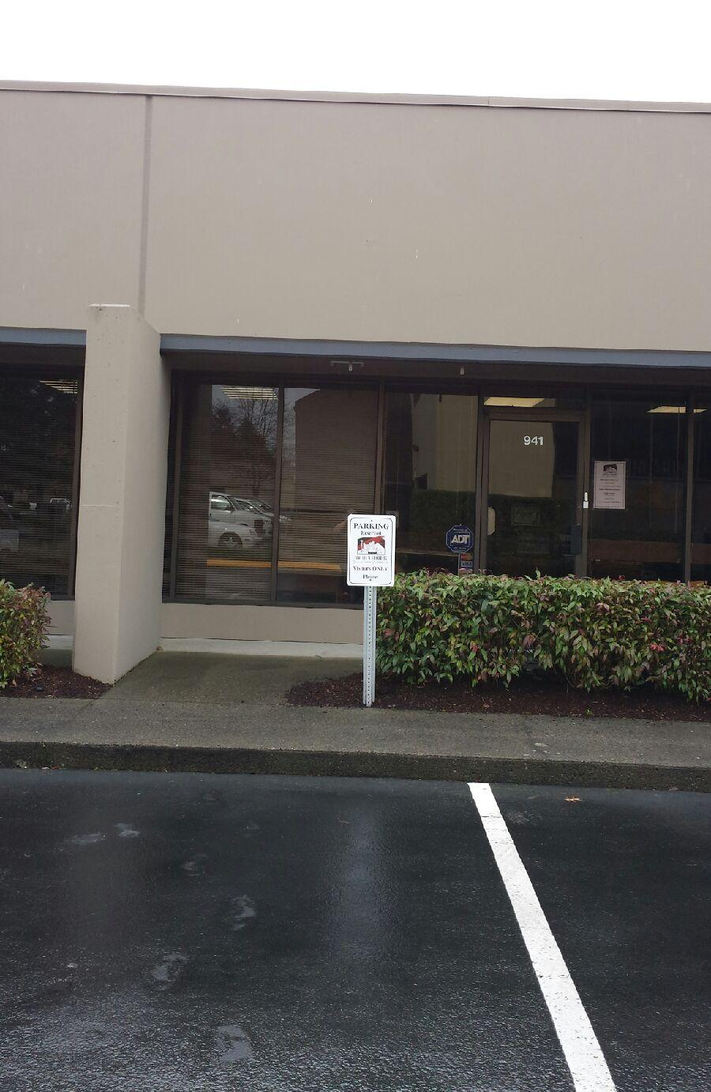
Process:
We decided to measure the building of Seattle’s Favorite in Tukwila. Which happens to be where I work as well. It was Friday February 13th at around noon and I saw that it was sunny outside which is when I took the time to run outside with my coworker Angela to come help me take the measurements (Normally by the time I am off the sun is already down or I am hustling to get to class. Which is why I was doing it in the middle of the work day).

To the left is a picture of the building. It is slightly hard to see, but there is a piece of material that juts out of the building to create a covered walkway which is why it is slightly hard to measure the height of it, so doing these calculations makes it easier to measure.

Data:
Below shows a table of all of the pertinent information that we used for the project. The original measurements were in Feet and Inches, but to make the calculations a little easier we converted it all to inches and we will convert it back to feet at the end of the experiment to see how our estimations add up.

Type of object being measured:  ______Office Bulding_____ | Visual estimate of height (feet):  ____15ft or 180in____

 | Object’s Shadow Length | 1st Person’s Shadow Length | 1st Person’s Height | 2nd Person’s Shadow Length | 2nd Person’s Height
Size (ft & in) | 29ft 6in | 9ft 7in | 5ft 4in | n/a | n/a
Size (inches) | 353in | 115in | 64in | n/a | n/a

In order to convert our feet to inches we just take the feet portion and multiply it by 12 for the number of inches in a foot and then add it to the inches. For instance I will show the calculation for my height
5ft x 12in = 60in + 4in = 64inches total
Justification and Calculations:

The Physical situation forces it to be congruent by the corresponding angle of the sun at the same time and the 90 degrees angle that your shadow starts at. The AA property of similarity guarantees the triangle similar because you have the angle of your shadow starting at the top and 90 degree angle that the bottom makes, which will give you the last angle as well which makes them similar.
Building
Me
My Shadow 115 inches

Building Shadow
353 inches

My Height
64 inches
Building Height
x inches

The calculations done are below.

First we start with finding out the proportion
Length of the Buildings Shadow 353 inches = 3.07
Length of my shadow 115 inches

Second we can then determine the height of building
My height times the proportion 64 inches x 3.07 = 196.48 inches

Third we need to convert the answer back to feet and inches
Height of the building 196.48 inches 16.37 Feet
Inches in a foot 12 inches ͌

Now this is still not feet and inches we so we to figure out how much .37 feet actually is
16 Feet x 12 = 192 inches
+ 4.5 inches ͌ 196.48 inches

So our final conversion will be would end up being 16 feet 4.5 inches

Results and Evaluation:
Based off of the calculations done the Building is about 16 feet and 4.5 inches tall.

My estimate was around 15 feet which is close to the actual total. I just thought to estimate how many me’s it would take to get to the top of the building and I thought it would be a little less than 3 of me.

It is hard to say exactly how close the calculations are without another set of data to go off of or the, but with the properties of similar triangles it would stand to reason that it is pretty close to the correct height.

To make this experiment more accurate next time, I will make sure to measure at least 2 people and make sure to bring an extra-long tape measure to be more accurate. Taking extra picture will be more helpful as well.

