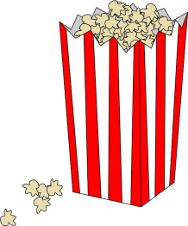 Popcorn Challenge 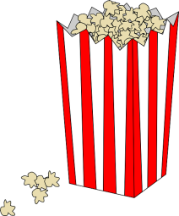

- Prediction: Which cylinder do you expect to hold more popcorn: taller, shorter, or the same amount? Explain your thinking.

2. In order to solve this problem, what information do you need? How can you gather this information? How will you use this information?

Gathered information... | Cylinder “A” Tall | Cylinder “B” Short

3. What formula will you use to solve your problem? Why?

4. Based on the results from problem #3, was your original prediction correct? Why or why not?

5. Test your cylinders. Explain why the cylinders do or do not hold the same amount of popcorn.

6. What changes can you make to the paper to increase the amount of popcorn held in the cylinder?

7. In what other situations might you need to understand how to apply geometric formulas?

