The Power of the Wind
In groups of 3 or 4, gather three sets of data for air speed and complete the worksheet below with the findings.

- Label the x and y axis according to their representations and copy the graph of data set #1 below:

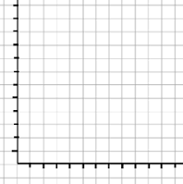

- Label the x and y axis according to their representations and copy the graph of data set #2 below:

- Label the x and y axis according to their representations and copy the graph of data set #3 below:

- a) Find a linear or polynomial function that best describes each data set, graph each function over each respective original graph.
b) Compare and contrast the original graph with the function, and write down your findings in the blank space below each graph. Be ready to share your observations with the rest of class.

