Full of Hot Air
Each student must use the Anemometer to test how fast they can blow. Each student is give three tries, the fastest of the three is what will be used.
Attempt #1 | Attempt #2 | Attempt #3
m/s | m/s | m/s

Now, collect what everyone recorded as their fastest blow and put it in the table below.
Student | Speed (m/s) | Student | Speed (m/s)

Who blew the fastest? __________________
Why do you think they blew the faster than everyone else?
______________________________________________________________________________________________________________________________________
What are factors that might make a person blow faster? (give 4-6)
______________________________________________________________________________________________________________________________________

As a class decide on the best 4 factors. What are those 4 factors? __________________________________________________________________

Fill out the table below with the information for everyone related to these factors.
Student | Factor 1: | Factor 2: | Factor 3: | Factor 4: | Speed (m/s)

Use the data from the tables to fill out the graphs on the next page. Use the Speed as the Y-value and the Factor as the X-value.

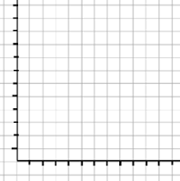
Is there a trend? If so, What is that trend?
Is there a trend? If so, What is that trend?
Is there a trend? If so, What is that trend?
Is there a trend? If so, What is that trend?

