GeoMath

Directions: Sign onto your google classroom page and click on the link for today’s lesson. Follow the prompts given to you by GoogleEarth and record your work and answers here. Please remember, no work means no credit. Once you are finished, feel free to virtually explore the world.

- Globe
Surface Area:

Volume:

- Head Building
Surface Area:

Volume:

- Transamerica Pyramid
Volume:

- World Trade Center site
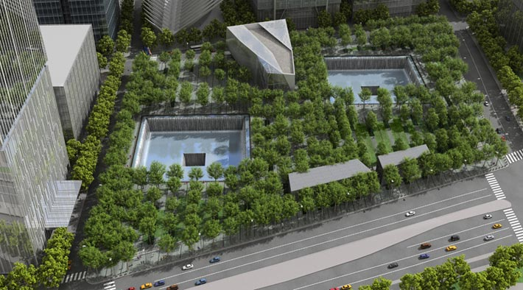
Volume:

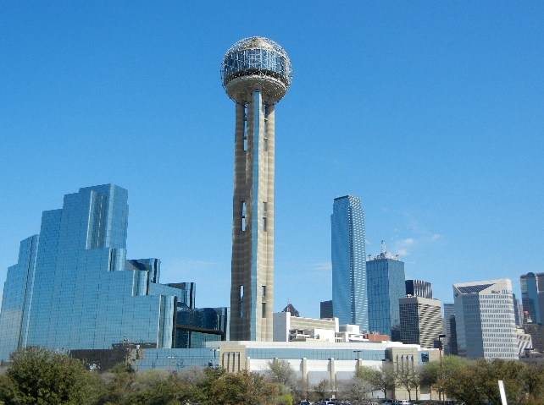
- Reunion Tower
Surface Area:

Volume:

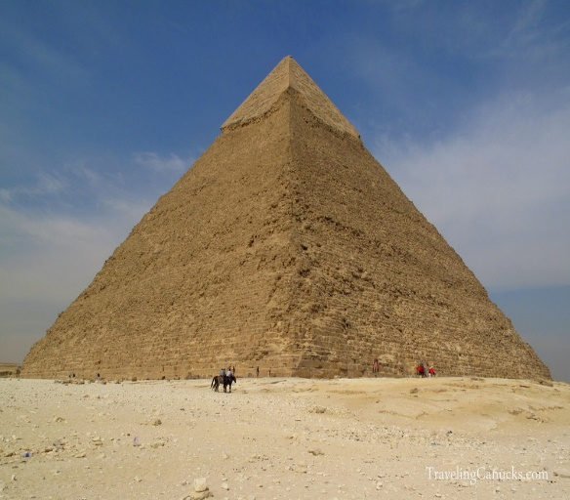
- The Great Pyramid of Giza

Surface Area:

Volume:

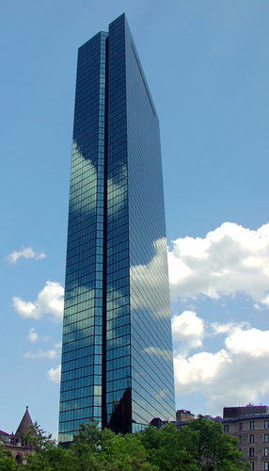
- John Hancock Tower
Surface Area:

Volume:

- Leaning Tower of Pisa

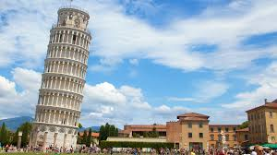
Surface Area:

Volume:

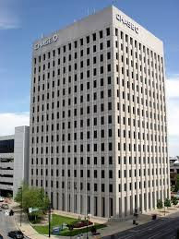
- Chase Tower
Surface Area:

Volume:

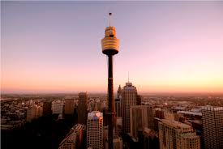
- Tower Building
Surface Area:

Volume:

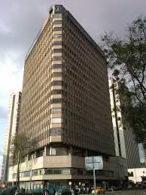
- Corficolombiana Building

Surface Area:

Volume:

- The Pentagon
Volume:

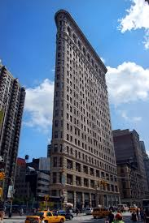
- Flat Iron Building

Surface Area:

Volume:

- Use a search engine to find a building that is relatively cone, sphere, or cylinder shaped. If you can, find the dimensions of the building and find the volume and surface area. Please name which building you chose and where it is located.

Success Criteria for Assessment

#’s 1-13 | 5  The student provides the correct answer and the correct work | 4  The student provides a mostly correct answer and mostly correct work. Only a very minor procedural error was made or an error was made in regards to units. | 3  The student had the wrong answer but provided work that indicated they were very close to reaching the learning target | 2.5  Correct answer but completely incorrect work or no work provided | 2  Wrong answer and wrong work but the problem was fairly attempted | 1  Wrong answer was given and no work was provided | 0  No attempt was made
#14 | 10  The student provides the correct answer and shows a deep understanding of the mathematical language and how to use it when explaining the formula used, procedures followed, and the answer. | 8  The student provides the correct answer but only shows an average understanding of mathematical language and how to use it when explaining the formula used, procedures followed, and the answer. | 6  The student provides the wrong answer but shows clear understanding of the mathematical language when explaining the formula, procedure, and answer to the class. | 5  The student provides the correct answer but struggles using mathematical language to explain the formula, procedure, and answer to the class. | 4  Correct answer was given but the student is unable to use mathematical language to explain the formula, procedure, and answer to the class. | 2  Wrong answer was given and the student was unable to use mathematical language to explain the formula, procedure, and answer to the class. | 0  No attempt was made

The assignment is out of 200 points. However, it is only going in the gradebook as a ten point assignment. The students’ grades will be converted to a percent and then divided by 10 to get the grade that the student will have in the gradebook. For example, if a student got 183, I would take $\frac{183}{200}$ and get .915 which is 91.5%. Divide that by 10 and you get 9.15. So that student would get 9.15 out of 10. (Chances are I will round up to the nearest .5 point). This is a fun way to teach the students that the number of points an assignment is worth doesn’t necessarily mean anything. It’s the percentage that counts. They can see for themselves that no difference is made when entered in Skyward if I made the assignment out of 200 or if I made it out of 10.

