Prediction
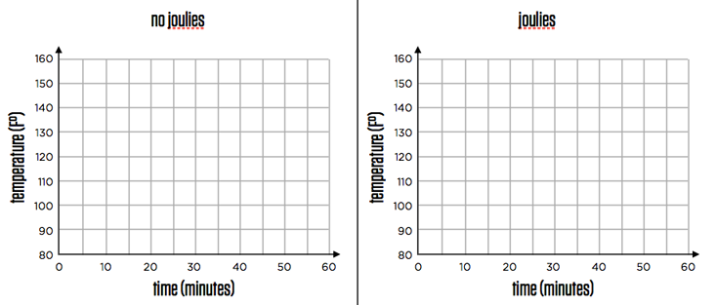
Results
Conclusion: In a short paragraph, make a final conjecture on if “Joulies” worked as they were advertised. Use justification from the graphs derived in the experiment using the temperature probes in your explanation. Would you purchase this product? Why or why not?

