**Solving the Volume of 3 Dimensional Shapes Using GeoGebra.**

**Name:**

**Date:**

Kassandra and her three friends, Linzy, Sarah, and Karla have objects that they would like to know the volumes for. Use GeoGebra to help you visualize and create the three dimensional objects.

Directions: Calculate the volume by hand and use the volume on GeoGebra to verify your answer.

1. Kassandra wants to know what the volume would be if her baseball has a radius of 2 units.
   1. What is the radius?
   2. What is your volume formula of a sphere?
   3. What is the volume?
2. 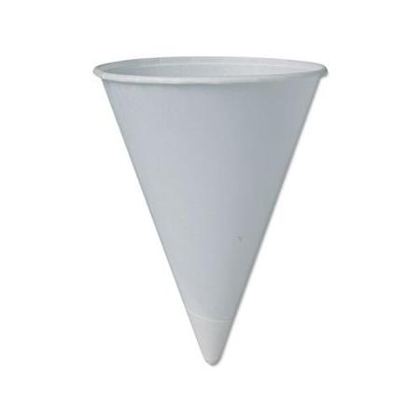Linzy’s object is a water cone filled with water. What is the volume of the water cone with a radius of 3 units and a height of 4 units?
   1. What is the radius? What is your height?
   2. What is your volume formula of a cone?
   3. What is the volume?
3. Sarah’s object is a pyramid with a length of 2 units, width of 2 units, and a height of 4 units.
   1. 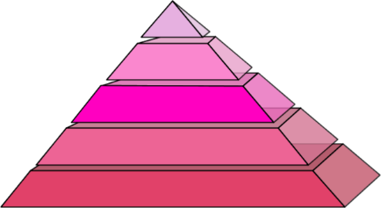What is the radius? What is your height?
   2. What is your volume formula for a pyramid?
   3. What is the volume?
4. 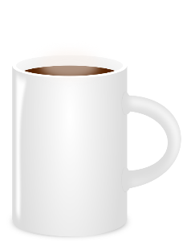Karla’s object is a cup that is filled with coffee with a height of 6 inches and a radius of 2 inches. What is the volume of the cup?
   1. What is the radius? What is your height?
   2. What is your volume formula for a cylinder?
   3. What is the volume?

**Exit Questions:**

Pick two three dimenstional objects that you like. Calculate the volume of the shapes you picked.

1. Shape:

Picture:

Volume:

1. Shape:

Picture:

Volume:

**Answer key:**

**Solving the Volume of 3 Dimensional Shapes Using GeoGebra.**

**Name:**

**Date:**

Kassandra and her three friends, Linzy, Sarah, and Karla have objects that they would like to know the volumes for. Use GeoGebra to help you visualize and create the three dimensional objects.

Directions: Calculate the volume by hand and use the volume on GeoGebra to verify your answer.

1. Kassandra wants to know what the volume would be if her baseball has a radius of 2 units.
   1. What is the radius?

The radius is 2 units.

* 1. What is your volume formula of a sphere?

The volume of a sphere is .

* 1. What is the volume?

1. Linzy’s object is a water cone filled with water. What is the volume of the water cone with a radius of 3 units and a height of 4 units?
   1. What is the radius? What is your height?

The radius is 3 units. The heights is 4 units.

* 1. What is your volume formula of a cone?
  2. What is the volume?

$$V=\frac{πr^{2}h}{3}=\frac{π{\left(3\right)}^{2}\left(4\right)}{3}=\frac{36π}{3}≈37.699 units^{3}$$

1. Sarah’s object is a pyramid with a length of 2 units, width of 2 units, and a height of 4 units.
   1. What is the length? What is your height? What is your width?

The length is 2 units. The width is 2 units. The height is 4 units.

* 1. What is your volume formula for a pyramid?
  2. What is the volume?

1. Karla’s object is a cup that is filled with coffee with a height of 6 inches and a radius of 2 inches. What is the volume of the cup?
2. What is the radius? What is your height?

The radius is 2 inches. The heights is 6 inches.

1. What is your volume formula for a cylinder?
$$V={πr}^{2}h$$

2. What is the volume?

$$V={πr}^{2}h=π{\left(2\right)}^{2}\left(6\right)=24 π≈75.398 inches^{3}$$

**Exit Questions:**

Pick two three dimenstional objects that you like that are either a cylinder, sphere, pyramid, or cone. Calculate the volume of the objects that you picked.

1. Shape:

Picture:

Volume:

1. Shape:

Picture:

Volume: