Walk This Way – Lesson Guidelines

Learning Target – I will be able to use a motion detector to match and then create a time-distance graph. Represent two numerical variables on a scatter plot and describe any correlation and/or relationship between the two variables.

Materials
- CBR, graphing calculator loaded with Easy data app, and Link Cable.
- Doc Camera
- Student handouts

Note:
Graphing Calculators should be setup before class in order to avoid confusion and time problems.
Students should be exposed to the CBR before lesson in order to accomplish time constraints.

Launch
Lead a whole class discussion regarding walking rates. Some questions that you might ask are the following”
- “Have you ever walked very quickly? If so, where were you going? How fast do you believe you were walking?”
- “Have you ever walked very slowly? If so, where were you going? How fast do you believe you were walking?”
- “What would be a really fast walking rate for someone?”
- “Have you ever watched a Walking Race? They are often conducted at the same time and in the same location as 5K, 10K, Half Marathon, of Marathon running races.”
Without pushing the issue too hard, pay attention to the units of measure they use to describe the walks. For example, do they express them in miles-per-hour or feet-per-second or some other unit of measure.

Procedure
Part 1

- Introduce the lesson by showing the students a time distance graph. Explain that time is the independent variable and will be graphed on the x-axis while distance will be along the x-axis.

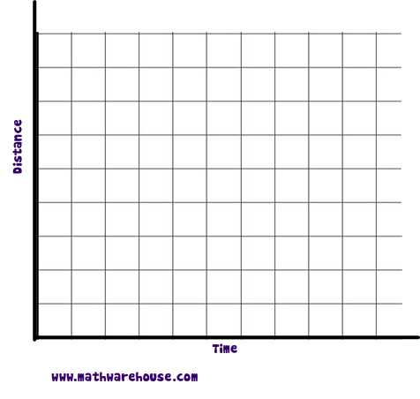

- Explain that we will be using a motion detector to record how the distance of the student changes as they move toward and away from the detector over time. Tell them that we will be recording distance in feet and time in seconds.

- Ask the class what they think the graph would look like if a student walked slowly away from the CBR. Use the CBR to collect data from a student volunteer walking at a constant pace for 5 seconds away from the CBR.

Directions for CBR – Press Apps – Easydata – Setup – Distance- OK – Start-OK.

Was the graph they predicted correct? Were they surprised?
- Choose a second student. Under the setup menu, select the distance match. Generate a graph and ask the class what the student should do to generate the graph. Let the student try to match the graph. Look at what he did and ask the class how to adjust what he did. Press retry and let him try to match the graph again. Repeat until the graphs match relatively well.

- Put students into groups of approximately 3. Hand out the sheet titled “Walking Instructions – Student Handout.” Let each group try to create the graphs assigned.

- After students have had time to collect their data. Bring them back together and discuss what they found out.

- If time permits, give students Part III of the worksheet .

Walking Instructions – Student Handout

Directions : On your calculator press the setup menu and select “Distance Match.” Press Start- OK – Next. Sketch the graph on the axis below. Talk with your friends and try to figure out how to walk the graph. Select one person to try to walk the graph. A second member of the group needs to press start when the person is ready to walk. You have 10 seconds to make the graph. See how well you matched the graph. If you need to press “Retry” and attempt it again. Keep doing this until you are happy with your graph. Write down what you did to make the graph. Let everyone in the group try one.

Walk 1

1. Draw the graph of the first walk.

Walking Instructions

2. Draw the graph of the second walk.

Walking Instructions

3. Draw the graph of the third walk.

Walking Instructions

4. Draw the graph of the third walk.

Walking Instructions

Part II

Directions: For each of the following graphs, try to recreate the graph by walking. For this section, you need to go back to the setup menu . Press Main-Setup-Time Graph-OK. At this point you will hear it clicking. When you are ready to walk the graph press start and begin.

Describe the walking instructions for each graph represented below. Be sure to confirm your instructions by using the CBR and graphing calculator.

1. Walking Instructions

Distance from CBR
(ft)

Time since CBR started (in seconds)

2.
Walking Instructions

Distance from CBR
(ft)

Time since CBR started (sec)

Walking Instructions

3.

Distance from CBR
(in feet)

Time since CBR started (in seconds)

Walking Instructions
4.

Distance from CBR
(in feet)

Time since CBR started (in seconds)

Walking Instructions
5.

Distance from CBR
(in feet)

Time since CBR started (in seconds)

Walking Instructions
6.

Distance from CBR
(in feet)

Time since CBR started (in seconds)

Part III

Directions: Draw a graph given the following scenarios.

- A person walks slowly away from the CBR for 5 seconds, stops and rests for 3 seconds then walks quickly toward the CBR for 2 seconds.

- A person walks slowly toward the CBR for 5 seconds, walks quickly away from the CBR for 3 seconds, and then quickly toward the CBR for 2 seconds.

