Title (primary CCSS Math with Title)

GPE.B.4- Square

Alignment to Content Standards

CCSS.MATH.CONTENT.HSG.GPE.B.4
Use coordinates to prove simple geometric theorems algebraically. For example, prove or disprove that a figure defined by four given points in the coordinate plane is a rectangle; prove or disprove that the point (1, √3) lies on the circle centered at the origin and containing the point (0, 2).

CCSS.MATH.CONTENT.HSG.GPE.B.5
Prove the slope criteria for parallel and perpendicular lines and use them to solve geometric problems (e.g., find the equation of a line parallel or perpendicular to a given line that passes through a given point).

Tasks

Plot these points on an x/y coordinate plane: A(4, 0), B(0, 3), C(-3, -1), and D(1, -4)

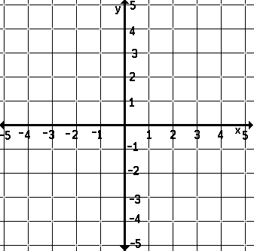

- Find the length of segment AB.

- Find the slope of segments AB and CB.

- Join the sides of quadrilateral ABCD. Prove that quadrilateral ABCD is a square. How do the answers in question 2 aid in this proof?

Commentary

The purpose of this task is to have students use coordinates to prove a simple algebraic theorem, i.e. proving that the quadrilateral from points ABCD in the task is a square (GPE.B.4.) The task involves students needing to use the Pythagorean Theorem to find lengths of segments. The visual representation of graphing the points on the x/y coordinate is used to help prompt students to come to this mathematical reasoning and discovery. Students will already have the prior knowledge on finding slope given two ordered pairs, and building on this prior knowledge we add the component of showing slope criteria for perpendicular lines and use it to prove that the geometric shape is a square (GPE.B.5.)

Solution

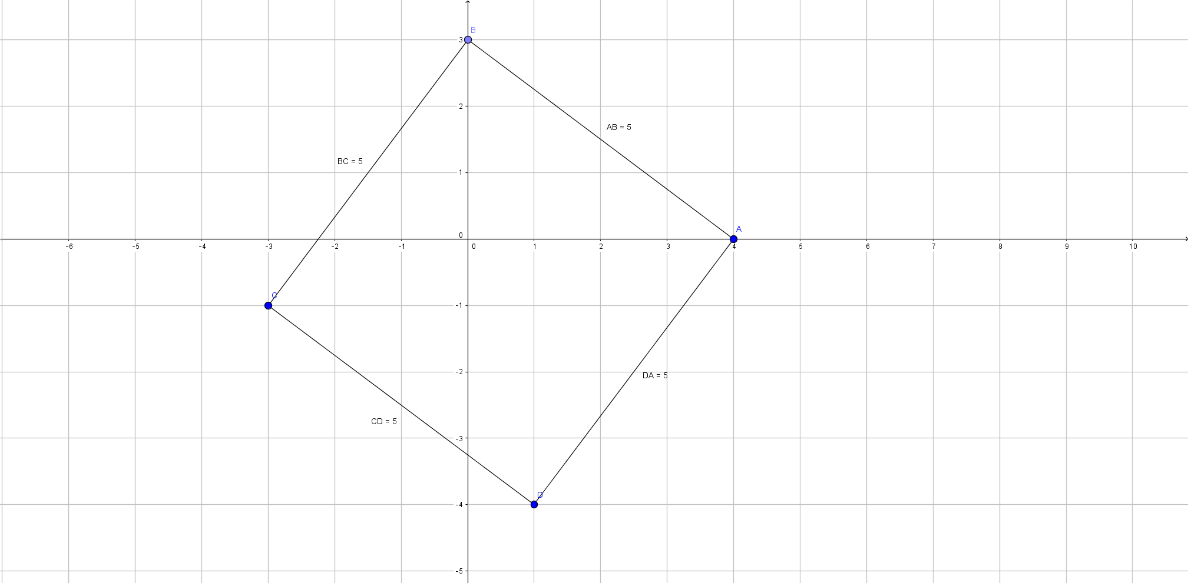

- To find the length of segment AB, from the plotted x/y coordinate we can see that AB can be represented as the hypotenuse of a triangle with legs of length 3 coordinate units and 4 coordinate units.

Using the Pythagorean Theorem we can derive: AB² = 3² + 4²
AB² = 25
√AB² = √25
AB = 5

- To find the slope of each segment we can use the ordered pairs of each endpoint of the segments; segment AB containing points A(4, 0), B(0, 3) and segment CB containing B(0, 3), C(-3, -1), and this formula for slope: (y₂-y₁)/ (x₂-x₁).

Using our formula and ordered pairs we find the slope of segment AB to be: (3-0)/(0-4) = -3/4

And the slope of segment CB to be: (-1-3)/(-3-0) = 4/3

        - This showing the perpendicular property of these segments

- To prove quadrilateral ABCD is a square one must show that each segment has the same length and that each angle measure is equal to a right angle.

Following the same steps as we used in the solution to the first question, using the Pythagorean Theorem we can derive the lengths of the other three segments: CB, CD, and DA.
CB² = 3² + 4²
CB² = 25
√CB² = √25
CB = 5

CD² = 3² + 4²
CD² = 25
√CD² = √25
CD = 5

DA² = 3² + 4²
DA² = 25
√DA² = √25
DA = 5

Likewise, following our logic from question two, which is what aids us in this proof, we can find that each pair of intersecting segments are perpendicular as their slopes are the negative reciprocal of each other, showing the measures of the quadrilaterals angles to each be 90°.

Slope of AB = (3-0)/(0-4) = -3/4
Slope of CB = (-1-3)/(-3-0) = 4/3
Slope of CD = (-4-(-1))/(1-(-3)) = -3/4
Slope of DA = (-4-0)/(1-4) = 4/3

Pairs of intersecting segments:
AB, CB: Perpendicular? Yes
CB, CD: Perpendicular? Yes
CD, DA: Perpendicular? Yes
DA, AB: Perpendicular? Yes

Therefore, quadrilateral ABCD is a square as it has 4 equal sides of length 5 as well as 4 equal angles that are all right.

