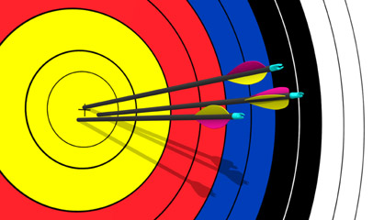
Flying Functions
Predictions
- Make a prediction about the speed(s) at which your arrow will fly. Write your answer using three different units: feet/sec, yards/sec, and miles/hour. Make sure that your conversions are correct.

_______ ft/sec

_______ yds/sec

_______ mi/hr

- When an arrow flys, the nock of the arrow can be modeled by a function. Make a prediction as to which type of function would best model the flight of the arrow. For example, it is a linear, quadratic, exponential, cubic, quartic, quantic, etc.? Explain why you think that function is the best fit.

Activity
Directions: After you have made your predictions, the class will go outside and I will film each of you shooting your arrow. Use your video and Logger Pro to answer the following questions.
- Record the speed of your arrow as it initially left your bow and the speed of your arrow as it hit the target.

Initial speed: Ending speed:
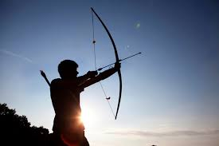
_______ ft/sec _______ ft/sec

_______ yds/sec _______ yds/sec

_______ mi/hr _______ mi/hr
- Use the “Curve Fit” button on Logger Pro to find the function that best fits the flight of your arrow. Record the function below.

- Compare the best fit function with the function that you originally predicted.

- Discuss your best fit function with a partner, what is similar and what is different? Why do you think that they are different?

- What do you think the red graph means? What about the blue graph? Why do you think that?

- What does RMSE stand for? What does it mean and why is it important?

