HSG-CO Finding Points

Alignment to Content Standards: HSG-CO.D.12

Tasks:

Perform the specified constructions on the triangles below using a compass and straight edge. For each give the necessary steps to the right of figures.

- Incenter

- Circumcenter

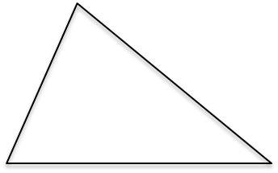

- Line parallel to the given line

Commentary:

In this assessment students will be demonstrating their ability to use a compass and straight edge. The construction of the Incenter and the Circumcenter are constructions that are necessary for every mathematics student to see. They are sometimes a student’s first experience with the dynamic characteristics of triangles. Although the students aren’t specifically asked to perform the construction of copying an angle, bisecting a segment, or creating a perpendicular bisector, students need these to perform the larger constructions. Beyond simply performing the individual minor constructions students get the experience of combining them together. This emphasizes the students mathematical precision and helps the students demonstrate neatness and organization.

Solution:
(a) 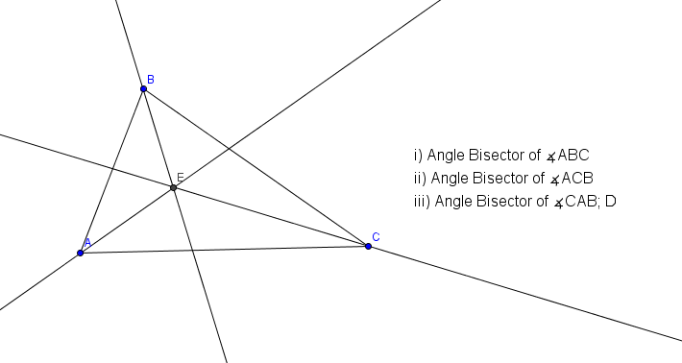
(b) 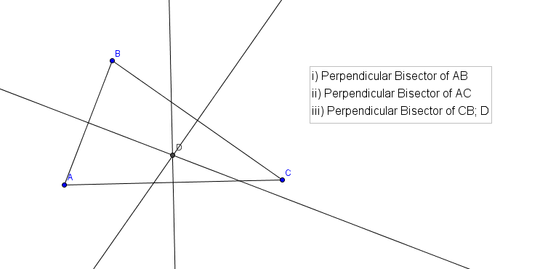

(c) 