Title

HSG.C – Math 101: How to Pick Up Chicks

Alignment to Content Standards

CCSS.Math.Content.HSG.CO.D.12
Make formal geometric constructions with a variety of tools and methods (compass and straightedge, string, reflective devices, paper folding, dynamic geometric software, etc.). Copying a segment; copying an angle; bisecting a segment; bisecting an angle; constructing perpendicular lines, including the perpendicular bisector of a line segment; and constructing a line parallel to a given line through a point not on the line.

CCSS.MATH.CONTENT.HSG.C.A.4
(+) Construct a tangent line from a point outside a given circle to the circle.

CCSS.MATH.CONTENT.HSG.CO.A.1
Know precise definitions of angle, circle, perpendicular line, parallel line, and line segment, based on the undefined notions of point, line, distance along a line, and distance around a circular arc

Tasks

Scheme:
- Using the above circle A and point B draw segment AB.
- Construct the Perpendicular Bisector of AB and label the point of intersection M.
- What is point M in relation to segment AB?
- What can you say about segments AM and BM?
- Construct a new circle centered at M with radius BM and label the points of intersection between circles A and M, as Q and R.
- Draw segments BQ and BR.
- What can you say about the length of segments BQ and BR? Explain with specifics.
- Draw segments AQ and AR.
- Describe what you notice about AQ, BQ, and segment AB.
- Describe what you notice about AR, BR, and segment AB.
- What is the relationship between BQ and BR? Explain and justify.

Commentary

The purpose of this task is to apply definitions from previous topics to be able to be precise when presenting mathematical arguments. This exercise uses many of the definitions from previous topics like perpendicular or line segment to explain why the segments BQ and BR are tangent to circle A. Even though the main plan was for students to construct a line tangent to a circle, this task also brings in other topics that teachers can review easily or branch into. For example, in the questions asked to the students during the task, students needed to understand that segments BQ and BR are congruent and why this was so. Thus, this task has a purpose, bringing together many pervious topics and showing students the continuity that exits and is necessary in Mathematics.

Solution

The bottom of the solutions page has the required diagram.

Scheme:
- Using the above circle A and point B draw segment AB.
- Construct the Perpendicular Bisector of AB and label the point of intersection M.
- What is point M in relation to segment AB?
The midpoint of segment AB.
- What can you say about segments AM and BM?
They are congruent in length.
- Construct a new circle centered at M with radius BM and label the points of intersecting circles Q and R.
- Draw segments BQ and BR.
- What can you say about the length of segments BQ and BR? Explain with specifics.
The lengths of BQ and BR are congruent. This is true by of the way points Q and R were constructed, being the same radius as point B from circle centered at M.
- Draw segments AQ and AR.
- Describe what you notice about AQ, BQ, and segment AB.
Since AB is the diameter of the second circle, lines AR, AB, BR for a triangle inside a semicircle then angle ∠ARB is right. Thus, segments AR and BR will meet at 90 degrees. Similarly, segments AQ and BQ meet at 90 degrees.
- Describe what you notice about AR, BR, and segment AB.
Since AB is the diameter of the second circle, lines AR, AB, BR for a triangle inside a semicircle then angle ∠ARB is right. Thus, segments AR and BR will meet at 90 degrees. Similarly, segments AQ and BQ meet at 90 degrees.
- In relation to circle A what are BQ and BR? Explain this relationship.
Rays BQ and BR are tangent to circle A. This is true because of meeting the radius from circle A at a 90-degree angle, rays BQ and BR touching the circle A in only one place.

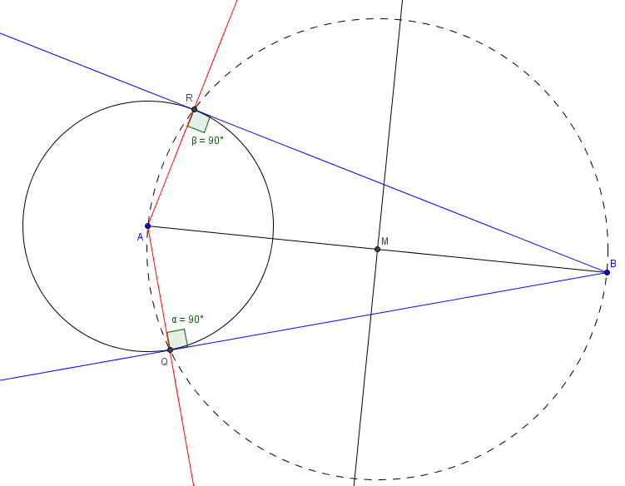
Author Note: Since this diagram was constructed with GeoGebra, I used rays instead of segments to amplify the image. However, most students will probably only draw the segment and not extend it past points of intersections, so be away of the answer keys variation.

