A-APR.B.3 Finding the Zeros of a Cubic Equations
Alex Heide

Alignment to Content Standards: A-APR.B.3, A-REI.A.1, A-REI.A.2

Tasks

- Find all the values of $x$ where the equation $16x=x^{3}$ is true.
- Using a graphing software, graph $f\left(x\right)=x^{3}-16x$. Do the values for $x$ found in part (a) have any relation to the graph? Why?
- Why is it incorrect to solve the equation by dividing by x on both sides of the equation?

Commentary

The purpose of this task is to prompt students to discover the connection from the factored form of a polynomial and the zeroes of the function’s graph. Another purpose of this task is to allow students to see the complications that come from dividing both sides by $x$. This is something that students are unaware of because of what they have learned in earlier grades. Earlier grades push the importance of the doing the same thing to both sides of the equation when dealing with linear equations. When introducing polynomial equations, it is important for students to see that this could cause complications when dividing by a variable. This is significant in this problem because one of the values for $x$ is zero and you cannot divide by zero. This will allow the students to understand the zero product property and find an alternative method of factoring for solving polynomial equations.

Solution

- The values for $x$ are 0, -4, and 4. The student could solve this by using the equation of $x^{3}-16x=0$, then factoring the left side of the equation so that $x\left(x^{2}-16\right)=0$. From the zero product property, we know that $x=0$ or $x^{2}-16=0$. This gives us the first solution of $x=0$ and then we can continue to solve for the other values by setting $x^{2}=16$. We can take the square root of both sides to get $x=±\sqrt{16}$, which results in $x=±4$. This gives us the values of $x$ to be 0, -4, and 4.
- We can use the graphing software Geogebra to graph the function $f\left(x\right)=x^{3}-16x$. 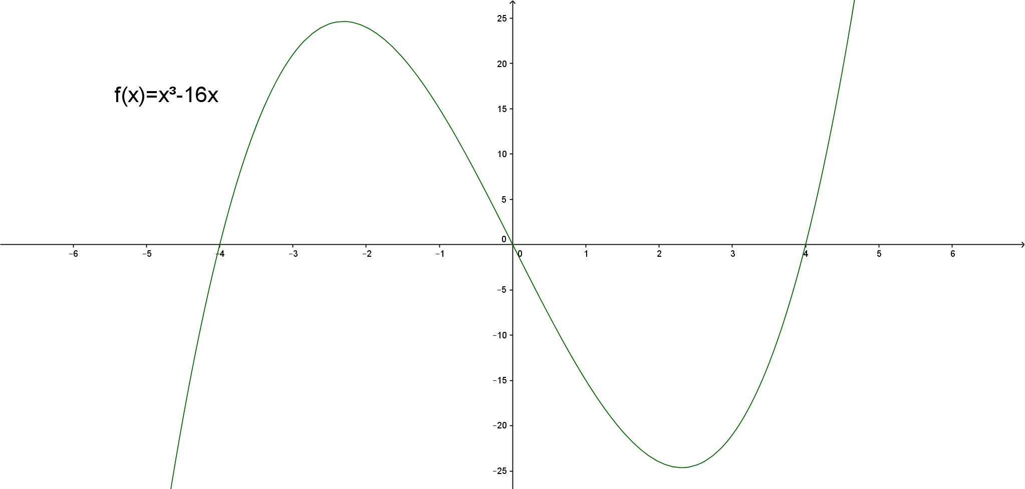
The function intercepts the x-axis when $x$ is -4, 0, 4. This matches the values of $x$ from part (a).
- If you divide both sides by $x$, then you would get $x^{2}=16$. This would get you only two of the solutions: $x=-4$ and $x=4$. This approach only considers non-zero values because it ignores the possibility that $x$ could be zero. It performs a mathematical step that is not valid since one of the values is zero and the step requires you to divide by zero.

