Title (primary CCSS Math with Title)

S-ID Texting Champion

Alignment to Content Standards

S-ID.A.1 S-ID.A.2 S-ID.A.3

Tasks

A student in Ms. Smith’s class claimed that girls text faster than boys. Naturally, the boys disagreed. Therefore, Ms. Smith’s statistics class did an activity where each student calculated the average words per minute they could text. The data is recorded below.

Boys Girls
30 | 46 | 48
36 | 55 | 18
29 | 33 | 35
28 | 32 | 50
5 | 41 | 36
31 | 37 | 29
39 | 40 | 27
23 | 51 | 30
52 | 10 | 53
38 | 45 | 47

- Sketch two side by side box plots to compare the average words per minute of girls and boys. Make sure to include the minimum, maximum, first and third quartiles, and median. Additionally, calculate the mean for each data set.

- Why is the mean less than the median in both boys and girls?

- Compare and contrast the two box plots. What does this mean when we are comparing words per minute between boys and girls?

- If I was trying to describe the center of these distributions, would the mean or median be more appropriate?

- Based upon the data presented above, which gender texts faster? Support your answer with statistical data.

Commentary

This problem could be used as an introduction to comparisons of different data sets. The students will be more engaged because the problem involves something that they are interested in: texting. This problem could also easily be modified to become an activity in which the students in the class are actually allowed to pull out their phones and see, on average, how many words they can text per minute. The purpose of this task is to help students understand the real world connections of box plots and to be able to compare, contrast, and interpret two different sets of data using the statistics necessary to create a box plot.

Being able to compare data sets is an important skill. These data sets have clear similarities and differences. In this case, it appears that females are able to text more words per minute than females. However, this data was just made up. Further research would be necessary to articulate a more precise data set.

A major discussion that can result from this problem is the significance of outliers and how they can “pull” the mean in one direction or another. Students can begin to realize how some statistics can be deceiving because extreme entries can skew the data significantly in either the right or left direction. This problem could be an introduction to data sets in which the mean is more affected by the median.

I made this data up from a random number generator which provided me data ranging from 13 to 55. I used these numbers because it is estimated that most people can type 30-40 words per minute. It would be a fun activity to complete in class in which the students are the ones that generate the data based on their personal average words per minute texting speed.

Solution
- Sketch two side by side box plots to compare the average words per minute of girls and boys. Make sure to include the minimum, maximum, first and third quartiles, and median. Additionally, calculate the mean for each data set.

Boys: mean 33.9
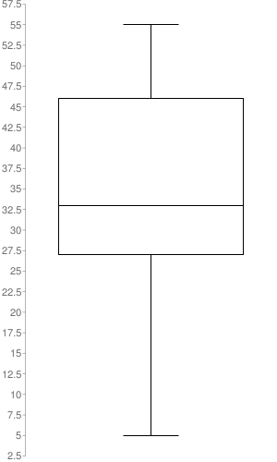

Girls: mean 36.8
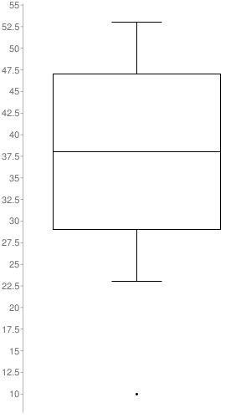

- Why is the mean less than the median in both boys and girls?

The mean is less than the median because the mean is affected by outliers. The distribution is slightly skewed to the right. Since the mean averages all the data, low number such as 5 for the males and 15 for the females causes the average to be pulled in the direction of these outliers.

- Compare and contrast the two box plots. What does this mean when we are comparing words per minute between boys and girls?

Both box plots are similar in that they both have outliers that pull the data to the right. It makes sense that there will be some students who will text slower than others. It will probably not be the case that there will be students who will text significantly faster than the rest of the students; however, it is plausible for there to be a couple students in class who do not have that much experience with texting and will text rather slow in comparison to their peers. The box plots are different in that the girls texted slightly faster than the boys so the first and third quartiles and the median are higher on the number line for the girls compared to the boys.

- If I was trying to describe the center of these distributions, would the mean or median be more appropriate? Why?

Since the mean is affected by the outliers, the median would be the most appropriate description of the centers for these distributions. The mean is only an appropriate description of the center when the data is relatively symmetric. The outlier of the girls affects the data more than the outlier for the males.

- Based upon the data presented above, which gender texts faster? Support your answer with statistical data.
According to this data, girls text faster than the boys. The median of the boys is 35 while the median of the girls is 38. The first and third quartiles for the girls are 29 and 47, respectively whereas first and third quartiles for the males are 29 and 46. The fact that the first and third quartiles are so similar shows that the difference between the speed of girls texting and boys texting is very minute.

