We will find YOU CO.B.8

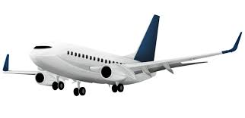

$42°$

*39,000 feet*

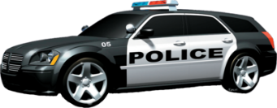

Ground

$$48°$$

What is the length of the laser?

How far does the police have to travel to reach the perpetrator?