Title

G.SRT Calculating the Area of a Traffic Sign

Alignment to Content Standards
HSG.SRT.C.6 Understand that by similarity, side ratios in right triangles are properties of the angles in the triangle, leading to definitions of trigonometric ratios for acute angles.
HSG.SRT.C.8 Use trigonometric ratios and the Pythagorean Theorem to solve right triangles in applied problems.*
Tasks

Yield signs are traffic signs shaped like an equilateral triangle. Estimate the area of the sign assuming that the triangle is an equilateral triangle (round to the nearest hundredth). Explain how you got to your conclusion.
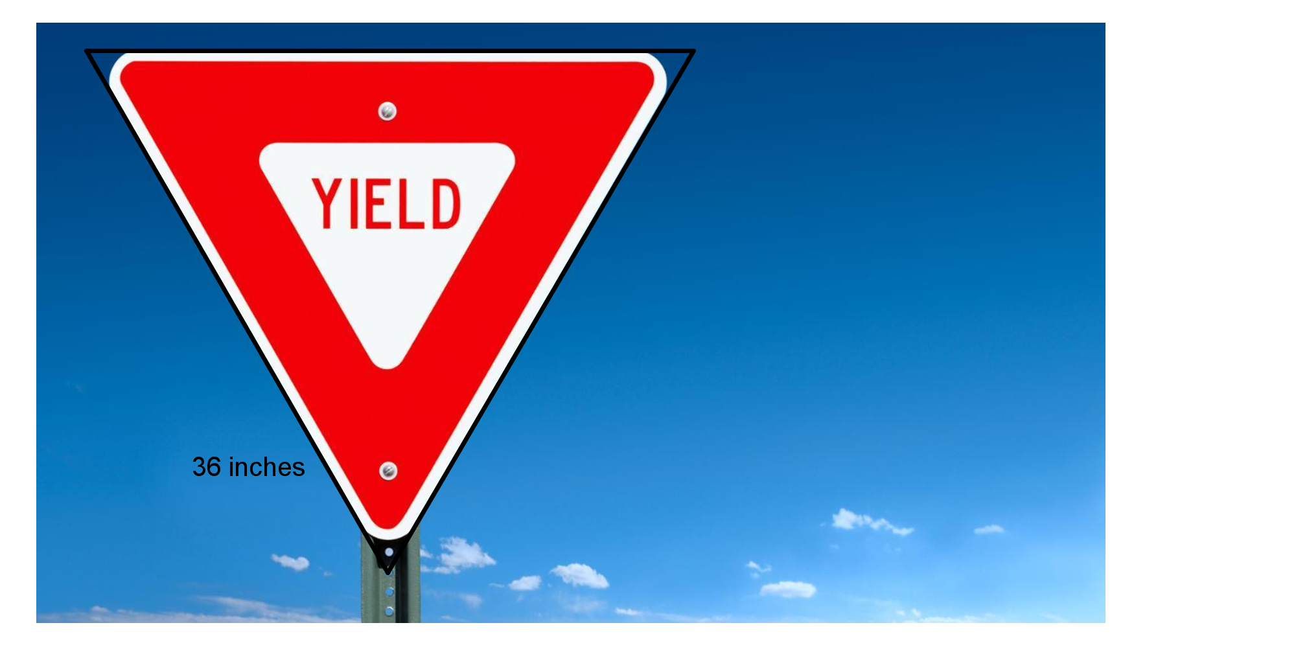

Commentary
This task involves area computation without all of the necessary components. In this, all that is given is the length of the side and the fact that the triangle is equilateral. Using these two facts, this problem can be solved using trigonometric ratios of a right triangle. Not only will students need to recognize the uniqueness of the 30° 60° 90° triangle, but they also need to utilize the special attributes to perform calculations.
This task would be used to reinforce concepts rather than introduce them. This task would suited to check for understanding after a lesson. Students will need to be familiar with the 30° 60° 90° configuration in order to recognize it in the triangle. When completed correctly, this task shows that students can utilize the important elements of a specialty triangle to complete a task.

Solution
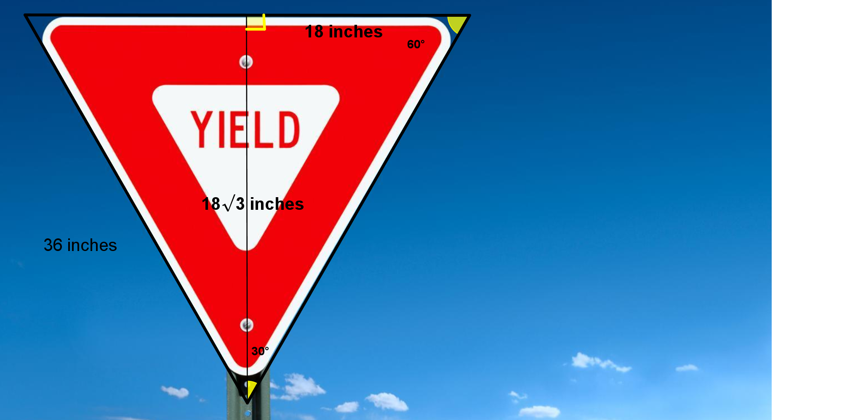
The instructions state to assume that the sign is an equilateral triangle. This means that all angles in the triangle are 60°. If an altitude is drawn from the bottom vertex to the midpoint of the top of the sign, a right triangle emerges. Because all angles in the triangle are 60°, the altitude bisects the bottom angle into a 30°. The right and left angles on the sign are still 60°, with a right angle on either side of the altitude.

Because this is a 30° 60° 90° triangle, the hypotenuse is twice the shortest leg and the last leg is equal to the shortest leg multiplied by $√3$ . This means that the shortest leg is 18 inches and the height of the triangle is $18√3$ inches. Now that the height and the length of a base is known, the formula for the area of a triangle can be used ($area=\frac{1}{2}bh$)

$$Area =\frac{1}{2} (36) (18\sqrt{3})$$
$$Area = 561.19 {inches}^{2}$$

