Lesson Title: Area and Surface Area
Unit Title: Geometry Learning Progression Part 2
Teacher Candidate: Alex Heide
Subject, Grade Level, and Date: High School Applied Geometry, February 17

Placement of Lesson in Sequence
This is the second lesson in the learning progression following the students discovering π. The students will use this knowledge of what π is to calculate the area of a circle. This will lead to including other shapes and finding the area or surface area. This lesson will lead directly into the final portion of the learning progression where the students will calculate the volume of certain objects.

Central Focus and Essential Questions
The central focus of this lesson will be on calculating area and surface area of certain objects. The lesson will begin with simple two-dimensional shapes such as rectangles, circles, and triangles. From these shapes, we can build into finding the surface area of three-dimensional objects that can be related to the real-world. Some essential questions that will be asked are “what is the difference between area and surface area?”, and “what real-world applications can be related to finding the area of a three-dimensional object?” (e.g. painting the outside your house).

Content Standards
CCSS.Math.Content.7.G.B.6
Solve real-world and mathematical problems involving area, volume and surface area of two- and three-dimensional objects composed of triangles, quadrilaterals, polygons, cubes, and right prisms.

Learning Outcomes | Assessment
The students will be able to calculate the area and surface area of two-dimensional and three-dimensional figures. | The students will be assessed from their answers on the in-class worksheet that they will need to complete by the end of the period. Each question will be graded on a point system that will vary depending the amount of work required of the problem.

Learning Targets | Student Voice
I can calculate the area of two-dimensional shapes and three-dimensional objects along with relating area with the real-world. | The students will be able to show their knowledge at the beginning of the lesson during the instructional portion of the class since it will require the students to come up with most of the answers. The students will also be given a worksheet that leads them write the equations to determine the area of each shape and for them to use reason to explain how to the surface area of a cylinder.

Prior Content Knowledge and Pre-Assessment
The students have been introduced to area so they will have an understanding of the equations and what area is. The students will be pre-assessed informally on this knowledge prior to getting the worksheet to see how much they remember about area and surface area. They have also just discovered π in the previous lesson so they have knowledge of where this value comes from.
Academic Language Demands
Vocabulary & Symbols | Language Functions | Precision, Syntax & Discourse
- Area and Surface Area  - Length and Width  - Radius  - Base and Height  - Rectangle, Circle, Triangle  - Cylinder and Prism | - The students will have to use the dimensions and height to define equations for area and surface area. | Mathematical Precision:  The students must accurately calculate the area and surface area of a figure either with the given information or by measuring it themselves.  Syntax:  The students will use proper syntax when writing out the equation for the area of each of the two-dimensional shapes.  Discourse:  The students will use correct discourse by writing what they notice about the shapes that make up a cylinder and what the difference between area and surface area is. The students will also need to justify orally why surface area is important in the real-world.

Language Target | Language Support | Assessment of Language Target
I will be able to show my knowledge of the terms that are needed to calculate the area or surface area to create a general equation. | I will provide language support by having the students determine what number goes to which dimension or height. I will also ask them at the end of the worksheet as to what the difference between area and surface area is. | The students will be assessed on the language target by accurately being able to label each term needed for calculating the area of a shape on the worksheet.

Lesson Rationale (Connection to previous instruction and Objective Standards)
This lesson builds on the previous lesson of discovering π by having the students apply this irrational number to equations for the area of a circle. The lesson also uses the students’ origami prisms that they created as a figure to calculate the surface area of.

Differentiation, Cultural Responsiveness and/or Accommodation for Individual Differences
The students have been introduced to area before but they struggle to retain certain information. The beginning of the class will be used to remind the students of what they know about the equations. The worksheet also leads the students to show the whole thought process of finding the area so that they can have an extra visualization of what they needed to find in order to calculate the area or surface area.

Materials – Instructional and Technological Needs (attach worksheets used)
The students will need a ruler, possibly a calculator, and the worksheet (attached below with rubric).

For problems 1-3, write the area equation for each the polygons and then find the area.

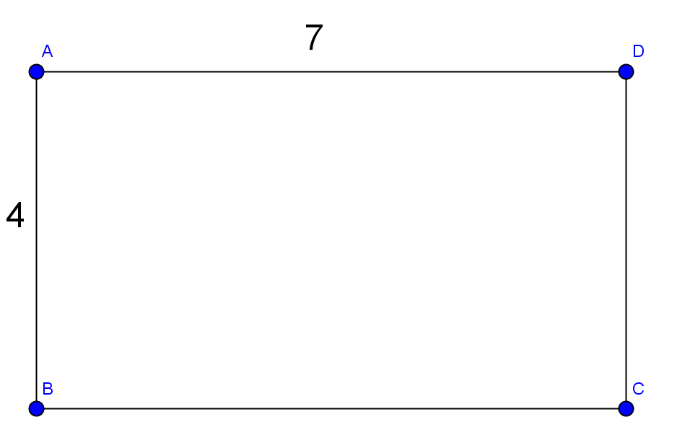
Length=
Width=
Equation:
Area=

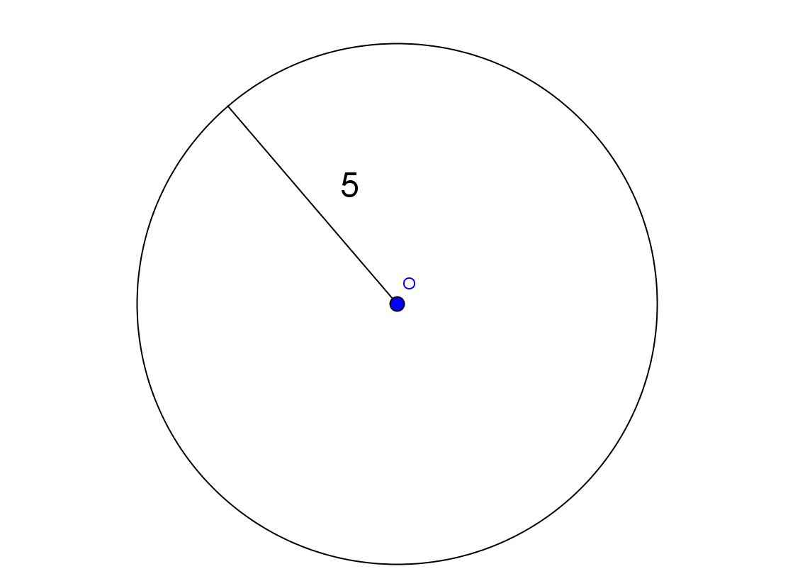
Radius=
Equation:
Area=

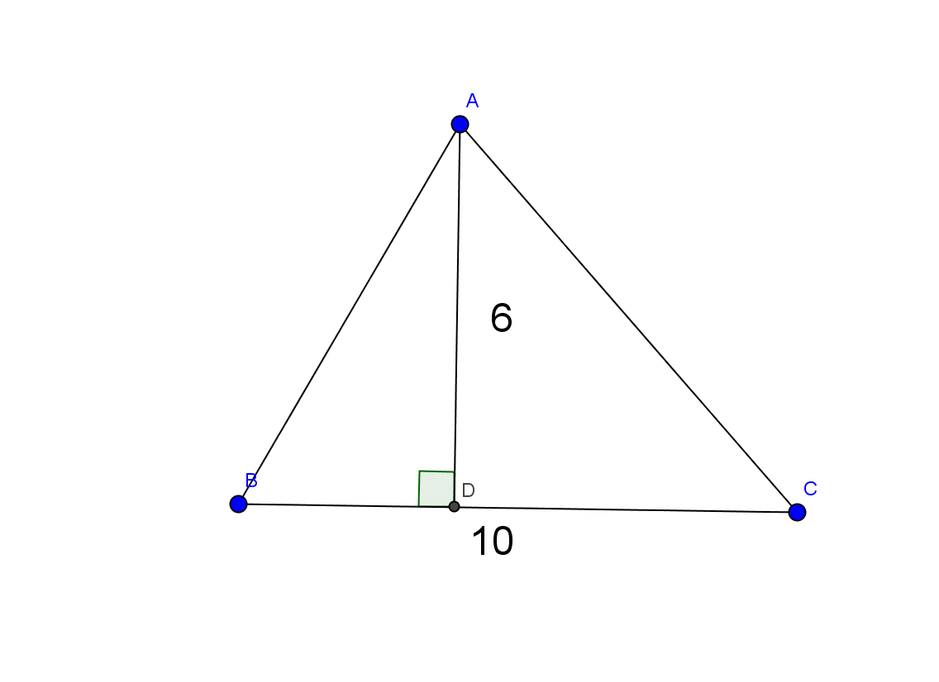
Base=
Height=
Equation:
Area=

- Find the surface area of your origami figure. (Show all work to receive full credit)

Surface Area=

- What do you notice about the shapes of a cylinder for calculating the surface area?

- Find the surface area of the given cylinder. (Hint: you will need to use a ruler to find the dimensions)
Radius= Height=

Surface Area=
- What is the difference between area and surface area?

Rubric

Problem | Points per Problem | Answer
1 | 1 | 28
2 | 1 | 25π
3 | 1 | 30
4 | 2 | Varies on prism
5 | 2 | Two circles and a rectangle with dimensions 2πr and h
6 | 2 | ≈8π
7 | 1 | Area is two-dimensional, Surface Area is three-dimensional
Total | 10

Teaching & Instructional Activities
Time | Teacher Activity | Student Activity | Purpose
5-10 minutes | Review of what the students know about area and surface area equations, real-world applications, and difference between area and surface area. | Be a part of the discussion to display their knowledge of area and surface area. | The purpose is to find out how much the students know in terms of area and surface area.
The rest of the period | Guide the students while they complete the worksheet. | Calculate the area and surface area of specific figures. | The purpose is for the students to show mastery of area and surface area.

