Ashley Browne
High School: Algebra
Seeing Structure in Expression

This learning progression will be used for a high school sophomore Algebra class. The textbook they have been working out of is an online book Cord Algebra 1 Learning in Context, Fourth Edition. The common core state standard Math domain High School Algebra, Seeing Structure in Expressions and the cluster is write expressions in equivalent forms to solve problems. The learning progression is aligned with the standard HSA.SSE.B.3: Choose and produce an equivalent form of an expression to reveal and explain properties of the quantity represented by the expression. Students will also be required to demonstrate the following mathematical practices; MP2: reason abstractly and quantitatively, MP6: attend to precision, and MP8: look for and express regularity in repeated reasoning.

Students have been previously working on foiling and factoring quadratic equation and seeing what they look like when graphed. Through this learning progression, students will be working with equations to complete the square to factor, and then using that to find the zeros of that equation. Students will also be working with exponents and exploring the various exponent rules. All these tasks align within the state standard HSA.SSE.B.3.

To teach the students the concept of equivalent expressions of polynomials, students will be going through many different lesson styles. The first being a cooperative learning lesson where students will work with their peers in a competitive and cooperative learning environment to help each other succeed. The second less is a more hands-on exploratory lesson so students can get familiar with different methods of completing the square to factor a quadratic equation. Finally, students will partake in a more traditional style lesson to learn different exponent rules, and then work on a worksheet to practice their proficiency.

Seeing Structure in Expression
Write Expressions in Equivalent Forms to Solve Problems
For the first lesson in the learning progression, the students will be using their prior knowledge to complete the squares and find the zeros in the equations. This lesson will align with the common core state standard HSA.SSE.B.3.A. The activity the students will be doing to solidify their knowledge on factoring and finding the zeros or functions will be a jeopardy style game where the students work in groups and compete against their fellow students. Students will be able to choose different categories in the jeopardy game to then answer questions for "points" that will be given to them if they answer the question correctly. Some examples of things the questions will ask are, "factor the function," "what are the zeros of the function?," and "looking at the graph, what are the zeros of this function?". There will be many of these types of questions ranging in difficulty to get the students working with their team to come up with solutions. This activity will allow the students to practice looking at equations in function format, factoring functions, and finding the zeros of the functions. This lesson will also allow the students to find patterns in factoring equations and completing the squares, MP8. The students will find patterns in completing the square, such as adding half of the coefficient in front of the b term and squaring it. This will help them create a formula for completing the square that will help them when the equations get more complex.  The assessment for this activity will be a hinge question in the form of an exit slip. The hinge question will ask students to look at finding zeros of a function in a different way. Instead of asking the students to factor and then find the zeros, the exit slip will ask them to find the functions that match the given zeros. The exit slip will be as follows:  What is a function that would have 5 and –6 as the zeros?  ANSWER: x² + x – 30 or –x² – x + 30.  This hinge question will allow the teacher to assess the students without having them feel the pressure of taking an exam or a quiz. It will also allow the teacher to assess whether they need to cover the material more in depth or move on to the next lesson  The next lesson in the progression will have the students working with completing the square to factor equations that will reveal the maxima and minima of the function which aligns with the standard HSA.SSE.B.3.B. The activity will span two class periods. The first class period the students will explore different methods to complete the square of a function. This will be an activity where students are put into groups and go to different stations around the classroom and work on completing the squares using a given method for each station. The second day of this lesson will be purely lecture and practice so the students can learn how to find the maximum and minimum of a function by completing the square. After the lecture portion of the class they will work on practice problems from the book. This lesson will have the students reason abstractly and quantitatively, MP2. The students will first complete the square to solve for the zeros in the equation; it will then be up to them to think abstractly to connect the zeros with the point of the equation that is either maxima or minima.  The final assessment for this common core state standard will be a completed worksheet that has the problems worked out for each of the methods covered in the class. This worksheet is located at the bottom of this document. The practice problems from day two of this lesson will be turned in and used as the formative assessment for the day.  The final lesson in the progression has students working with exponent rules and using them to write statements that are equivalent to each other. This is aligned to the standard HSA.SSE.B.3.C. To start with I would directly model simplifying operations of exponents on like terms. Once the students have gone through examples of exponent rules they will be given a worksheet that will help them get a firm grasp on the content. The students will work with adding exponents, subtracting exponents, and changing the base values to make equal statements. The worksheet will be a cooperative worksheet where the students are allowed to work with their peers to help each other problem solve through the worksheet. The assessment for this section will be the worksheet that they worked on in class, handed in at the end of the day or finished as homework and handed in the next day. This worksheet will also be located at the end of this document. This lesson has the students practicing their precision in calculating numbers using the exponent rules, MP6. The students will be doing this by completing the work sheet that can be seen below. Students will be able to practice putting the exponent rules to use in their worksheet that is located below. This will allow them to attend to the precision of using the exponent rules correctly. | HSA.SSE.B.3.A Factor a quadratic expression to reveal the zeros of the function it defines.  MP8 Look for and express regularity in repeated reasoning.  HSA.SSE.B.3.B Complete the square in a quadratic expression to reveal the maximum or minimum value of the function it defines.  MP2 reason abstractly and quantitatively  HSA.SSE.B.3.C Use the properties of exponents to transform expressions for exponential functions. For example the expression 1.15t can be rewritten as (1.151/12)12t ≈ 1.01212t to reveal the approximate equivalent monthly interest rate if the annual rate is 15%.  MP6 Attend to precision

Worksheet
CCSS.MATH.CONTENT.HSA.SSE.B.3.B
Complete the square using the box method
a² + 2a – 3 ANSWER

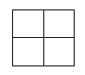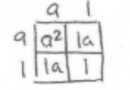

Use algebra and manipulation of the quadratic to complete the square
x² – 4x – 8 = 0 ANSWER
x² – 4x + 4 = 8 + 4
x² – 4x + 4 = 12
(x – 2)² = 12
Complete the square algebraically
x² + 2x + _____ ANSWER
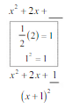

Worksheet
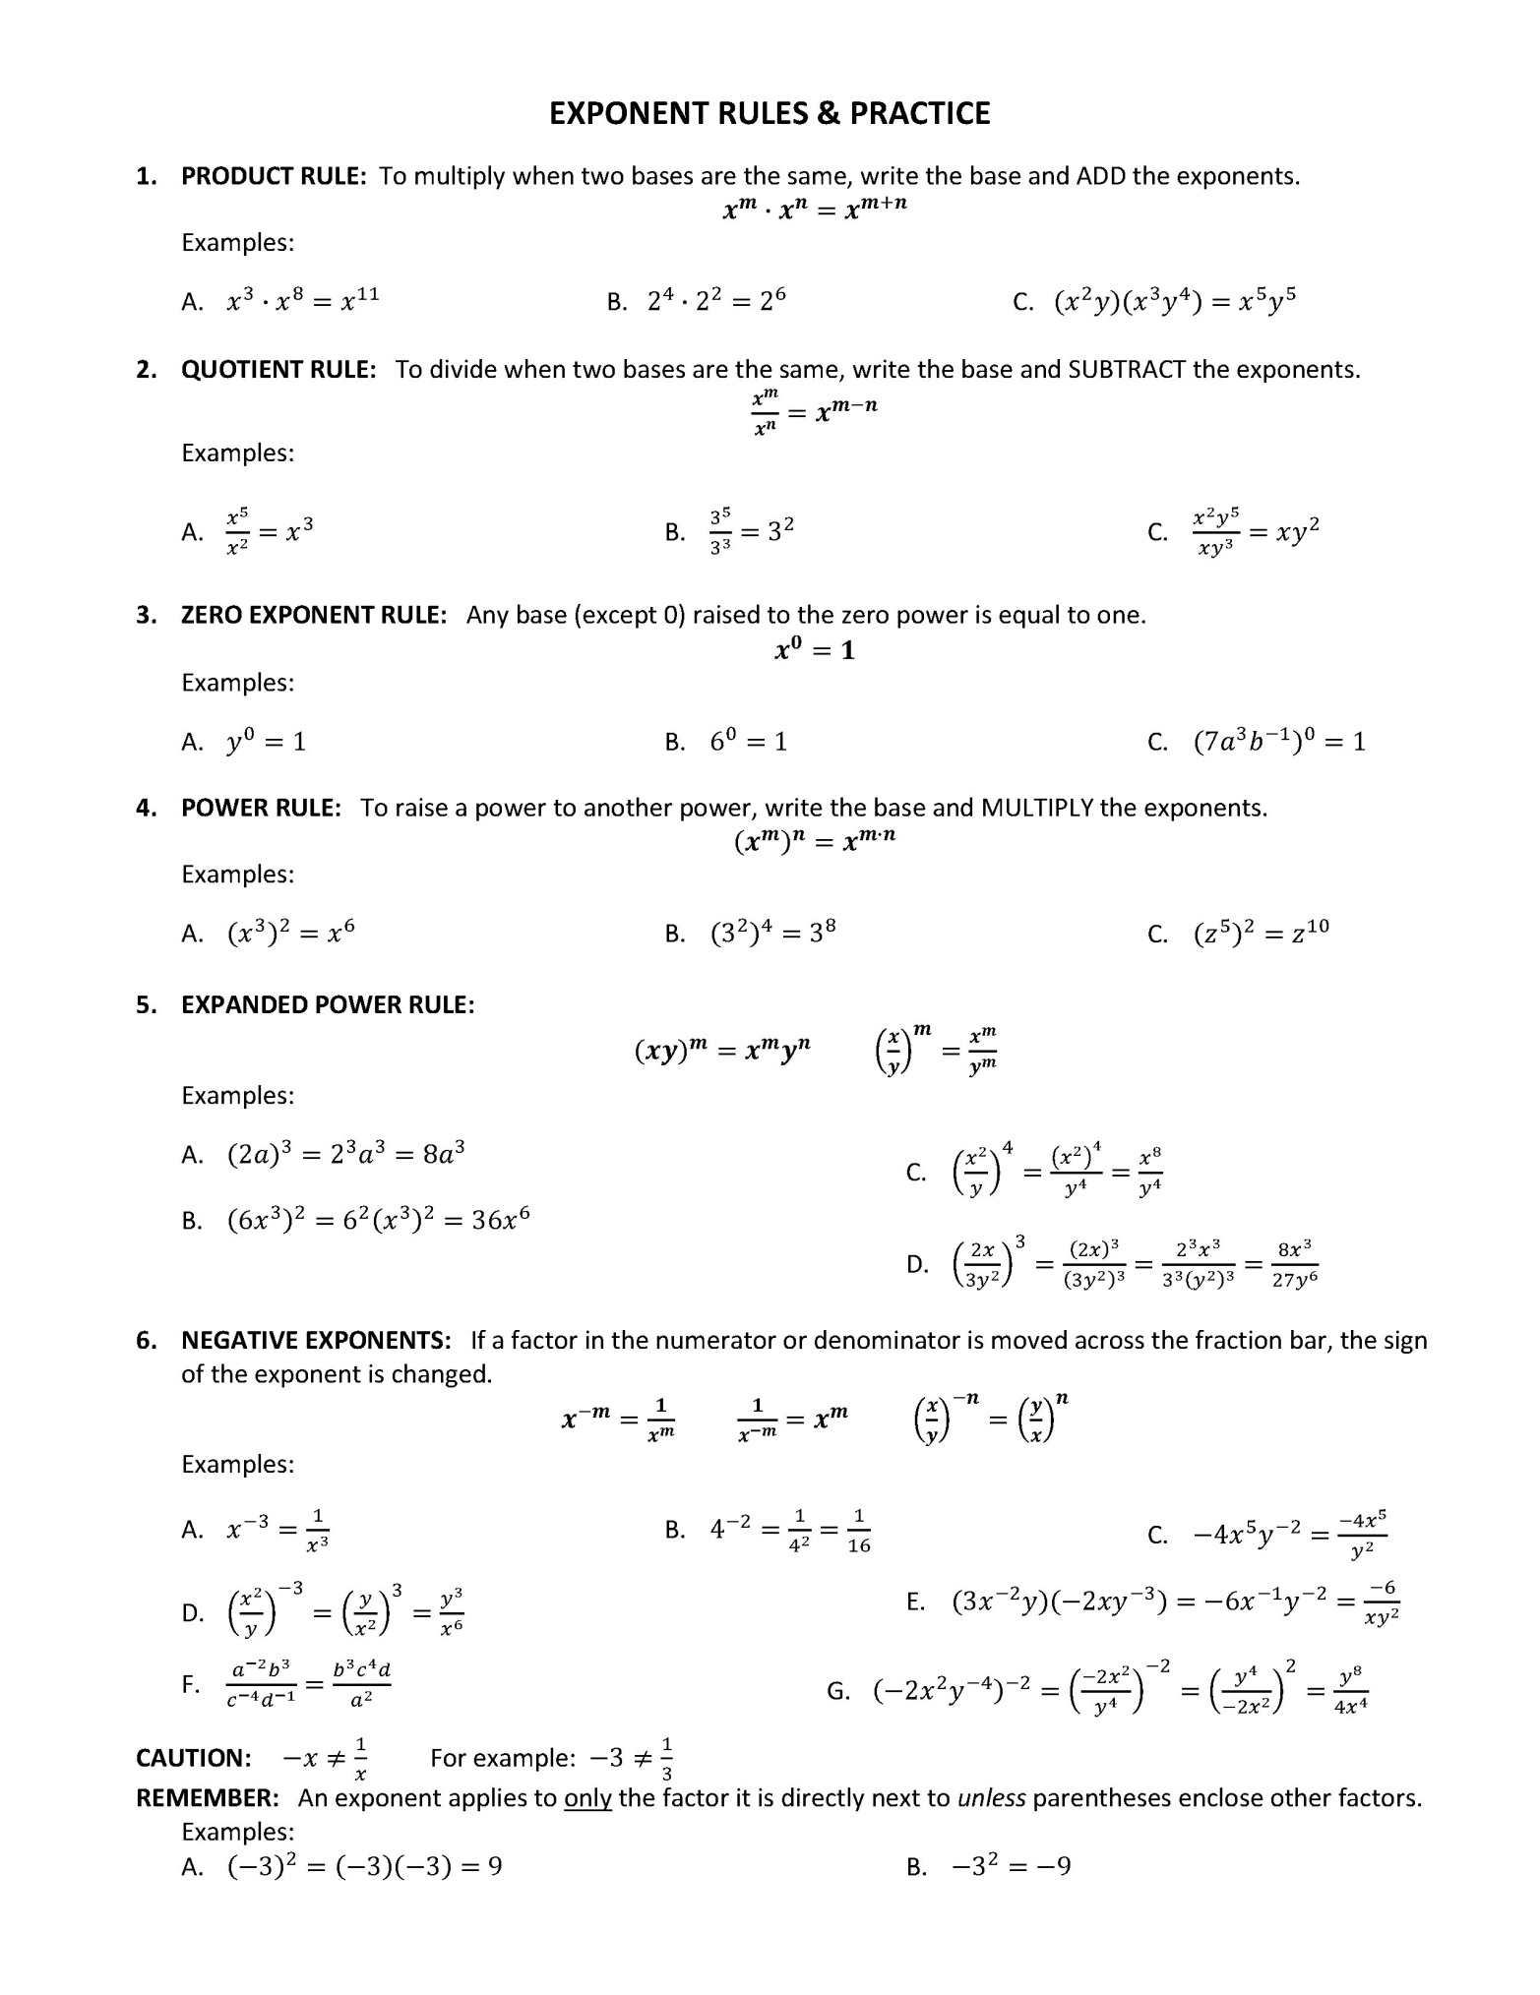
CCSS.MATH.CONTENT.HSA.SSE.B.3.B
