Algebra 1: Exploring Linear Functions Understanding Slope and Intercepts

Overview

Sections 10.5, 10.6, and 10.7 assemble the learning progression for the Algebra 1 class at the Granger High School. The Algebra 1 class consists of 25 students (23 freshmen and 2 sophomores). These students were placed in this classroom because they showed difficulty in their mathematics course in the 8th grade and their testing done before high school.
The curriculum used in this Algebra class is called Agile mind.

What is agile Mind?

Agile Mind is a research-based curriculum that emphasizes on formative assessments. Modeling is one of the key components of this curriculum. All the concepts and lessons are tied to a real world concept that focuses on helping students understand their surroundings whether they are done through economics or engineering. Most of the modeling is done through animations. The curriculum is aligned with standards that implement the Common Core standards. One of their focuses is Academic Youth Development (AYD):
“Move beyond growth mindset. AYD is based on new knowledge emerging from the psychological sciences that reshapes students’ academic identities, enhances their engagement in learning, and transforms their achievement.”- agile Mind

The curriculum consists of workbook, online program, and teacher notes. The workbook, Intensified Algebra I: Student Activity Book, Volume I Representing mathematical relationships: the graders Linear Functions and their foundations, 2015-16 Edition contains the students’ outlined lesson (fill-in-the-blank) notes with homework and a staying sharp section. The staying sharp section consists of homework problems review concepts taught in previous lesson. The online portion of this curriculum contain the student’s outlined notes, plus animations (videos and interactive content) to draw students’ attention. Animations are usually real world problems or modules that show students’ step-by-step solutions during the lesson. The animations also show students different ways to approach all the problems. One of the biggest components of the online portion of this curriculum is the formative and summative assessments online. Students log on to the Agile Mind website with their assigned username and password to take the formative and summative assessments. Students are able to move on at their pace. The teacher is allowed to see the students’ progress as they finish questions. Agile mind provides the teacher with a summary of each student’s progress and the average comprehension among the whole class. This curriculum is built for students and for teachers who preferred formative assessments, job-embedded professional supports and real-time data & reports. Curriculum was made for middle school students and high school students.

Common State Standards used for this learning progression are as follows:

CCSS.MATH.CONTENT.8.F.A.2
Compare properties of two functions each represented in a different way (algebraically, graphically, numerically in tables, or by verbal descriptions). For example, given a linear function represented by a table of values and a linear function represented by an algebraic expression, determine which function has the greater rate of change.

Use functions to model relationships between quantities.
CCSS.MATH.CONTENT.8.F.B.4
Construct a function to model a linear relationship between two quantities. Determine the rate of change and initial value of the function from a description of a relationship or from two (x, y) values, including reading these from a table or from a graph. Interpret the rate of change and initial value of a linear function in terms of the situation it models, and in terms of its graph or a table of values.

Analyze and solve linear equations and pairs of simultaneous linear equations.
CCSS.MATH.CONTENT.8.EE.C.7
Solve linear equations in one variable.

CCSS.MATH.CONTENT.8.EE.C.8
Analyze and solve pairs of simultaneous linear equations.

CCSS.MATH.CONTENT.8.EE.C.8.A
Understand that solutions to a system of two linear equations in two variables correspond to points of intersection of their graphs, because points of intersection satisfy both equations simultaneously.

CCSS.MATH.CONTENT.8.EE.C.8.C
Solve real-world and mathematical problems leading to two linear equations in two variables. For example, given coordinates for two pairs of points, determine whether the line through the first pair of points intersects the line through the second pair.

The Mathematical Practices used for this learning progression are as follows:

CCSS.MATH.PRACTICE.MP1 Make sense of problems and persevere in solving them.
Mathematically proficient students start by explaining to themselves the meaning of a problem and looking for entry points to its solution. They analyze givens, constraints, relationships, and goals. They make conjectures about the form and meaning of the solution and plan a solution pathway rather than simply jumping into a solution attempt. They consider analogous problems, and try special cases and simpler forms of the original problem in order to gain insight into its solution. They monitor and evaluate their progress and change course if necessary. Older students might, depending on the context of the problem, transform algebraic expressions or change the viewing window on their graphing calculator to get the information they need. Mathematically proficient students can explain correspondences between equations, verbal descriptions, tables, and graphs or draw diagrams of important features and relationships, graph data, and search for regularity or trends. Younger students might rely on using concrete objects or pictures to help conceptualize and solve a problem. Mathematically proficient students check their answers to problems using a different method, and they continually ask themselves, "Does this make sense?" They can understand the approaches of others to solving complex problems and identify correspondences between different approaches.

CCSS.MATH.PRACTICE.MP4 Model with mathematics.
Mathematically proficient students can apply the mathematics they know to solve problems arising in everyday life, society, and the workplace. In early grades, this might be as simple as writing an addition equation to describe a situation. In middle grades, a student might apply proportional reasoning to plan a school event or analyze a problem in the community. By high school, a student might use geometry to solve a design problem or use a function to describe how one quantity of interest depends on another. Mathematically proficient students who can apply what they know are comfortable making assumptions and approximations to simplify a complicated situation, realizing that these may need revision later. They are able to identify important quantities in a practical situation and map their relationships using such tools as diagrams, two-way tables, graphs, flowcharts and formulas. They can analyze those relationships mathematically to draw conclusions. They routinely interpret their mathematical results in the context of the situation and reflect on whether the results make sense, possibly improving the model if it has not served its purpose.

CCSS.MATH.PRACTICE.MP7 Look for and make use of structure.
Mathematically proficient students look closely to discern a pattern or structure. Young students, for example, might notice that three and seven more is the same amount as seven and three more, or they may sort a collection of shapes according to how many sides the shapes have. Later, students will see 7 × 8 equals the well-remembered 7 × 5 + 7 × 3, in preparation for learning about the distributive property. In the expression x² + 9x + 14, older students can see the 14 as 2 × 7 and the 9 as 2 + 7. They recognize the significance of an existing line in a geometric figure and can use the strategy of drawing an auxiliary line for solving problems. They also can step back for an overview and shift perspective. They can see complicated things, such as some algebraic expressions, as single objects or as being composed of several objects. For example, they can see 5 - 3(x -y)² as 5 minus a positive number times a square and use that to realize that its value cannot be more than 5 for any real numbers x and y.

CCSS.MATH.PRACTICE.MP8 Look for and express regularity in repeated reasoning.
Mathematically proficient students notice if calculations are repeated, and look both for general methods and for shortcuts. Upper elementary students might notice when dividing 25 by 11 that they are repeating the same calculations over and over again, and conclude they have a repeating decimal. By paying attention to the calculation of slope as they repeatedly check whether points are on the line through (1, 2) with slope 3, middle school students might abstract the equation (y - 2)/(x - 1) = 3. Noticing the regularity in the way terms cancel when expanding (x - 1)(x + 1), (x - 1)(x² + x + 1), and (x - 1)(x³ + x2 + x + 1) might lead them to the general formula for the sum of a geometric series. As they work to solve a problem, mathematically proficient students maintain oversight of the process, while attending to the details. They continually evaluate the reasonableness of their intermediate results.

These standards in Algebra address:
Unit 4: Linear Functions, Topic 10: Understanding slope and intercepts which will be addressed in this learning progression. This unit will reinforce the vocabulary, and analyze of linear functions using strategies and routines used in class. Topic 10 will connect the ideas of rate of change with the slope of a line and perpendicular lines. As well as understanding intercepts through the standard from of a line. The last lessons consist of teaching students how to use Point-slope form. The use of different representations such as graphs, tables, function rules, and verbal expressions will be an essential part of this learning progression.

The themes with in these three lessons (10.5-10.7) are as follows:

- Practice of using graphs, tables, and function rules to analyze a linear function.
- Discover the connection between the slope of a line and perpendicular lines.
- Use first differences to determine whether a function is linear or not.
- Explore the difference between an x-intercept and y-intercept and see how it is represented in a graph.
- Understand the several representations of a line through a formula including standard form, point slope, and slope form.
- Learn how to determine whether a line is parallel

Linear Equations is one of the most essential lessons in the Algebra 1 curriculum. Emphasizing the retention of the concepts learned in this lesson is essential for the successful progressions for the rest of the mathematics sequence in high school. Formalizing a vocabulary and algebraic processes involving & analyzing attributes of linear functions will be the goal of this learning progression. In addition, Mathematical practices will be compacted in the following lessons. These are the mathematical practices being used in the previous learned strategies and routines that students will be developing will enhance the learning of the students. During the introduction of functions students will plot the points from the table and determine how linear functions work and look like. By graphing and analyzing, students will begin to understand linear equations. Students will begin by understanding rate of change and slope whether the line is parallel and perpendicular. The equation slope will be learned and shown in different manners. Students will not be required to learn formulas, but build comprehensive understanding that help them understand and find key components of a linear equation/function. The lessons of the learning of the progression plan consists of an opener, core activity (main lesson), consolidation activity (wrap-up example), homework, and staying sharp worksheet. All the examples are based on a real-world problem that emphasizes the key points of a linear function.
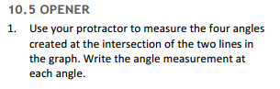
Throughout the learning progression students will learn that a linear function has one input and only one output.
The Common Core State Standards are intermixed because the topics will be mixed since the lessons the teacher like to use previous knowledge learned in previous lessons.
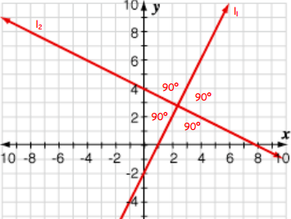
Figure 1
10.5 Slope and Perpendicular Lines

Opener
Students will be asked to use a protractor to measure the angle of the given lines. Students then will be able to determine that the angle is 90 degrees therefore emphasizing the concept of perpendicular lines (Fig. 1). They will understand that perpendicular lines make a right angle. Students will then be asked to describe the relationship between the given two lines using the following vocabulary: right angle, intersection, lines, and perpendicular.

Core Activity

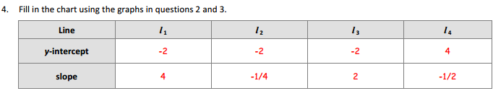
The first problem will ask students to dissect the term perpendicular lines. Students must name the vocab term as well as describing what it means to them. They will also draw an example of what perpendicular lines are. Both exercises two and three will have students analyze a pair of perpendicular lines. Students will use the idea of slope triangles to discover the similarities and differences in slope of two perpendicular lines. They will discover that a pair of perpendicular lines have slopes that are either negative or positive. Given exercises two and three, students obtain the slope and y-intercepts of all four line. They must now compare the slope and y-intercepts among each of those lines (Fig. 2).

Figure 2
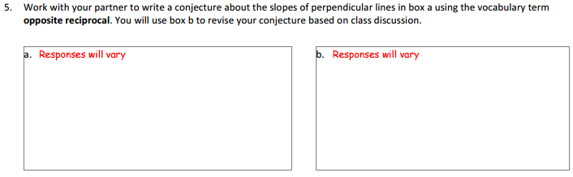
In Figure 3, students must work with a partner to obtain each other’s definition of a perpendicular line using the term opposite reciprocal. The following exercise requires students to compare the slope between a pair of parallel lines or perpendicular lines.

Figure 3
Consolidation Activity
The first exercise in the consolidation activity is to have students generate the slope of the perpendicular line given the original slope. For exercises two and three students will be required to use the information given to find the perpendicular line to the given point and line. In the third exercise students are required to determine whether the perpendicular given is correct (Fig. 4).
Figure 4

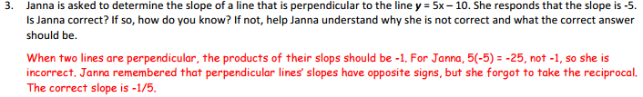
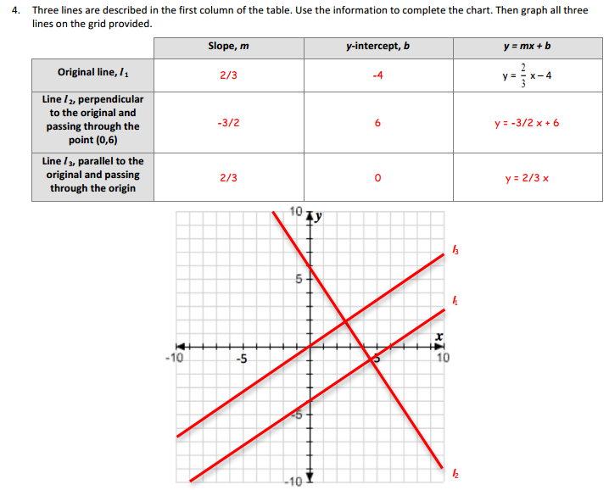
Problem number 4 requires that students dissect the given equation to determine the slope for a parallel and perpendicular line and then graph all the lines in the given problem (Fig. 5). Problem 5 is connected to problem four because It asks students to determine whether the $l_{3}$ is perpendicular to$l_{2}$. Students will discover that given a line and its parallel lines, a perpendicular line to any of those given lines is perpendicular to any of the lines. The conclusion of the lesson involves students using the point slope formula to obtain new equations that are either perpendicular or parallel to the given line.
Figure 5

Homework
Students will have the freedom to choose their line given the slope while sketching its perpendicular line, then students will analyze their two lines. The second problem in the homework has students analyzing 8 equations and they will determine whether the given pair are perpendicular lines (Fig. 6). Problems 3 and 4 requires students’ ability to plot points and come up with a perpendicular line, and then explain algebraically why they are perpendicular. Problems 5, 6 and 7 has students using the point slope formula to find the perpendicular lines given the slope.

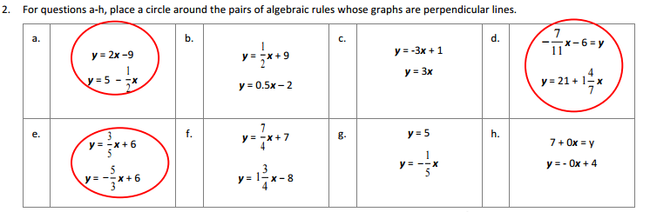
Figure 6
Staying Sharp
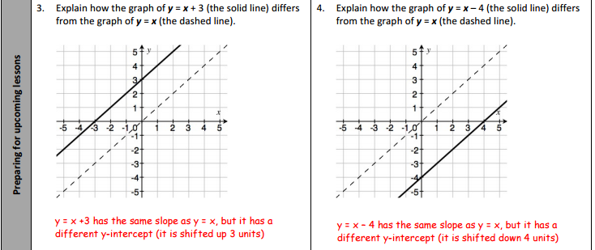
The staying sharp activity will focus on the students’ ability to read a graph in problems 1 and 2. Problems 3 and 4 students analyze the given graphs and decide their differences (Fig. 7). Conversions will also be part of the lesson giving the students the opportunity to practice previous knowledge.
Figure 7

10.6 intercepts and Standard Form
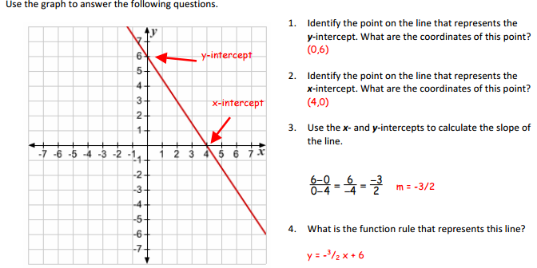
Figure 8
Opener
Students will be asked to identify the x-intercept and y-intercepts. Once they identify and write their ordered pair students will find the slope and write the slope form of the line and then graph it (Fig. 8).

Core Activity
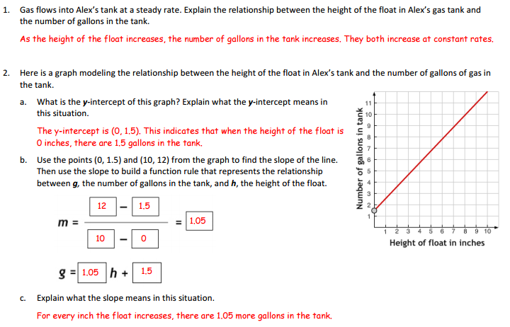
Problem 1 and 2 analyzes the float of Alex’s (a character from the animations) car. They will study the relationship between Alex’s float and the number of gallons in the tank. Problem 2 provides a line that models Alex’s tank and the number of gallons within the gas tank. Students will interpret the meaning of the y-intercept. Students will then identify two points within the graph to find slope. Teacher will then proceed to teach students how to find slope and its overall meaning and within the problem (Fig. 9).
Figure 9
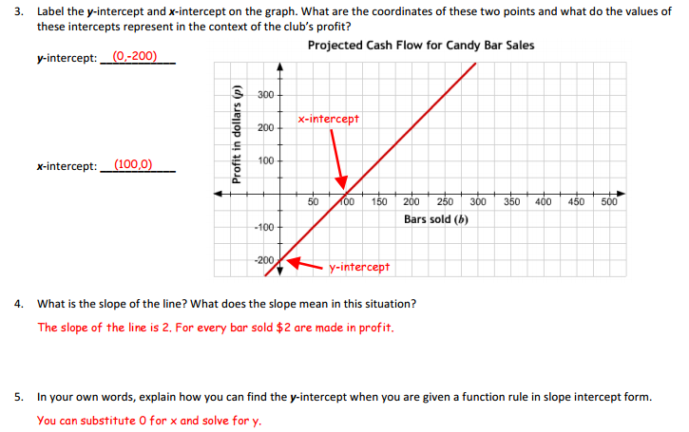
Problem 3, 4, and 5 provides students with the intercepts of an equation, students will then find the slope and interpret its meaning as well as the intercepts (Fig. 10).

Since one of the main goals of the lesson is for students to learn how to obtain intercepts and standard form, problem number 6 and 7 shows students the steps to obtain the intercepts using standard form (Fig. 11).
Figure 10
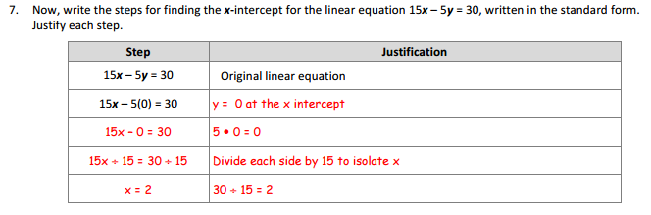
Figure 11

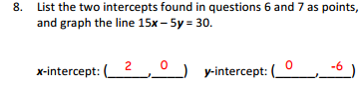
Questions 8 and 9 has students analyze the given graph and
obtain the slope using the intercepts ordered pairs. After that students are asked to confirmed that calculated slope using slope triangles (Fig.12).

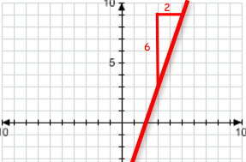
Consolidation Activity
Figure 12
Problem number has students analyzing 5 equations. They will need to find the intercepts and slope of the given equations, which are in standard form. In problem 2, students will do the same for an equation in standard form, but they will be asked to graph the line once they find the intercepts and slope. The last problem in the core activity has students explore a skateboard and bicycle making problem that allows them to understand the building of equations (Fig. 13).

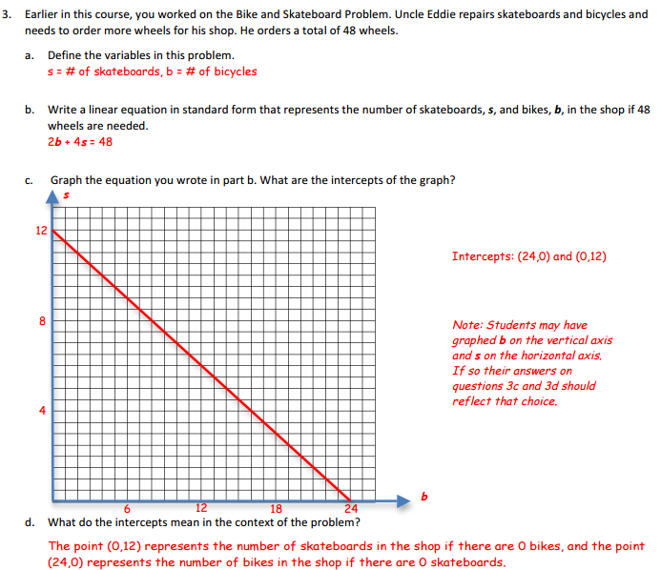
Figure 13

Homework
Through number sense students will solve for the values for x and y. Exercise number one will help students understand how to isolate a given variable (Fig. 14). Then students will review the concept of obtaining the intercepts within standard from. After that, students will need to use those points to calculate the slope. For problem three, given the intercepts will have to calculate slope-intercept form, then sketch the line and put the slope intercept formula in standard form. Students will then have the four representations because in questions three they will have to explain it through writing, algebraically, graphically, and abstractly. Students will then apply these concepts and methods to solve a real-world problem related to the making bicycle and tricycle. The last problem students will compare the components of two functions and decide which has a greater slope, y-intercept, and x-intercept. This exercise helps students determine what makes linear equations different or similar.

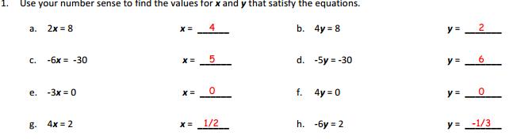
Figure 14
Staying Sharp
In questions 1 and 2, students will find the slope of a given line and then obtain the slope of the perpendicular line. Then the students will move on to interpreting real data. After that students will calculate with integers and their multiplicative identities using exponents. The last problem will then explore the idea of square roots using integers.

10.7 Point-Slope Form

Opener
During the opener students will analyze a pattern given a pond and its tiles. They will decide whether the equation for it is linear or not. They will also analyze the equation of the line given the y-intercept (Fig. 15).
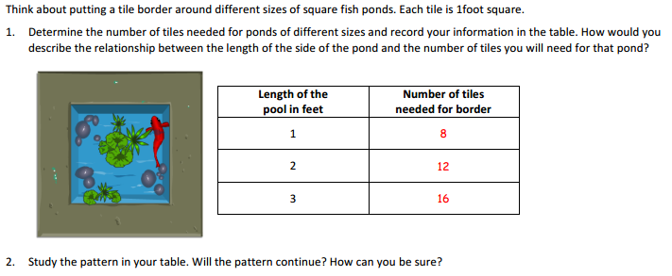
Figure 15
Core Activity
Problems 1, 2, and 3 shows students how to apply the point-slope formula. They will apply it to the previous problem that involve the pond. They will learn the formula after applying the concept (Fig. 16).
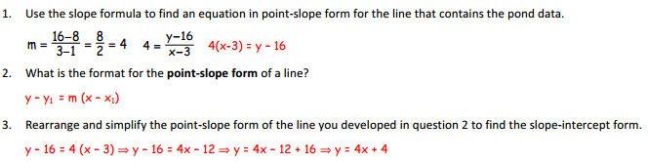
Figure 16
In problem 4, students will be able to use the point slope formula given a point and a slope and simplify into the slope formula. In problem 5 students will apply the formula to a real world problem. They will analyze the information given about a car and then apply it to another car using their new material, which is the point formula (Fig. 17). In question 6, students will explore why point slope and slope form formula represent the same point/data using different representation. They will compare and contrast the given equations.
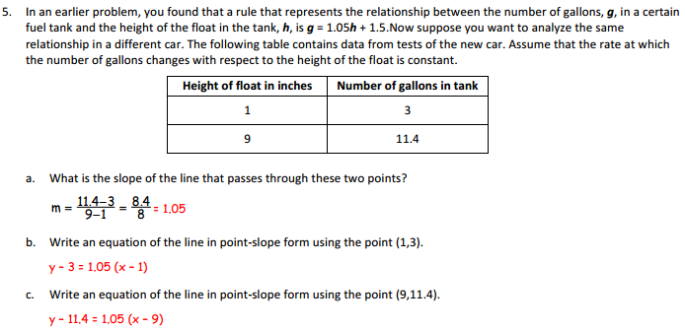

Figure 17
Consolidation Activity
No consolidation activity in this lesson because students will do an online assessment.
Homework
Students once again will be exposed to comparing and contrast point slope and slope intercept form. They will be given four lines in the first problem they will be expected to represent them in point slope and slope intercept whether they are given the original, perpendicular, and parallel line (Fig. 18).

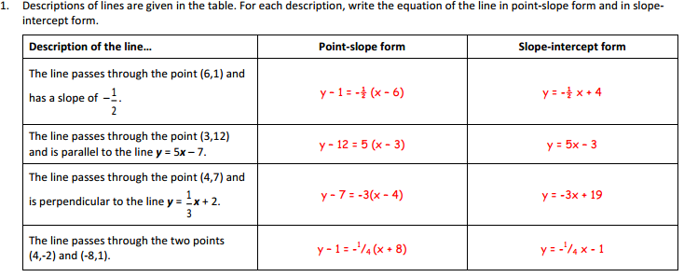
Figure 18
Problem 2 is made up out five questions where students will demonstrate their knowledge acquirement of the fuel problem in the core activity using their notes.

Staying Sharp
For problems 1 and 2 students will able to remember how to obtain slope given a line or several points (Fig. 19).

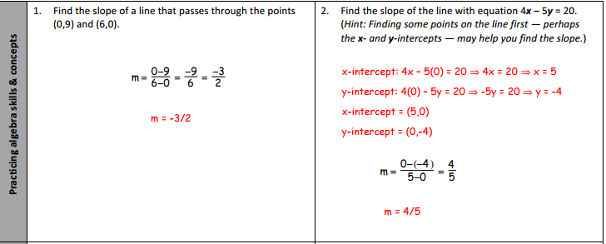
Figure 19

In Problems 3 and 4 students will analyze the given lines and describe their difference and similarities (Fig. 20).

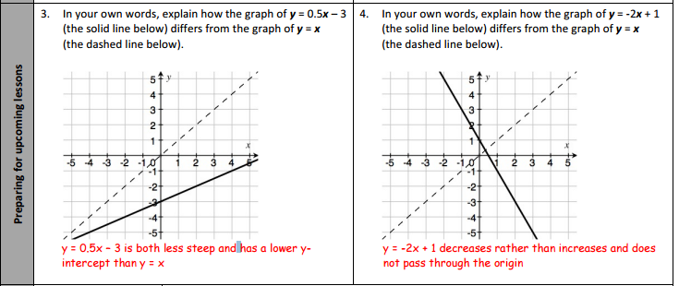
Figure 20

The last problem in staying sharp will once again emphasize how to do conversions (Fig. 21).

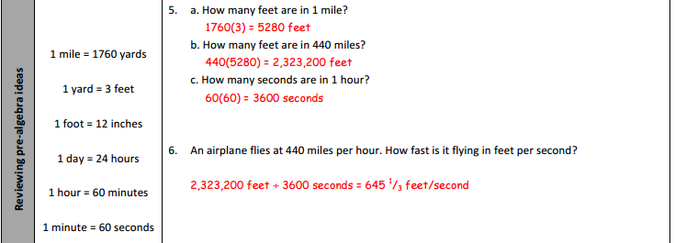
Figure 21

