Algebra 1: Exploring Linear Functions

Overview

CCSS.MATH.PRACTICE.MP2 Reason abstractly and quantitatively.
Mathematically proficient students make sense of quantities and their relationships in problem situations. They bring two complementary abilities to bear on problems involving quantitative relationships: the ability to decontextualize—to abstract a given situation and represent it symbolically and manipulate the representing symbols as if they have a life of their own, without necessarily attending to their referents—and the ability to contextualize, to pause as needed during the manipulation process in order to probe into the referents for the symbols involved. Quantitative reasoning entails habits of creating a coherent representation of the problem at hand; considering the units involved; attending to the meaning of quantities, not just how to compute them; and knowing and flexibly using different properties of operations and objects.

This learning Progression is for the Algebra 1 Class at the Granger High School. The curriculum used in this class is called Agile Mind which consists of a workbook, online animations, and formative & summative assessments. The name of this workbook is Intensified Algebra I: Student Activity Book, Volume I Representing mathematical relationships: the graders Linear Functions and their foundations, 2015-16 Edition. The math workbook has a guided lesson notes (fill in the blank) that follow the online animations that concur with the lesson, homework assignments, and a staying sharp section. These 25 students (23 freshmen & 2 sophomores) are in this class because they showed difficulty in Algebra during 8th grade -and during their testing before high school. The book based on the agile mind curriculum. This curriculum is built for students and for teachers who preferred formative assessments, job-embedded professional supports and real-time data & reports. Curriculum was made for middle school students and high students. The Common Core State Standards cluster that this learning progression uses are as follows: Functions: 8th grade Define, evaluate, and compare functions, CCSS.MATH.CONTENT.8.F.A.1, CCSS.MATH.CONTENT.8.F.A.2,
CCSS.MATH.CONTENT.8.F.B.4, and CCSS.MATH.CONTENT.8.F.B.5.
These standards in Algebra address:
Unit 4: Linear Functions, Topic 10: Understanding slope and intercepts, will be the learning progression. This unit will reinforce the vocabulary, and analyze of linear functions using strategies and routines used in class. Topic 10 will connect the ideas of rate of change with the slope of a line. The use of different representations such as graphs, tables, function rules, and verbal expressions will be an essential part of 3 lesson learning progression.

CCSS.MATH.PRACTICE.MP4 Model with mathematics.
Mathematically proficient students can apply the mathematics they know to solve problems arising in everyday life, society, and the workplace. In early grades, this might be as simple as writing an addition equation to describe a situation. In middle grades, a student might apply proportional reasoning to plan a school event or analyze a problem in the community. By high school, a student might use geometry to solve a design problem or use a function to describe how one quantity of interest depends on another. Mathematically proficient students who can apply what they know are comfortable making assumptions and approximations to simplify a complicated situation, realizing that these may need revision later. They are able to identify important quantities in a practical situation and map their relationships using such tools as diagrams, two-way tables, graphs, flowcharts and formulas. They can analyze those relationships mathematically to draw conclusions. They routinely interpret their mathematical results in the context of the situation and reflect on whether the results make sense, possibly improving the model if it has not served its purpose.

CCSS.MATH.PRACTICE.MP8 Look for and express regularity in repeated reasoning.
Mathematically proficient students notice if calculations are repeated, and look both for general methods and for shortcuts. Upper elementary students might notice when dividing 25 by 11 that they are repeating the same calculations over and over again, and conclude they have a repeating decimal. By paying attention to the calculation of slope as they repeatedly check whether points are on the line through (1, 2) with slope 3, middle school students might abstract the equation (y - 2)/(x - 1) = 3. Noticing the regularity in the way terms cancel when expanding (x - 1)(x + 1), (x - 1)(x² + x + 1), and (x - 1)(x³ + x2 + x + 1) might lead them to the general formula for the sum of a geometric series. As they work to solve a problem, mathematically proficient students maintain oversight of the process, while attending to the details. They continually evaluate the reasonableness of their intermediate results.

The themes with in these three lessons (10.1-10.3) are as follows:

• Practice of using graphs, tables, and function rules to analyze a linear function.
• Discover the connection between rates of change versus slope and use it to analyze a linear function.
• Use first differences to determine whether a function is linear or not.
• Explore the difference between an x-intercept and y-intercept and see how it is represented in a graph.
• Learn how to determine whether a line is parallel

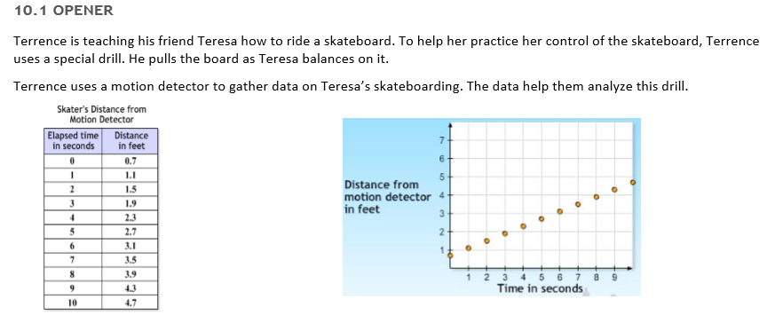
Linear Equations is one of the most essential lessons in the Algebra 1 curriculum. Emphasizing the retention of the concepts learned in this lesson is essential for the successful progressions for the rest of the mathematics sequence in high school. Formalizing a vocabulary and algebraic processes involving & analyzing attributes of linear functions will be the goal of this learning progression. In addition, Mathematical practices will be compacted in the following lessons. These are the mathematical practices being used in the previous learned strategies and routines that students will be developing will enhance the learning of the students. During the introduction of functions students will plot the points from the table and determine how linear functions work and look like. By graphing and analyzing, students will begin to understand linear equations. Students will begin by understanding rate of change and slope. The equation slope will be learned and shown in different manners. Students will not be required to learn formulas, but build comprehensive understanding that help them understand and find key components of a linear equation/function.

The lessons of the learning of the progression plan consists of an opener, core activity (main lesson), consolidation activity (wrap-up example), homework, and staying sharp worksheet. All the examples are based on a real-world problem that emphasizes the key points of a linear function.
CCSS.MATH.CONTENT.8.F.A.1 Understand that a function is a rule that assigns to each input exactly one output. The graph of a function is the set of ordered pairs consisting of an input and the corresponding output.

Throughout the learning progression students will learn that a linear function has one input and only one output.
Figure 0
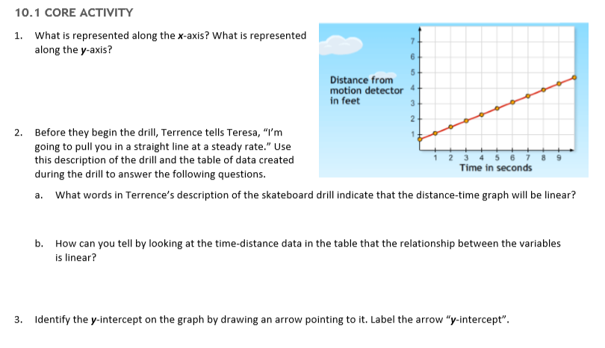
In addition, Mathematical practices will be compacted in the following lessons. These are the mathematical practices being used.

10.1 Connecting rate of change and slope
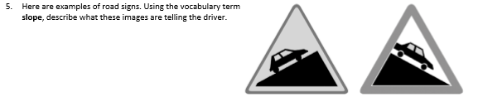
The opener will ask students to analyze the given graph and derive information from it. Students will use the given table and graph. The main activity will teach students about each of the axis in the x-y graph and their meanings. By analyzing the axes students will derive their meaning when solving the problem (fig. 0).
Figure 1
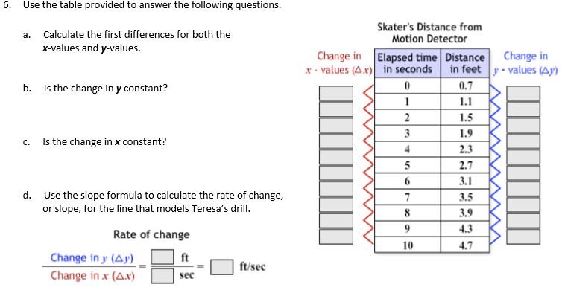
The problem consists of understanding the use of a motion detector. Students will have to figure out what the axes represent that make up the linear function. Making a hypothesis of the rate Terrence is pulling Teresa in her skateboard is what students will be doing. Students will analyze and determine whether the data graphed is linear or non-linear. Having the students label the intercepts students will determine where the intercepts are located and their meaning (fig. 1). After locating and labeling the intercepts students will learn the syntax and write them as coordinates (fig. 1). After, students will learn the how to determine if slope is negative or positive through pictures to help comprehension (fig.2). So far, the common state standard that was used is CCSS.MATH CONTENT.8.F.B.4 and CCSS.MATH CONTENT.8.F.B.5.
Figure 3
Figure 2
CCSS.MATH.CONTENT.8.F.B.4 Construct a function to model a linear relationship between two quantities. Determine the rate of change and initial value of the function from a description of a relationship or from two (x, y) values, including reading these from a table or from a graph. Interpret the rate of change and initial value of a linear function in terms of the situation it models, and in terms of its graph or a table of values.

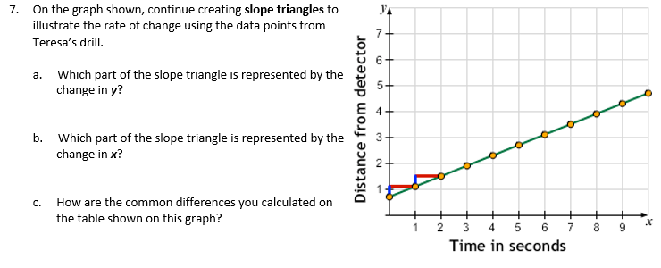
Students will then learn what first differences are and if they constant. The slope formula will be used to determine the rate of change/ slope that models Teresa’s drill (fig. 3).
Figure 4
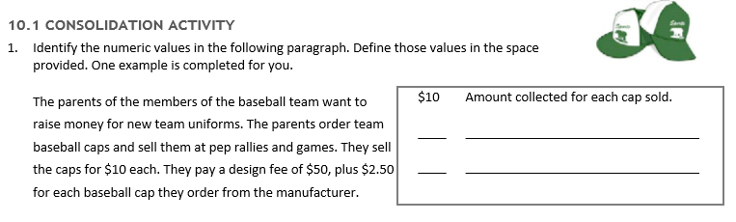
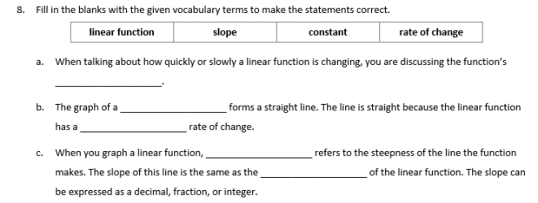
The way the guided notes have formatted this exercise, students will be able to efficiently see how first differences are obtained and slope is derived (fig. 3). On the next exercise students will explore another way to find slope/rate of change. Slope triangles will help students understand the y-value and x-value movement in the x-y grid (fig. 4). Using student language, problem 6 asks students to fill in the blank with vocabulary terms learned through the lesson (fig. 5). Problem 6 uses common state standard CCSS.MATH.CONTENT.8.F.B.5.
Figure 6
Figure 5
CCSS.MATH.CONTENT.8.F.B.5 Describe qualitatively the functional relationship between two quantities by analyzing a graph (e.g., where the function is increasing or decreasing, linear or nonlinear). Sketch a graph that exhibits the qualitative features of a function that has been described verbally.

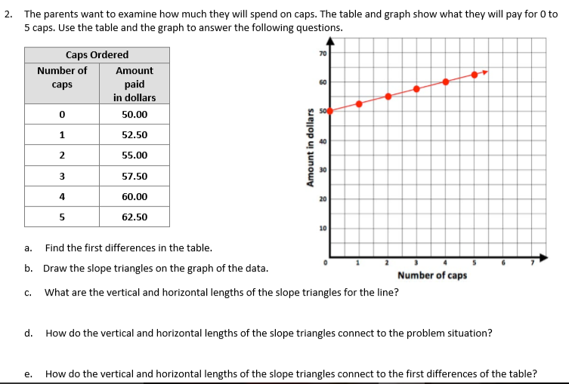
In the consolidation activity, students will dissect a paragraph to obtain the information necessary to graph a linear equation (fig. 6). Next students will analyze a table and a graph to obtain the first differences, draw and quantify slope triangles. Interpret the slope triangles within the problem and the first differences (fig. 7). Using the same table students will graph a different scenario and answer the same questions (fig. 8). This goes hand in hand with CCSS.MATH.CONTENT.8.F.A.2.
Figure 7
CCSS.MATH.CONTENT.8.F.A.2 Compare properties of two functions each represented in a different way (algebraically, graphically, numerically in tables, or by verbal descriptions). For example, given a linear function represented by a table of values and a linear function represented by an algebraic expression, determine which function has the greater rate of change.

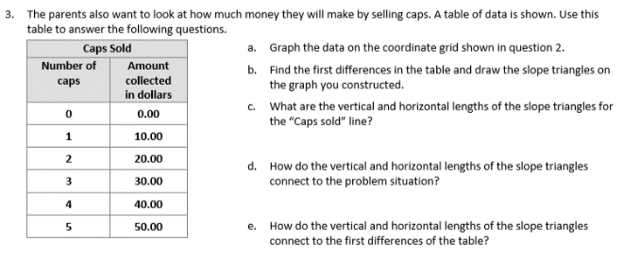
After the lesson students will work on their homework since no staying sharp worksheet is included in this lesson which exercises the new material on linear functions. Student will plot points that lead to a linear function and analyze it by finding the first differences and slope. Also, students will determine whether the slope is negative or positive through graphs.
Figure 8

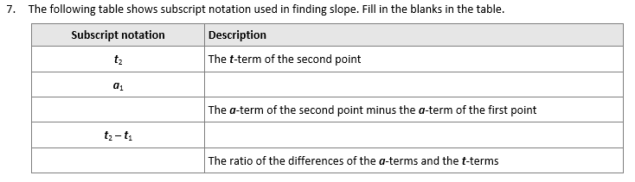
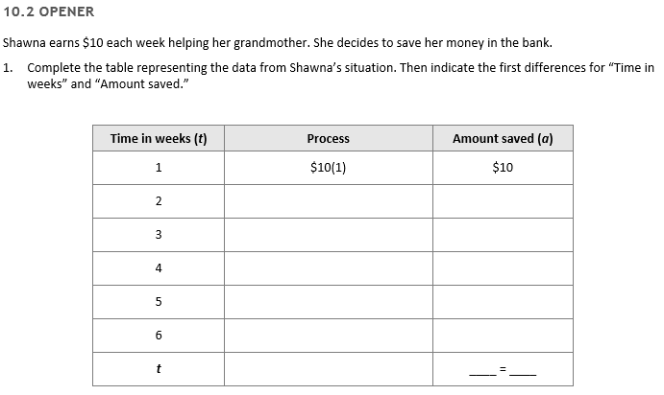
10.2 Connecting slope and rate of change through multiple representations
Figure 9

This lesson will open through a problem that gives a scenario that asks students to organize the information. After the information is organized students will learn how to set up a linear equation (fig. 9).
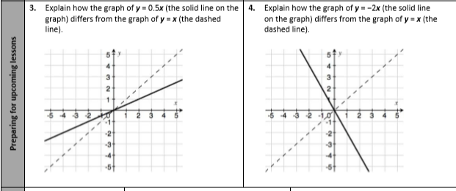
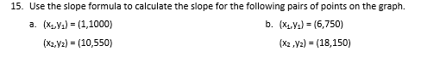
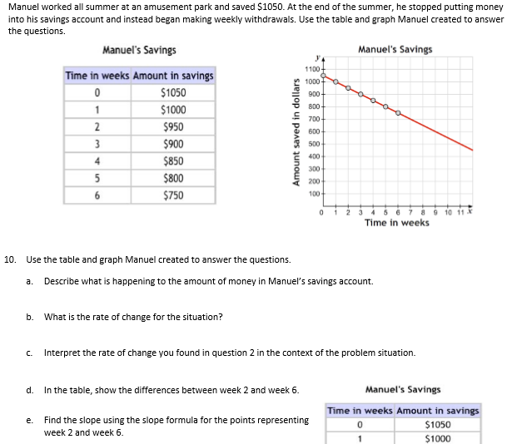
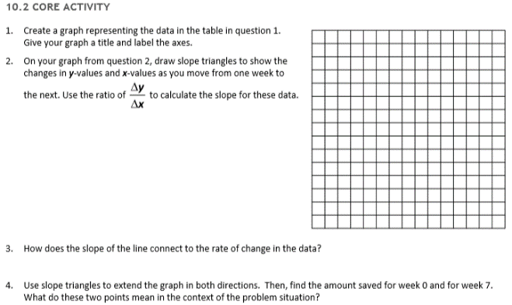
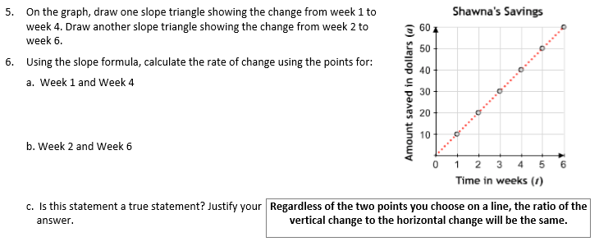
The core activity will begin by graphing the table from the opening problem. Students then will draw slope triangles and use a ratio of the slope triangles to find slopes. For this students will refer to the ratio as “delta y over delta x.” Students will connect slope to the rate of change. When extending the triangles both ways, students will find the intercepts and determine their meaning (fig. 10). Problem number 5 asks students to find the slope using two different sets of points to show them that slope can be obtain using any of the two points on the line (fig. 11). Students will then explore notation. This will help students get ready to build linear equations (fig. 12). Problem number ten is a benchmark assessment because it summarizes all the material learned so far (fig. 13). Moving on after problem 10, problem 11 and twelve pushes students to come up with a function rule regarding Manuel’s Savings and to determine the amount in savings during the 10th and 15th week. On problem 14, students are asked to graph Manuel’s savings account savings and expenditure up to 25 weeks or until he has no more money. Problem 15 students will be asked to calculate slope using the given coordinates (fig. 14). The homework for this lesson concentrates on word-problem dissection. Students use their knowledge on linear equations to solve the problems. This section does contain a staying sharp worksheet which exercises their slope analyzation skills (fig. 15).
Figure 14
Figure 12
Figure 10
Figure 11
Figure 13
Lesson10.2 is based on CCSS.MATH.CONTENT.8.F.B.4.
Figure 15

10.3 m, b, and the graph of y=mx + b
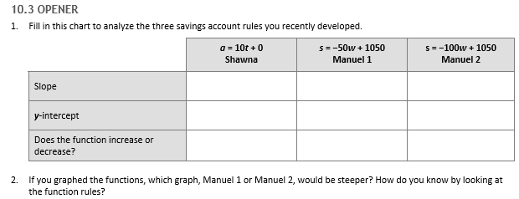
Figure 16
Most of the examples that have been done in class have dealt with saving accounts or movements. Therefore, students will have a chance during the opener to explore the slope intercept form to figure out how to find and compare slopes (figure out if it is positive or negative) and the y-intercept (fig. 16).
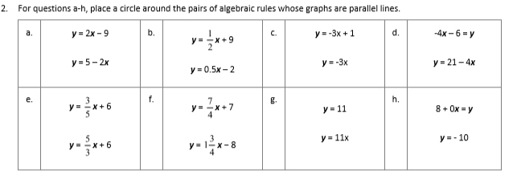
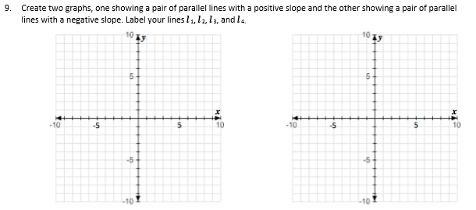
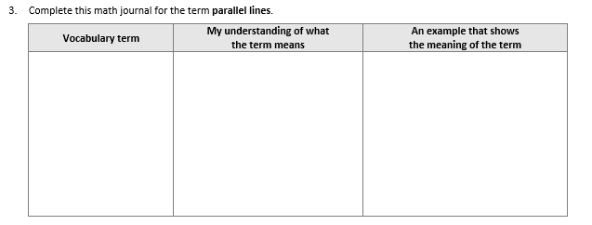
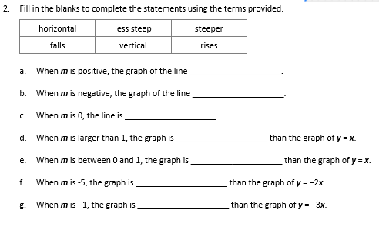
The core activity consists of graphing and comparing slopes whether they are negative or positive. Question 2 has students fill in the blanks for statements about slopes. This gives students an opportunity to define what slopes mean (fig. 17). By exploring different slopes, students will soon encounter parallel lines (lines with the same slope). Students will discover that different lines with the same slopes are distinguish through their y-intercept. Problems 3- students will explore parallel lines (fig. 18). On figure 19, students get the opportunity to create their own parallel lines with negative and positive slopes. Given those graphs are created, students then have to derive their equation. In the consolidation activity students will reinforce the idea of parallel lines and their y-intercept. Students explore different lines and decide whether they are parallel or not and find out their characteristics. On the homework students will be given a line and the students have to come up with a parallel line. They will also compare algebraic rules and decided whether the equations signify parallelism (fig. 20). Students will also explore the slope of Students will also explore the slope of y=0 and x=0. In the staying sharp worksheet for 10.3 students will analyze a graph to find slope, and intercepts. They will also find the correlation of question number 3. They will review square roots and their properties with a number line.
Figure 20
Figure 19
Figure 18
Figure 17
10.3 lesson is on CCSS.MATH.CONTENT.8.F.B.4.
Algebra lessons & class
The class will always begin with the opener, and the moving onto the core activity which is the main lesson. The consolidation activity serves as a focus to main topics of the lesson and exercising of those topics. The Agile mind website is used for the animations that go with the core activity (fig.21). The homework and staying sharp worksheet is graded on correctness and completion. The lessons are through and long because the lessons are student based and help students understanding through discussion. This is done this way because the class periods are 90 minutes.

What is agile Mind?

Agile Mind is a research based curriculum that emphasizes on formative assessments. Modeling is one of the key components of this curriculum. All the concepts and lessons are tied to a real world concept that focuses on helping students understand their surroundings whether they are done through economics or engineering. Most of the modeling is done through animations. The curriculum is aligned with standards that implement the Common Core standards. One of their focuses is Academic Youth Development (AYD):
“Move beyond growth mindset. AYD is based on new knowledge emerging from the psychological sciences that reshapes students’ academic identities, enhances their engagement in learning, and transforms their achievement.”- agile Mind

