High School Functions:
Build new functions from existing functions.
This learning progression will be applied in a high school end of course class, and there will be no textbooks being used however there will some outside supplements such as a Khan Academy video to supplement instruction. The common core state standards being aligned with this progression are: HSF.BF.B.3, HSF.BF.B.4, HSF.BF.B.4A, HSF.BF.B.4B, and HSF.BF.B.5. The following standards for mathematical practice are also included in the progression: MP1: Make sense of problems and persevere in solving them, MP2: Reason abstractly and quantitatively, and MP4: Model with mathematics.
Students have the previous knowledge of function notation as well as being able to compute values given functions and also having the ability to graph the functions. This progression will build upon their knowledge of functions and transform them, such as in HSF.BF.B.3 applying a constant k to the function or as well as HSF.BF.B.4 transforming a function into its inverse. Students will use technology to compare various graphs of similar functions, slightly skewed with the addition of a constant, k, into the function, take f(x) = 2x and f(x) = 2x + k for example. Then students will then learn how to manipulate or transform a function to make a function of its inverse (if possible), in essence re-solving the function in terms of x and learn how to prove by composition if two functions are inverses of each other. Lastly, students will investigate the inverse relationship between exponential functions and logarithms.
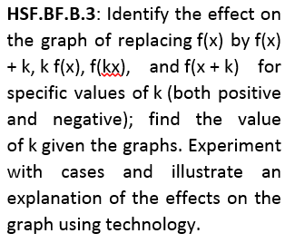
There will be a formative assessment at the end of the progression in the form of a short standards-based quiz that covers the cluster of standards. There will be worksheets collected after each lesson as well for benchmark assessments.
Build new functions from existing functions.
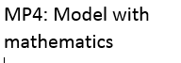
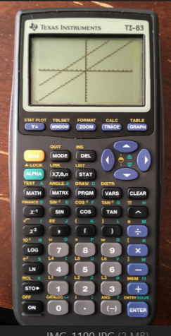
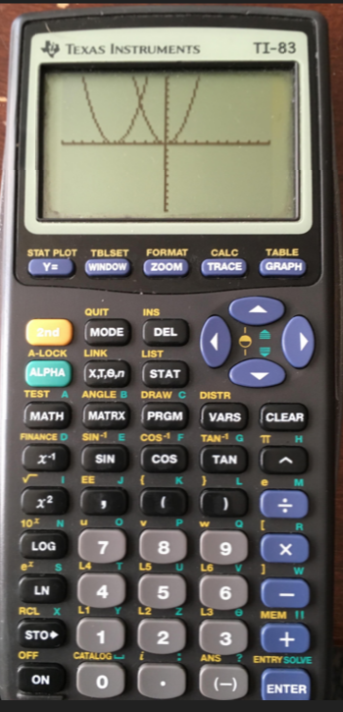
To begin the progression, we will be using technology to spark the student’s previous knowledge with the new learning. Modeling a very familiar linear equation, y = x, we will graph this on our calculator’s graphing tool. With this still highlighted, we will now put the graph of y = x + 5, and the graph will overlay the two functions, the 2nd function being the 1st shifted up 5 units. A hinge question can be used early, where the teacher can ask, “If I wanted to change my function so that it will be shifted below our first function y = x, what would I change?” The answer subtracting 5 (or any number) from x would result in this. Abstractly, the teacher will write on the board f(x) = x + k and f(x) = x – k. Next, the instructor will pose the question, “What if our constant, k, was being multiplied by x instead of just being added or subtracted? How would this change our function?” Again using technology, we can model the function y = x to the transformation of a new function with a constant k such as y = kx, where k is 2. Visually we will see that the slope of the second function has been doubled, so our slope will be multiplied by the value of k. Re-engaging previous knowledge, the students are familiar with y = mx + b, and thus show how the position our constant, k, relative to the function can be interpreted as the variable m in y = mx + b or the intercept constant, b.
Next, the teacher will introduce a familiar quadratic equation, y = x². Again using technology, students will discover how a constant can transform the given function, graphing functions such as y = x² + 5 and y = (x+5)². Students will be able to use the tools of technology to visually see and explore the vertical, horizontal, stretching, and shrinking effects that a constant, k, has when being applied in various ways onto functions.
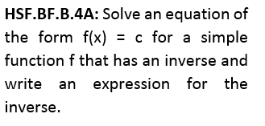
The following lesson will introduce the students into building the inverse of a function when given an initial function. They may or may not be familiar with the term inverse, so a mathematical definition will be provided: An inverse is a function that "reverses" another function. That is, if f is a function mapping x to y, then the inverse function of f maps y back to x. To help supplement the definition, we will start the lesson with a Khan Academy video that I felt did a good job of introducing the inverses of functions and application of the process to find them, which can be accessed here:
(https://www.khanacademy.org/math/algebra2/manipulating-functions/introduction-to-inverses-of-functions/v/introduction-to-function-inverses.)
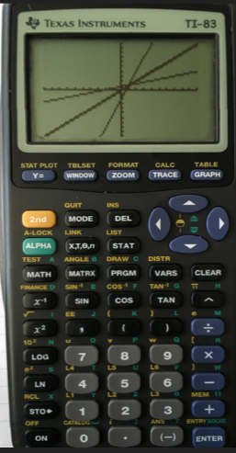
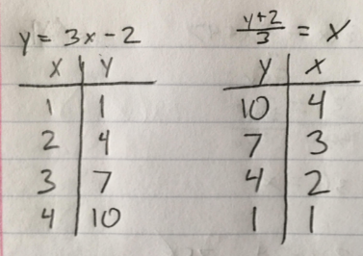
The mathematical process will subsequently be modeled by the instructor on a whiteboard to help clarify how to do this. For example, we will start with an initial function, say, y = 3x - 2. Since we want to be able to build a new function in which y maps back to x, since we have solved for y in the initial function we will algebraically manipulate the function and solve for x. Therefore, with a first step we have, y + 2 = 3x and lastly $\frac{y+2}{3}=x$. We have now produced a new function given an initial that will map outputs of the original back to inputs. To help better visualize what an inverse function does, we will build a data table for each function, and students will physically see and compute that if f is a function mapping x to y, then the inverse function of f maps y back to x, proving our definition of inverse. To capitalize even further, we will use the calculator to graph and model the two functions. Students should be familiar with function notation and be fine with putting both in terms of x as our calculator reads, y₁ = 3x – 2 and y₂ = $\frac{x+2}{3}$. With these two overlaying graphs, inserting y = x will show the reflection, and the mathematical reasoning behind inverses, and as our domains are mapped to ranges in the initial functions, the ranges will map back to the domain in the inverse function.
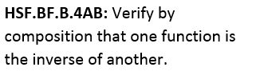
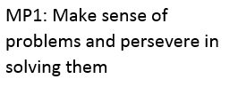
Next, the students will be shown how to prove algebraically that two functions are indeed inverses of each other. To prove that two functions are the inverses of each other you will compose the functions, that is, plug x into one function, plug that function into the inverse function, and then simplify, and verify that you end up with just x. For example, using the same function and inverse we have been dealing with, plugging y = 3x – 2 into $\frac{y+2}{3}=x$ we see $\frac{(3x-2)+2}{3}=x$ and simplifying gives is $\frac{3x}{3}$= x or x = x. Composing in reverse we have, y = 3($\frac{y+2}{3}$) – 2 or y = $\frac{3y+6}{3}$ – 2 and simplifying further y = y + 2 – 2 or y = y, proving we have built the correct inverse of our original function. Mathematically reasoning, this should make sense as whatever we put into the inverse function, we would expect to output whatever “x” was from the initial function, which proves abstractly for all numbers that two functions are inverses of one another.
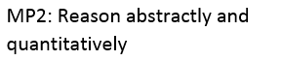
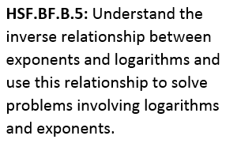
In the last lesson, students will investigate the inverse property of logarithms and exponents. Students are familiar with exponents and should be familiar with a logarithm but the instructor will model both forms abstractly, also showing concretely with a random valued model. Thus, for an exponent a^{x}=b is saying some number a, raised to the power x equals some number b. Inversely, a logarithm will be seen in the form log_{a}b = x, which states there is a number a, that when raised to the power of x brings us to the value of b. From the previous lesson students may begin to conceptually realize a logarithm is the reverse of an exponent!
However, thinking abstractly is very challenging and thus the instructor will model a given equation. For example, let us say a=2, b=16, and x=4. This is a solution to both equations as in 2⁴=16 we have 2 raised to the power of 4, or 2*2*2*2 = 16 which is true and with the logarithm we have log₂16 = 4, or again reading 2 raised to the 4th power must equal 16, which is computed to be true. The output from our exponential equation, has become the input for the inverse logarithm, in which the output was the input of the exponential, or 4. Students should make the connection from the previous lesson that when this property happens between two functions, then those functions are inverses of each other.
In the final formative assessment, the students will be challenged to show mastery of each standard by successfully finding the solutions to 3 standards based questions. Below are the benchmark assessments that will be given following each of the first two lessons, with the final being a formative assessment of the mastery of the cluster.
Lesson One Benchmark
- Describe how the following two functions would compare to each other: y = 4x + 2 , y = 4x – 1

- Draw the graph of the function f(x) = x². Then, draw a new graph of f(x) shifted up 2 units and left 3 units. What would this new function look like symbolically, label it g(x).

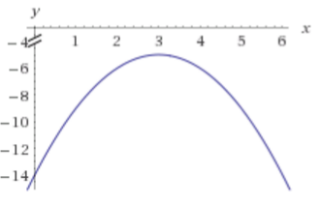
- For what value of k, does the graph fit the following function: y = -(x+k)² – 5. In writing, briefly explain how you know.

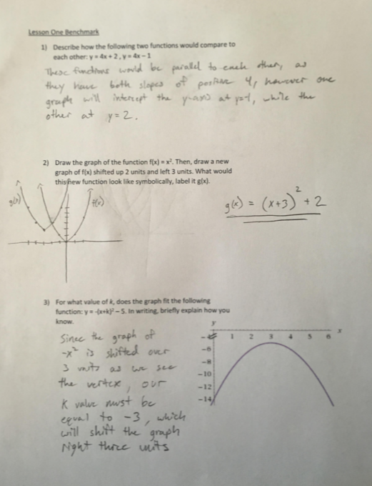
Lesson Two Benchmark
Name:

Find the inverses for each of the following functions:
- $y=-\frac{1}{2}x+4$ 2) $y=5x+7$

Prove or disprove algebraically that the two given functions are inverses of each other. In writing, give a brief explanation as to how the algebra proves or disproves the inverse property.
3) $f\left(x\right)=3x-2$, $g\left(x\right)=\frac{x+2}{3}$

4) $f\left(x\right)=-\frac{1}{2}$x + 4, $g\left(x\right)=2x-2$

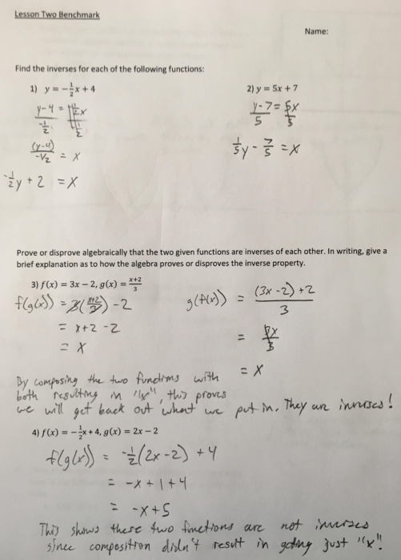
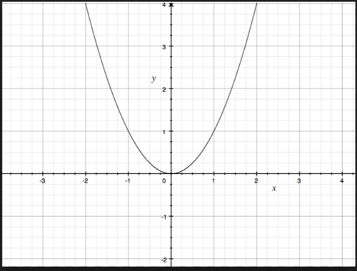
Formative Assessment
- Given the function f(x) = x², identify the effects of adding a positive or negative constant, k, to the function does and draw a graphical representation of the effects HSF.BF.B.3:
  - -2(f(x))
  - F(x-5)
  - F(x) + 3

- Find the inverse of the function y = 5x – 3, then show algebraically how to prove that the two functions are in fact inverses of one another HSF.BF.B.4.

- Using the inverse relationship of logarithms and exponents, rewrite the following equations into their inverse forms and solve HSF.BF.B.5.
  - Log ₃ 81 = x

  - 2⁵=x
