7th Grade Mathematics:
Investigate chance processes and develop, use, and evaluate probability models.
This learning progression will be applied in a 7th grade mathematics classroom, and the textbook being used will be; Core Connections – Course 2, by Dietiker, Kysh, Sallee & Hoey, specifically lessons 5.2.3-5.2.5. The common core state standards aligning with the lessons in the progression are 7.SP.C.8.A, 7.SP.C.8.B, and 7.SP.C.8.C. The following standards for mathematical practice are also included in the progression: MP1: Make sense of problems and persevere in solving them, MP4: Model with mathematics, MP5: Use appropriate tools strategically.
Previously, when studying probability students focused on the probabilities of single events. In this learning progression students will be analyzing theoretical probabilities of compound events, such as flipping a coin and then rolling a dice. Students will investigate dependent and independent events, and ask themselves if the outcome of one event would affect the other. As students begin to understand compound events and their relations they will be introduced to various ways of representing various possible outcomes of random events using probability tables and tree diagrams. Students will also design and use a simulation to generate frequencies for compound events.
Multiple formative assessment techniques will be implemented in the progression to help myself and the students be more aware of their understanding and comprehension in relation to each of the standards and learning targets. Students are going to use learning logs throughout the learning progression and record personal entries summarizing their own understanding of the learning targets relative to each lesson. All students have personal mathematics notebooks in class each day to make these recordings in. Exit slips/hinge questions will also be used at the conclusion of each of the first two lessons as a pre-cursor towards the next.

Investigate chance processes and develop, use, and evaluate probability models.
Find probabilities of compound events using organized lists, tables, tree diagrams, and simulation.
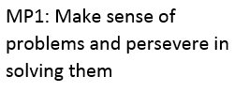
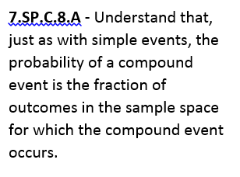
As students are already familiar with probabilities of random single events and how to interpret and evaluate those, students will be engaged into compound events by starting off the learning progression with an entry activity of pairing up and playing rock-paper-scissors. This classic game will physically engage the students and spark interest for the progression. In order for students to build knowledge on finding the probabilities of compound events, creating sample spaces of all possible outcomes of an event will be introduced first. A systematic list will be the initial approach of consolidating the sample space.
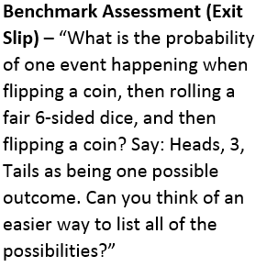
In order for students to grasp the concept smoothly, a very simple compound event will be used initially to create the first example sample space, the results of flipping two coins. Coins will be available for students who may need the visual representation of the possible outcomes of the event. As students begin to build their sample spaces, I will use these questions to help focus group discussions, “How many possibilities are there?” and, “Does the result of one event affect the other?” By compiling lists of the sample space, students will be able to evaluate the probability of a certain event happening by counting how many times the result occurred in their list compared to the total number of outcomes in their complete sample space. Note the different ways that students are organizing their lists, as they exhibit MP1. They will be introduced to more specific systems of organization such as probability tables and tree diagrams later in the progression.
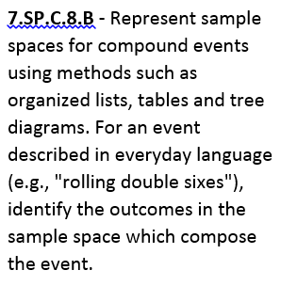
Re-introducing rock-paper-scissors as a compound event, students will then practice building larger sample spaces that have more disperse outcomes. Students now firsthand will begin to see the hassle of having to create larger and larger lists. A hinge question will be implemented at the conclusion of the first lesson to gage the students in thinking of more effective ways of representing sample spaces. Allow students to conjecture their thoughts and opinions on different representations. In the learning logs, students will record in their own understanding the steps or procedures in finding the sample space of a compound event. The method of exhausting all possibilities from fixing one event at a time should be frequent.
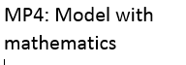
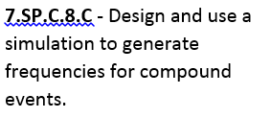
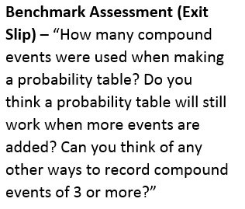
To follow, as (friendly) competition is sure to spark student interest and motivation, an activity or game will be used to start lesson two based on students personal predictions of likely outcomes, the game is called Ten O’s. Students will create a number line from 1-12 of counting integers, (show students a model example) and place ten 0’s over numbers, with the goal of eliminating all of your O’s. To do so, two dice will be rolled and if you have an O over the sum of the two dice you can cross it off. The first person to eliminate all of their O’s will win. Students will all likely have different strategies for determining their placement of O’s (allow students to place 0’s over 1 if they choose to do so, as they will discover the theoretical odds of rolling two die and their sum being 1 as being a 0 percent chance.)
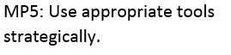
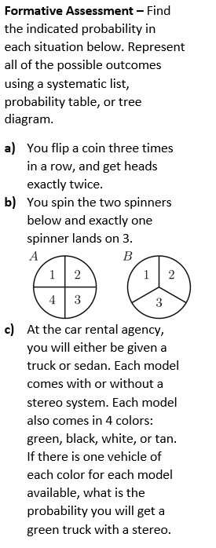
The activity worksheet following the game will introduce students into creating probability tables, which resemble a very familiar table from younger grades, the dreadful multiplication table. This sort of organization tool will be much easier to construct than using a systematic list, which was our initial approach in creating sample spaces of compound events in the first lesson of the progression. With the use of a probability table, students will begin to see that their ten O’s can be theoretically be placed to give them a better chance to win. Allow students to create another learning log in their notebooks recording their new strategy and reasoning for placing 10 O’s based on the probability table they’ve constructed. Again another hinge question will be used to conclude the lesson, what happens when there are more than 2 events or options, could you use a probability table still? Or is there another effective system of organizing a sample space.
The final lesson in the progression will have students exploring the use of probability trees as a model for outcomes of compound events, notably when there are more than two events. Investigating a situation with this case, for example picking between two ice cream flavors, 3 mix-ins, and 4 fruit options, to determine how many different combinations could be made. Allow students to experiment with their own ideas on listing these combinations, allowing students to practice MP4 and MP5. Discussion will occur on why it is challenging to keep track of all possible outcomes in this example situation. A tree diagram will be modeled with the example situation, with each complete line or branch of the tree representing possible outcomes. Students will work through the final activity worksheet from lesson 5.2.5 and resultantly have the tools to investigate chance processes and develop, use, and evaluate probability models. The last formal assessment will inform me if students have successfully met all of the standards in culmination from the learning progression.

