Name:________________________
Warm-up Task
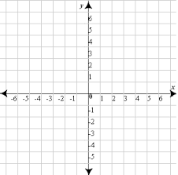
For $f\left(x\right)=x^{2}+3$ fill out the following table of values and graph it on the grid provided.
$$x$$ | $$f(x)$$
-2
-1
0
1
2

Name:_____________________________
Activity 1
For each pair of functions $f(x)$ and $g(x)$, graph them on the same sheet of graph paper and compare them. Next to each graph write how the second one is different from the first one.
- $f\left(x\right)=x^2$ and $g\left(x\right)={\left(x+2\right)}^{2}$

- $f\left(x\right)=x$ and $g\left(x\right)=3x+2$

- $f\left(x\right)=x^{2}$ and $g\left(x\right)={-x}^{2}+2$

- $f\left(x\right)=x$ and $g\left(x\right)=2x-2$

Name:____________________________
Activity 2
For each of the following, write out the function that describes the graph. The parent function is listed to the right of the graph for reference.
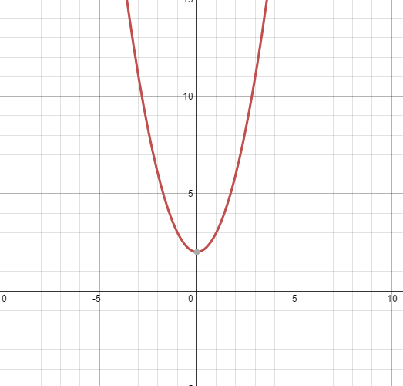
If $f\left(x\right)=x^{2}$ is the parent function, then
$g\left(x\right)=____________________________________$

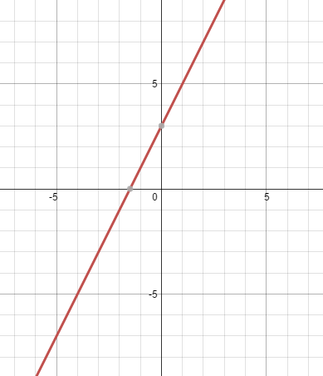
If $f\left(x\right)=x$ is the parent function, then
$g\left(x\right)=______________________________________$

Name:__________________________________________
Exit Slip
If $f\left(x\right)=x^{2}$, then what is $g(x)$ if $g(x)$ is $f(x)$ shifted vertically up by 2 and shifted horizontally to the left by 2?

$g\left(x\right)=__________________________________________$

If $f\left(x\right)=x^{2}$, then what is $g(x)$ if $g(x)$ is $f(x)$ shifted vertically down by 3 and opens downward?

$g\left(x\right)=__________________________________________$_

Answer the following questions on a scale of 1 to 5, with 1 being not comfortable at all and 5 being extremely comfortable.
How do you feel about the first Learning Target?
How do you feel about the second Learning Target?
How do you feel about the third Learning Target?
How comfortable are you with the material taught today?

