High School: Functions
Understanding and Interpreting Functions
This learning progression would take place in a 10th/11th grade Algebra 2 class and is aligned to multiple Common Core State Standards regarding the ‘Interpreting Functions” domain – specifically HSF.IF.A.1 and 2, as well as HSF.IF.B.6. Furthermore, this learning progression aligns with the McDougal Littell Algebra 2 textbook. Chapter 2 of the textbook covers “Linear Equations and Functions and this progression follows the first 4 sections of the chapter.
The Common Core State standards mentioned above have to do the understanding the concept of a function, including function notation and interpreting functions with regards to the rate of change of a graph. While instructing on these topics, students will be using multiple mathematical practices – MP2: reason abstractly and quantitatively, MP4: model with mathematics, and MP6: attend to precision.
In the beginning of the progression, the lessons will be primarily teacher driven in order to cement the foundation for the material. As soon as students are demonstrating understanding of the topics, instruction will move into a more student based discovery learning where students will be able to build upon those foundations and delve deeper into the content.
Students will be working as individuals, as well as in pairs to complete some activities. The think-pair-share formative assessment will be applied in order to let students work with their peers to obtain learning. Cooperative learning also helps students work on their academic language. In this way, students can practice their vocabulary while explaining their thought processes while in the ‘share’ portion of the assessment.

Understanding and Interpreting Functions
HSF.IF.A Understand the concept of a function and use function notation.
For the first day, students will be introduced to key terms and concepts. This day will be purely instruction, with opportunities for students to demonstrate their understanding by answering guiding questions. To introduce the topic, a graph of college enrollment over the years will be presented and students will have to describe enrollment trends and predict the trends for the next 5 years. At this point, students won’t have any academic vocabulary to describe the trends, so their descriptions will be pretty basic.

HSF.IF.A.1
Understand that a function from one set (called the domain) to another set (called the range) assigns to each element of the domain exactly one element of the range. If f is a function and x is an element of its domain, then f(x) denotes the output of f corresponding to the input x. The graph of f is the graph of the equation y = f(x).
This small activity broaches the idea of a relationship between two variables on a very surface level, while also being applicable to the students’ lives.
After the warm-up activity, students will be introduced to the terms relation, domain, and range. A relation will be described as a way to ‘map’ certain input values (domain) to output values (range). Use the metaphor of a “function machine” – input values are put in and the machine performs a function to turn them into new output values. It is important to make the connection between the domain and the independent variable in a study.
At this point in their math career, students should be familiar with the Cartesian plane and plotting points on the plane. However, it is still good to review certain concepts. Use example graphs to plot points – stressing that the x values are the domain (HSF.IF.A.1, MP6). While going over how to plot points, be sure to stress the importance of labeling the axes. It is a good practice to teach students the most precise language and procedure in order for them to be successful later on. To quickly check for understanding, pull up the warm-up activity graph of college enrollment over the years and ask students to name the points.
Students should have a solid grasp on relations and how to plot them at this point in the lesson, so defining what the term function is the next step in the progression. This is where the vertical line test would be introduced, as well as function notation (HSF.IF.A.2, MP6). Function notation is an example where students will need to make sure they are using the correct symbols to precisely communicate their ideas. After this, students should be able to determine if a relation is a function. See Benchmark Assessment 1 (BM1).
Once students have a firm grasp of what a function is, it is time to introduce a specific kind of function, linear functions. It is best that students understand what a function is before defining linear functions, as it would be hard to build upon a shaky foundation.
As an end task, students will be given 4 problems to complete by the end of the period or finish it for homework.
HSF.IF.A.2
Use function notation, evaluate functions for inputs in their domains, and interpret statements that use function notation in terms of a context.

BM 1: Determine if the relations below are functions. Why or why not?
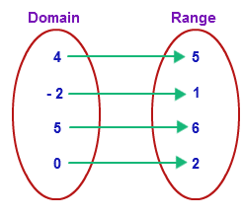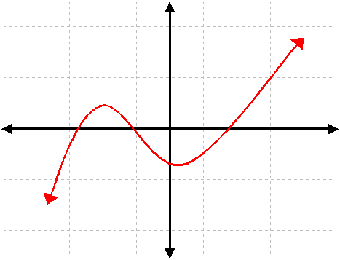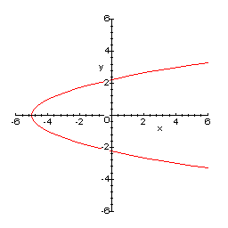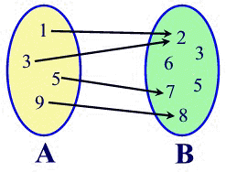

The problems include graphing a relation from a table of values and determining if it is a function or relation, graphing an equation, evaluating a function at a given point and a story problem where students will have to create mapping diagrams and explain whether the relation is a function or not.
The second day of instruction would be focused on the topic of rate of change and the slope of a line. This lesson is more discovery based while still being teacher focused. To start off, the students will work with the instructor to go through a real life example that highlights rate of change. For example, using the change in temperature in a desert from day to night to show rate of change as a ratio of the change in temperature over the change in time. This allows students to model a real life situation with math, while also using their reasoning skills (MP2, MP4). In this way, students will have to use their problem solving skills to determine how certain quantities while simultaneously using their math knowledge to model a real life situation. By the end of this activity, students will have analyzed a real life situation and used their mathematical skills to draw conclusions and answer questions.
After the example, the concept of slope would be analyzed. It would be prudent to give the students the formula and highlight that the slope of a line is a ratio between the change in the y value over the change in the x value – or more simply put, rise over run. For future lessons, make sure students understand the notation for slope and how that is linked to the variable m. (HSF.IF.B.6)
Once students have a grasp on the technical and procedural side of the concept of slope, it is important to go over what the slope can tell you about a line and the relationship between the different variables. The vocabulary introduced would include: positive slope, negative slope, zero slope and undefined slope. When explaining undefined slope, be sure to describe it as a line with “infinitely steep” slope. Connecting these terms with visual representation will cement the definitions.

HSF.IF.B.6
Calculate and interpret the average rate of change of a function (presented symbolically or as a table) over a specified interval. Estimate the rate of change from a graph.*

In high school geometry, students are introduced to the slope properties of parallel and perpendicular lines. It follows, then, that students in Algebra 2 should be able to determine if two lines are parallel or perpendicular based on their slopes. It is still good practice to review these properties.
To assess whether students have reached an understanding of this topic, a small worksheet will be handed out containing three different types of problems. See Formative Assessment 1 (FA1).
On the third day, students will learn how to write equations for a line. At this point in the progression, students should have knowledge of functions, slopes of functions, and basic algebraic reasoning. To build on this knowledge, the slope-intercept equation should be introduced – y = mx + b. Since students are familiar with slope already and with the notation, the m variable should be easy to explain. The only ‘new’ material presented here is the y-intercept, the b variable. To introduce this, it would be good to gather a handful of functions, some of the form y = mx + b and some not, and evaluating these functions at x = 0. Students should be able to pick up a pattern and link that to the concept of y-intercept.
Once students understand what the b variable is, graphing the function becomes simpler. Now, students just need to plot the y-intercept and apply the slope.
Another topic to be introduced is the standard form of a linear equation – ax + by = c. There is no set variables in this type of equation, but in order to help students learn how to write equations, explaining the standard form as below can be helpful.
Rate₁ (amount₁) + Rate₂(amount₂) = total
Now, when students are working on writing an equation from a story problem, they’ll have a little better idea on what to look out for. It also might be helpful to go over an example to further cement the point. For example, a car wash charges a certain rate for a car wash and a higher rate for a car wash and wax, if the total sales for the day is given have
FA1: Complete a worksheet containing variations of three types of problems.
- Given a graph, estimate the slope of a line.
- Given 3 pairs of points, find the slope for each pair. Then rank the lines from steepest to shallowest slope.
- Given 2 pairs of points, determine if the lines are parallel, perpendicular, or neither.
Note: when writing specific problems, make sure to include abnormal cases (ex. Lines with zero and undefined slopes).

the students come up with an equation. After they come up with an equation, graph it in front of the class and show that the different points on the line represent the different solution sets to the equation.
Formative assessment for this day involves giving students multiple story problems to work through on their own and then discuss with a partner. This could be described as a think-pair-share formative assessment. For examples of story problems, see FA2 and FA 3(MP2, MP 4). These problems, much like the introduction activity for the second day, will stimulate student’s reasoning and modeling skills. Both problems are applicable to real life and require the student to use math to describe a realistic situation. Not only do these problems stimulate reasoning, they also are tied to real life and, therefore, are more likely to engage students.

FA 2: You are buying a $300 Xbox on layaway. You make an initial payment of $50 and then set up a payment plan to make weekly payments of $10. Starting at the day you pick up the Xbox (time = 0), how many weeks will it take to pay off the full amount of the Xbox? Write and equation to solve the problem and graph the function.
Note: a common misconception would be to not account for the $50 initial payment. Students will assume that the starting value is $300 and use that for their y-intercept.

FA3: A sailboat is sailing to an island 25 miles away. When using the sails and the motor it travels at 16mph. Write an equation to model the time in hours it will take to travel 25 miles. Graph the equation. Give one possible combination of the usage of the sail and the sail and motor to travel the 25 miles.

