Lesson Title: Rotation
Unit Title: Reflection, Rotation, and Translation
Teacher Candidate: Kelsie Summit
Subject, Grade Level, and Date: Geometry, 10th-11th , February 23, 2016

Placement of Lesson in Sequence
This is the second lesson out of four lessons about reflection, rotation, and translation. In the past lesson student learned about reflections.
Central Focus and Essential Questions
The central focus of this lesson is for student to learn how to do a rotation given any shape. The students will learn and how to do rotations by direct instruction, and independent work. When students get to class they will be hand an entry task. On this entry task student will need to define past vocabulary word in their own words and identify the quadrant on a Cartesian plane. Next I will teach them using direct instruction on what is rotation is, do any example of a rotation, and create a general formula for clockwise and counterclockwise rotations. After the lesson is taught, students will would on the worksheet. On this worksheet student will be given three shapes and must do the given rotation to the shapes and two problems where the student must identify the type of rotation done to a given shape and it rotation. At the end of the worksheet student will get the chance to reflect on the learning target by state what they understood and what they did not understand.]
Content Standards
CCSS.MATH.CONTENT.HSG.CO.A.3
Given a rectangle, parallelogram, trapezoid, or regular polygon, describe the rotations and reflections that carry it onto itself.
CCSS.MATH.CONTENT.HSG.CO.A.4
Develop definitions of rotations, reflections, and translations in terms of angles, circles, perpendicular lines, parallel lines, and line segments.
CCSS.MATH.CONTENT.HSG.CO.A.5
Given a geometric figure and a rotation, reflection, or translation, draw the transformed figure using, e.g., graph paper, tracing paper, or geometry software. Specify a sequence of transformations that will carry a given figure onto another.
Learning Outcomes | Assessment
Student will be able to do rotation for clockwise and counter clockwise for 90 and 180 degrees. Also student will be able to describe two already done rotations and how they found there answer. | I will have one informal assessment which will be the entry task. In the entry task student will show there conceptual understanding of the past term reflections and identify the quadrant on a Cartesian plane. The formal assessment will be the worksheet which will show me conceptual understanding, procedural fluency, mathematical reasoning, and problem-solving skills. For the first three problem student will be given a guide to help them with procedural fluency, mathematical reasoning, and problem-solving skills. For problems four and five student will need to use conceptual understanding, procedural fluency, mathematical reasoning, and problem-solving skills to explain what is happen to a shape that has been rotation and how they found there answer.]

Learning Targets | Student Voice
I can rotate an object in counter clockwise and clockwise for degrees of 0, 90, and 180. | I will be able to rotate an object in counter clockwise and clockwise for degrees of 0, 90, and 180.

Prior Content Knowledge and Pre-Assessment
In previous lesson my students have learned how to do reflection across the y-axis, x-axis, and the line y=x. Student also know the definition of reelection, y-axis, x-axis, origin, order pair, and quadrant. They can identify each quadrant on the Cartesian plane. This group also knows how to graph in the Cartesian plane and how to write order pairs. The students are still learning how to find prime of a shape given a transformation.
Academic Language Demands
Vocabulary & Symbols | Language Functions | Precision, Syntax & Discourse
- Rotation  - Cartesian plane  - Order Pairs  - Quadrant  - Prime  - 90 degrees  - 180 degrees  - Clockwise  - Counter clockwise  - Reflection | - On the entry task student will be able to define reflection.  - On the worksheet student will be able to explain how they found there answer for problem four and five. | Mathematical Precision: Student will need to label there graph that they make for problem one to three on the worksheet. For example, student need to label A’, B’, C’ and D’ on their graphs.  Syntax:  Students will be needs to write out there order pairs for problem number one to three for before and after the rotations.  Discourse:  Students must write down the kind of rotation done to shape that has already been rationed.

Language Target | Language Support | Assessment of Language Target
Students will be able to explain in word how do a rotation given a shape that is already rotated and explain how they found there answer. | I will provide language support by defining what a rotation is after giving the learning targets. I will also give an example of how to do a 90 degree counterclockwise rotation and how to explain you answer. | The assessment that will be used in order to meet the language target is the last part of each question on the worksheet.

Lesson Rationale (Connection to previous instruction and Objective Standards)
Before this lesson, students learned how to do reflection on a given shape using graphs. To connect to this I asked in the entry task to define reflection. Also to connect student must graph yet again but this time doing rotation and not reflections.
Differentiation, Cultural Responsiveness and/or Accommodation for Individual Differences
Snice everyone in this class struggling math I have made so that all student are sitting with a partner(s). The students get to pick where they sit as long as they are sitting next to a partner. During each activity students will be able to as there partner around them for help. If they whole area is struggling I will ask them leading question to help the partners figure out the answer. The one student who needs orally directions, I will tell the directions orally to the class. Then once I turn them to work on the given activity I will then go to the student and make sure they understand what they need to do. I often end up going over the whole worksheet with her before I leave her.
Materials – Instructional and Technological Needs (attach worksheets used)
The materials needs are document camera, 12 entry task, 12 worksheet, 12 note sheets, and projector.
Teaching & Instructional Activities
Time | Teacher Activity | Student Activity | Purpose
5 minutes | Hand out entry task | Work on entry task | Get student in the mind set of math
15 minutes | Going over entry task with class. Given notes and teaching the class about rotation. | Answer teacher question about entry task. Write done class notes in notebook and answer teacher’s questions. | Stop any misunderstanding on entry task and prepares students for the worksheet.
30 minutes | Handout worksheets and go around the classroom help students. | Doing the worksheet and asking questions to peer and the teachers | The worksheet purpose is to help students understand the learning target and practice their new skills.

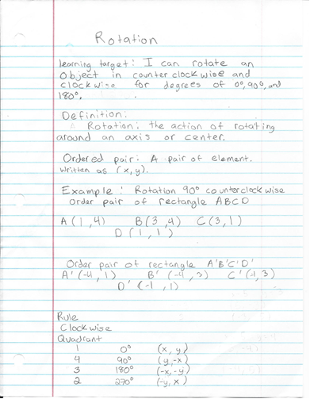
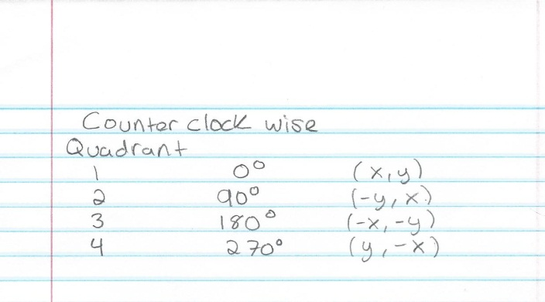
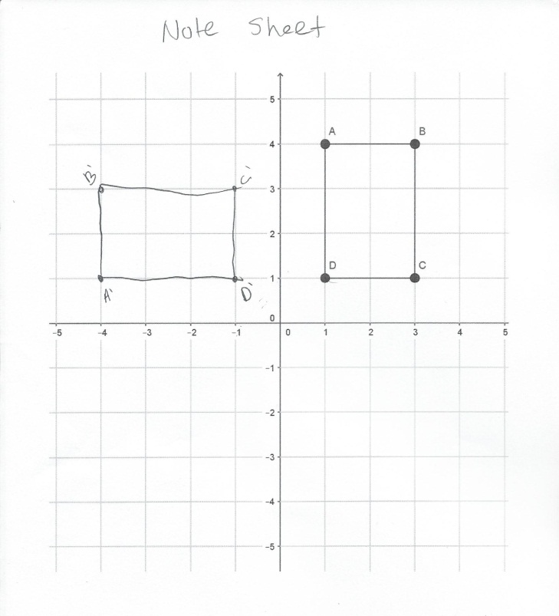
Notes

Entry task
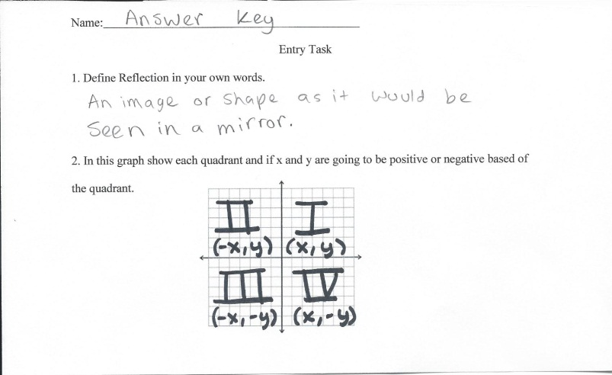
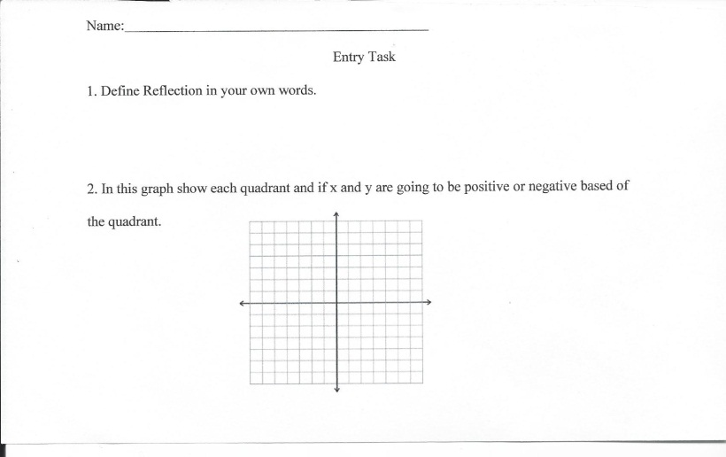

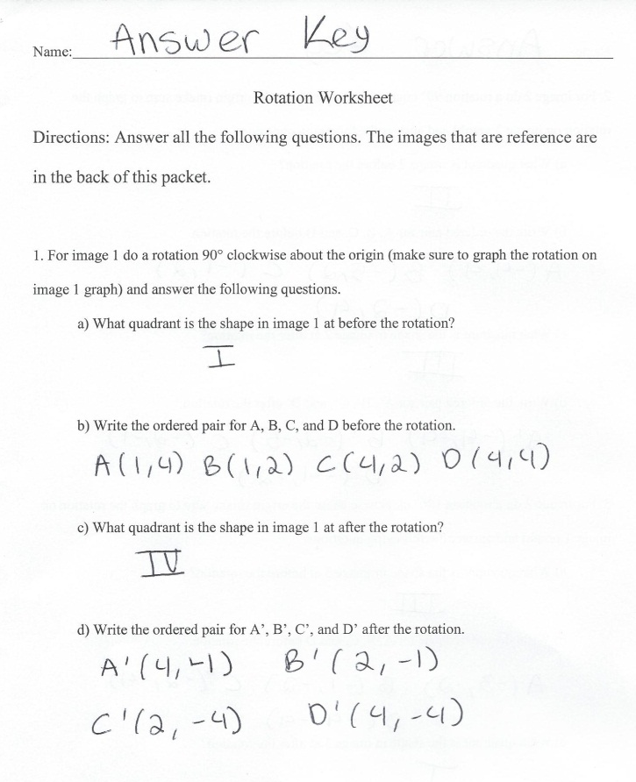
Worksheets
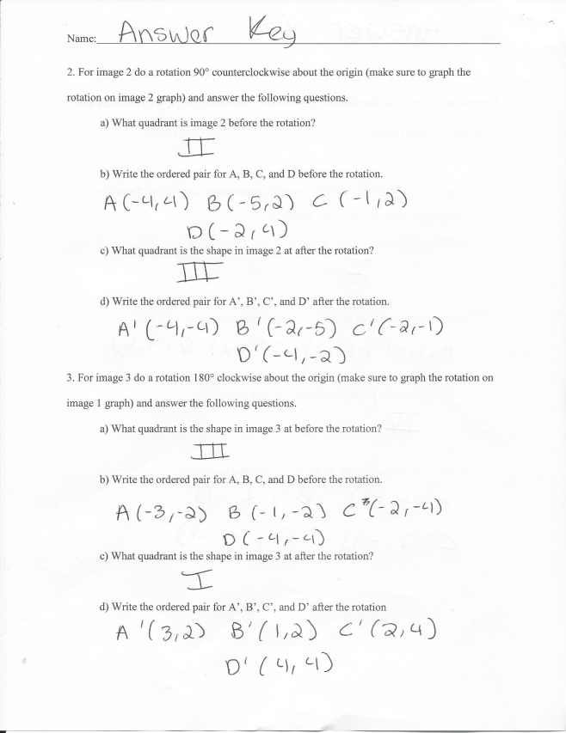
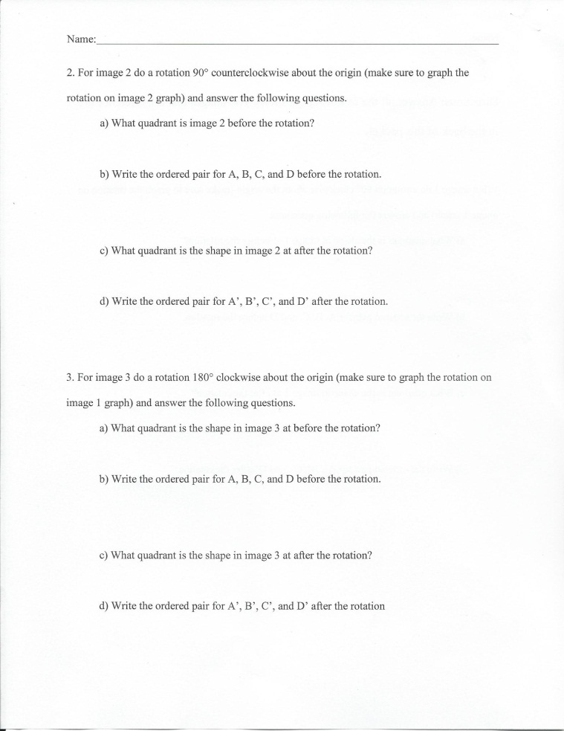
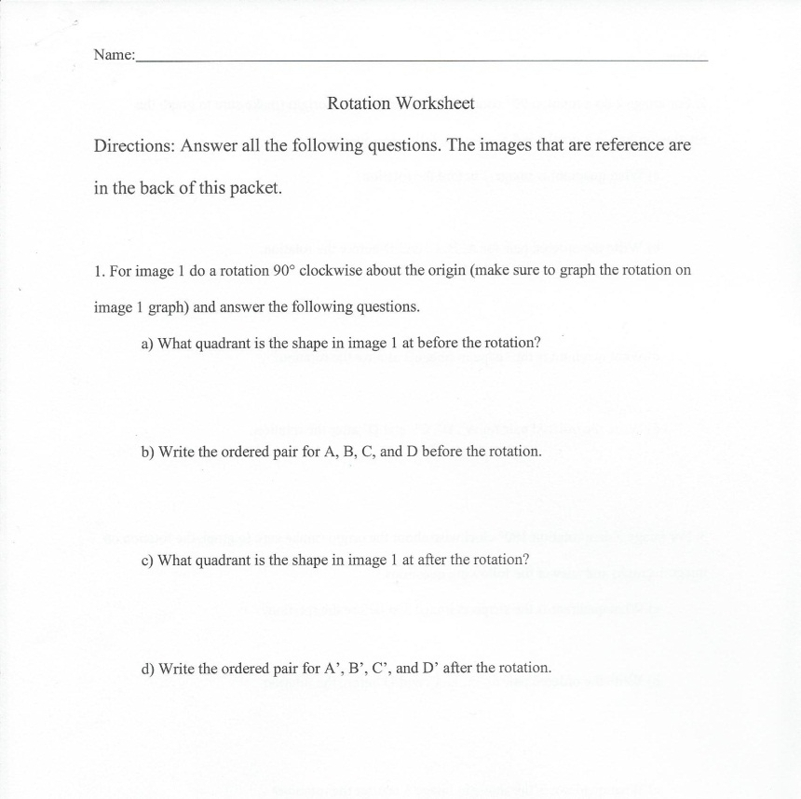

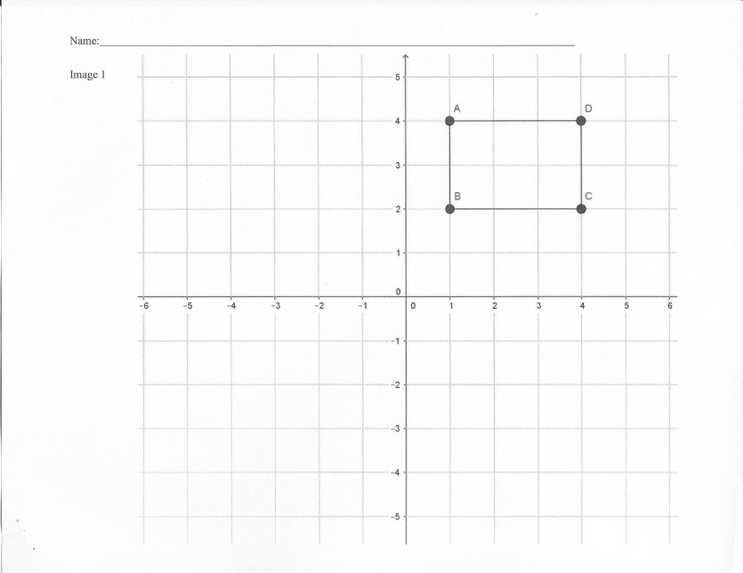
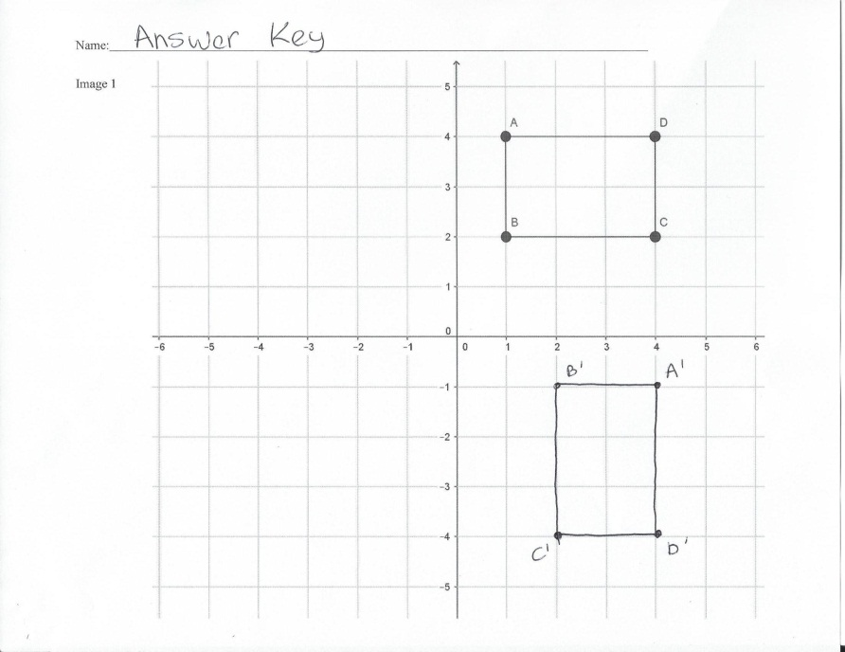
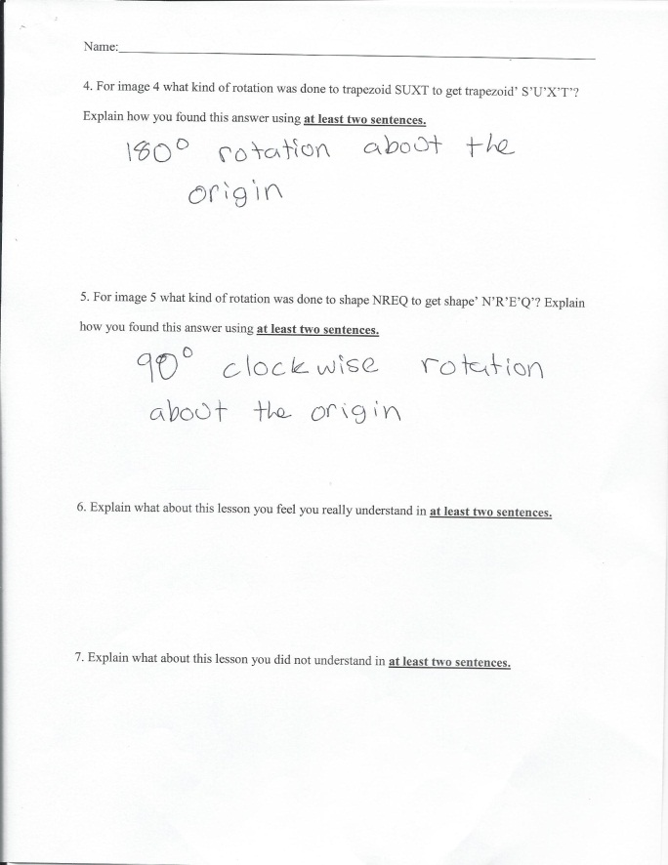
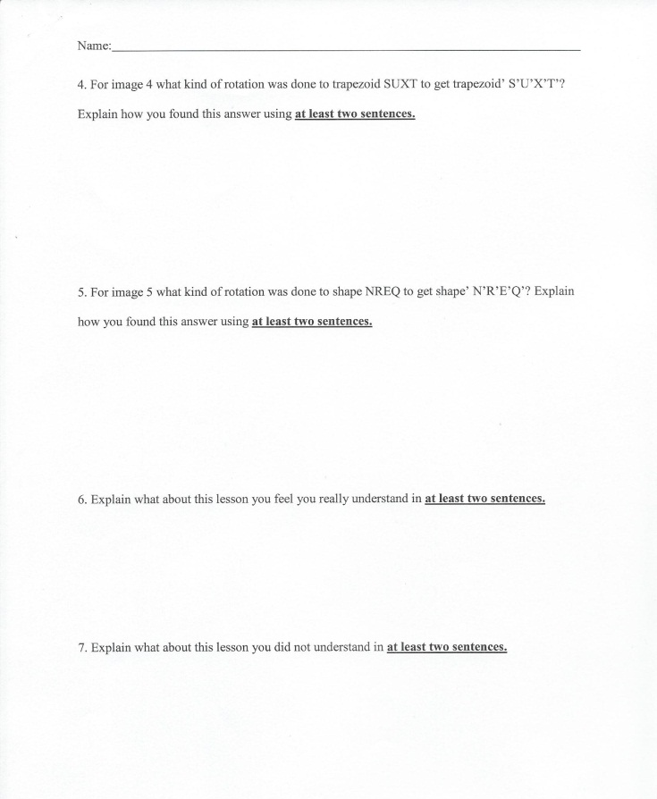

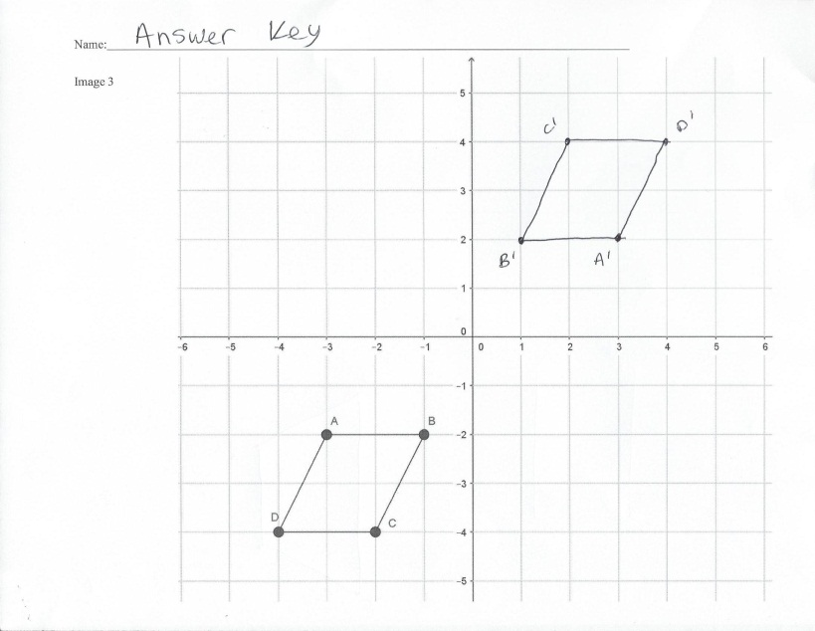
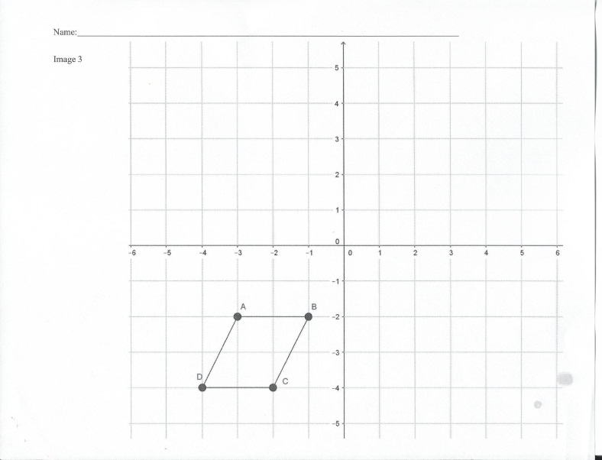
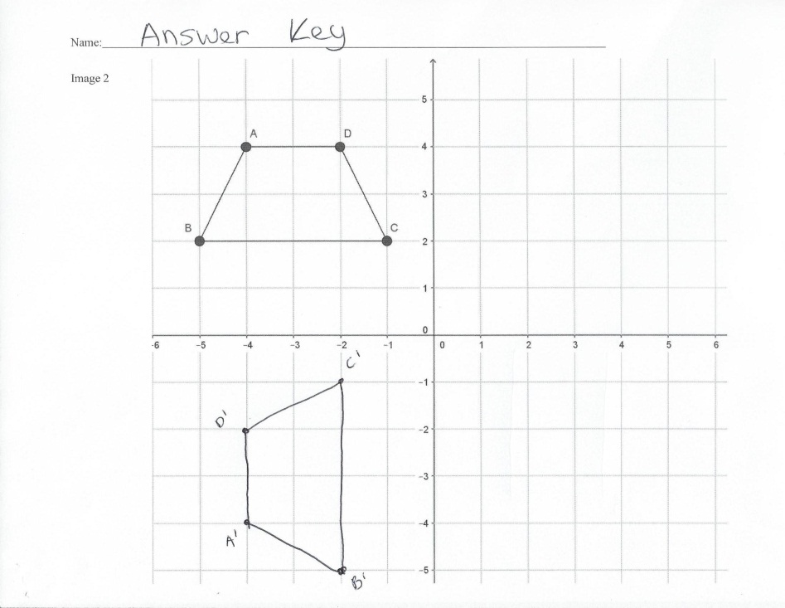
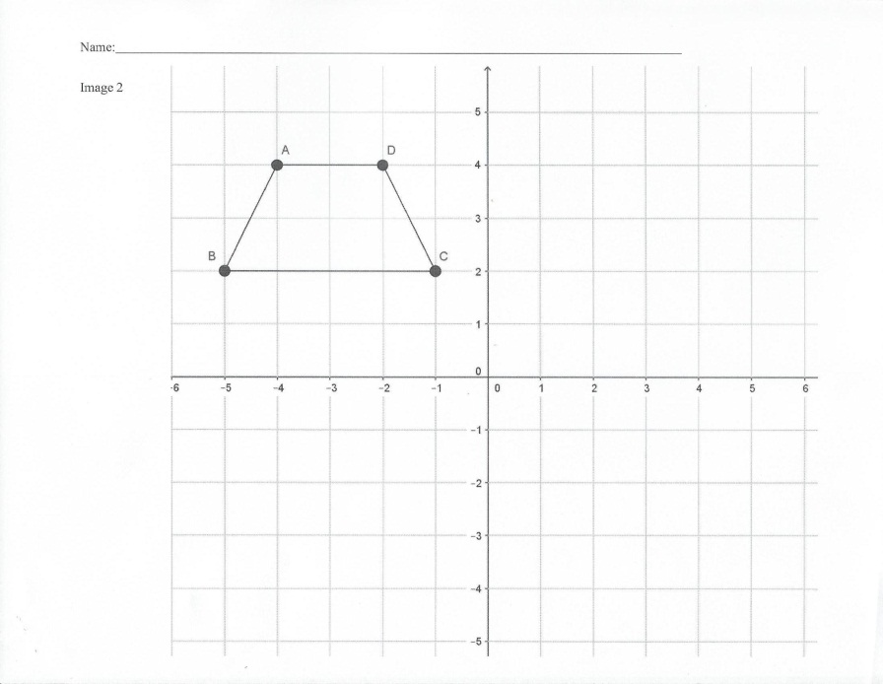

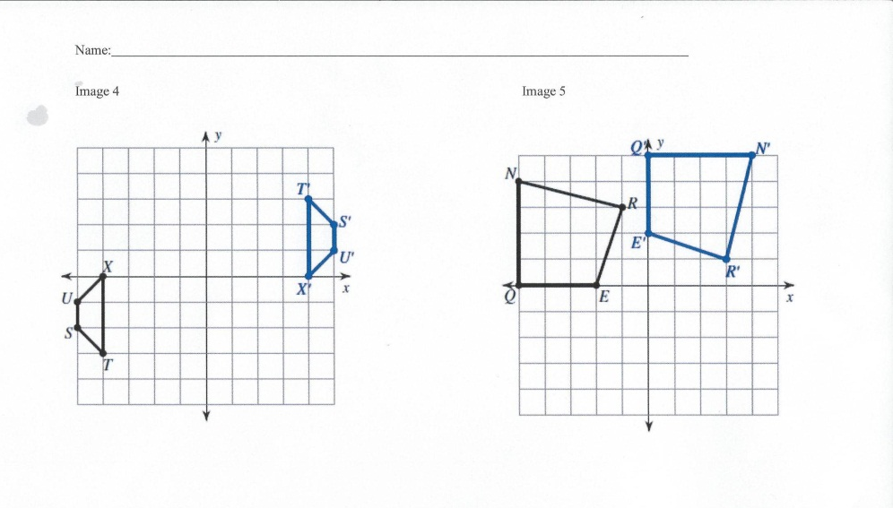

Rubric
Question 1 | pts
Student wrote which quadrant the shape is in before the rotation | 1
Student wrote the correct order pair for A,B,C and D (.25 pts for each correct order pair) | 1
Student wrote which quadrant the shape is in after the rotation | 1
Student wrote the correct order pair for A’,B’,C’ and D’ (.25 pts for each correct order pair) | 1
Student graph the rotation (1 pts for each correct graphed order pair) | 4
Student label the graph for pinot A’,B’,C’ and D’ correct (.25 pts for each correct label of order pair) | 1
Total | 9
Question 2 | pts
Student wrote which quadrant the shape is in before the rotation | 1
Student wrote the correct order pair for A,B,C and D (.25 pts for each correct order pair) | 1
Student wrote which quadrant the shape is in after the rotation | 1
Student wrote the correct order pair for A’,B’,C’ and D’ (.25 pts for each correct order pair) | 1
Student graph the rotation (1 pts for each correct graphed order pair) | 4
Student label the graph for pinot A’,B’,C’ and D’ correct (.25 pts for each correct label of order pair) | 1
Total | 9
Question 3 | pts
Student wrote which quadrant the shape is in before the rotation | 1
Student wrote the correct order pair for A,B,C and D (.25 pts for each correct order pair) | 1
Student wrote which quadrant the shape is in after the rotation | 1
Student wrote the correct order pair for A’,B’,C’ and D’ (.25 pts for each correct order pair) | 1
Student graph the rotation (1 pts for each correct graphed order pair) | 4
Student label the graph for pinot A’,B’,C’ and D’ correct (.25 pts for each correct label of order pair) | 1
Total | 9
Question 4 | pts
Student got the correct rotation (1pt for the degree and 1pt for the directions) | 2
Student wrote two sentences to explain how they found there answer (1pt per sentence) | 2
Total | 4
Question 5 | pts
Student got the correct rotation (1pt for the degree and 1pt for the directions) | 2
Student wrote two sentences to explain how they found there answer (1pt per sentence) | 2
Total | 4
Question 6
Student wrote two sentences to explain what they understood (1pt per sentence) | 2
Total | 2
Question 7
Student wrote two sentences to explain what they did not understand (1pt per sentence) | 2
Total | 2

